**MANUAL TESTS**

**Syed Mudabbir**

**Alexander Ferrard**

**Ayush Patel**

**Team Expressionary**

**Sprint 3**

**USER STORY # 1**

**Test No.1**

Try Accessing User Page without Logging In or selecting A user

**Procedure:**

* Navigate to the home page of the website
* In the URL, type /user to access user page without logging in
* Validate the response

**Test**

Navigate to the home page

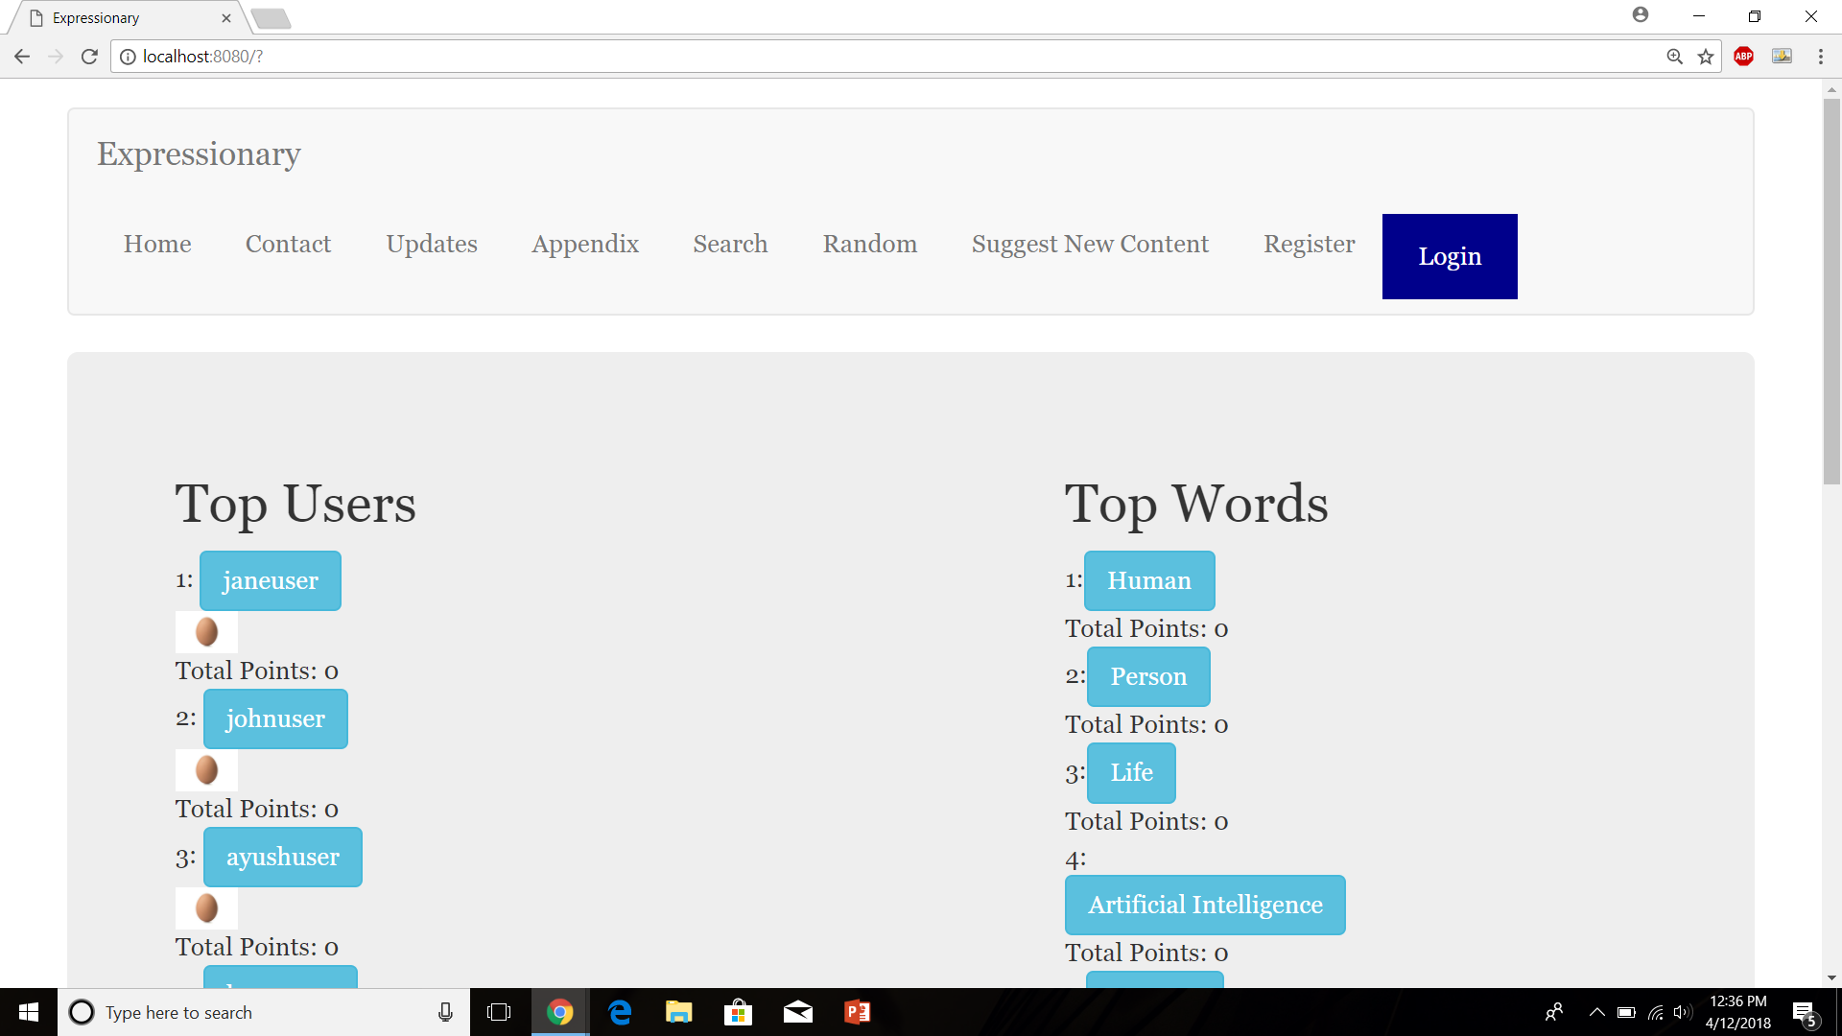

Type “/user”

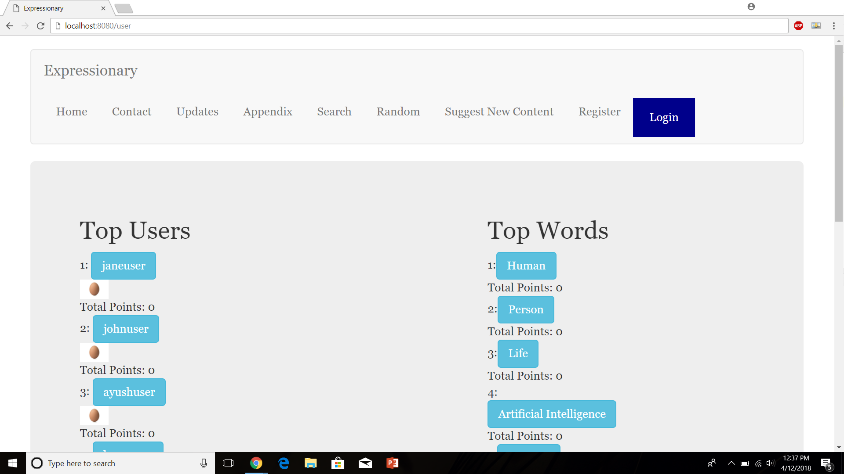

Press Enter

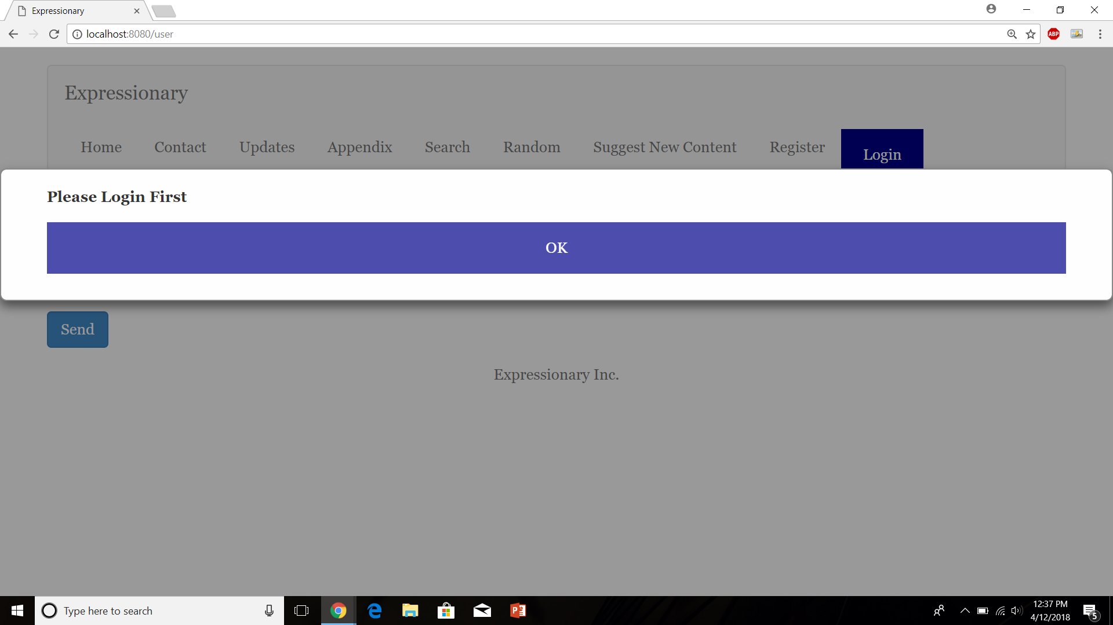

**Results:**

Trying to access a user page without specifying a user or other information doesn’t break the website and an error is shown.

**Test No.2**

Try accessing User Edit page without logging In or selecting a user

**Procedure:**

* Navigate to the home page of the website
* In the URL, type /useredit to access user edit page without logging in
* Validate the response

**Test**

Navigate to the home page



Type “/user”

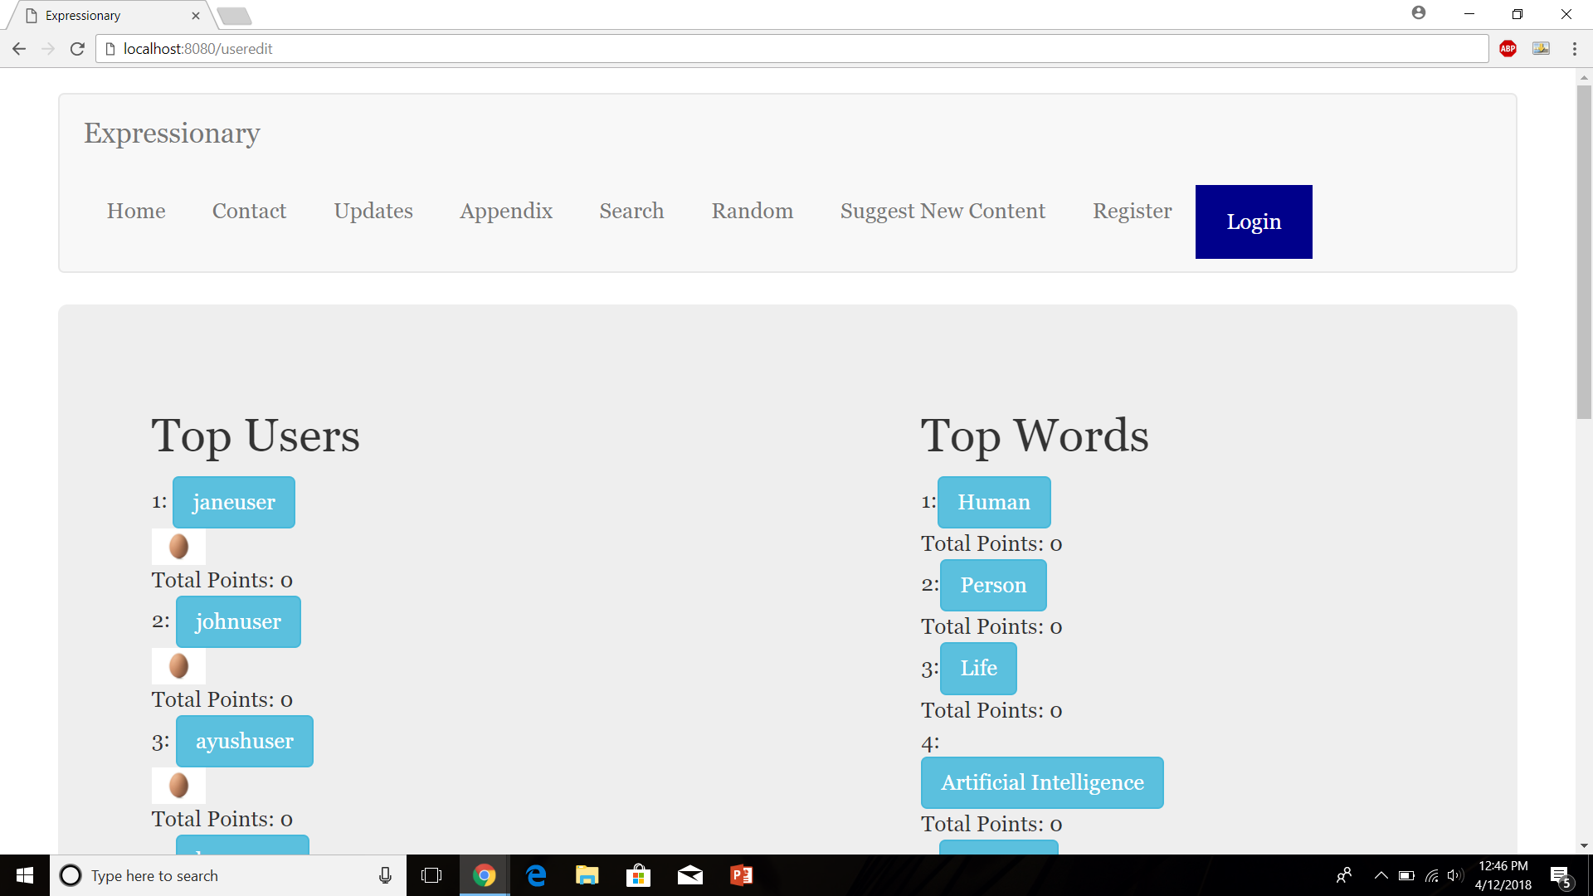

Press Enter



**Results:**

Trying to access a user edit page without specifying a user or other information doesn’t break the website and an error is shown.

**Test No.3**

Error Popup for logging in when an invalid User is given

**Procedure:**

* Navigate to the home page of the website
* Press the login button
* Enter Invalid Username
* Report the result

**Test**

Navigate to the home page



Press Login

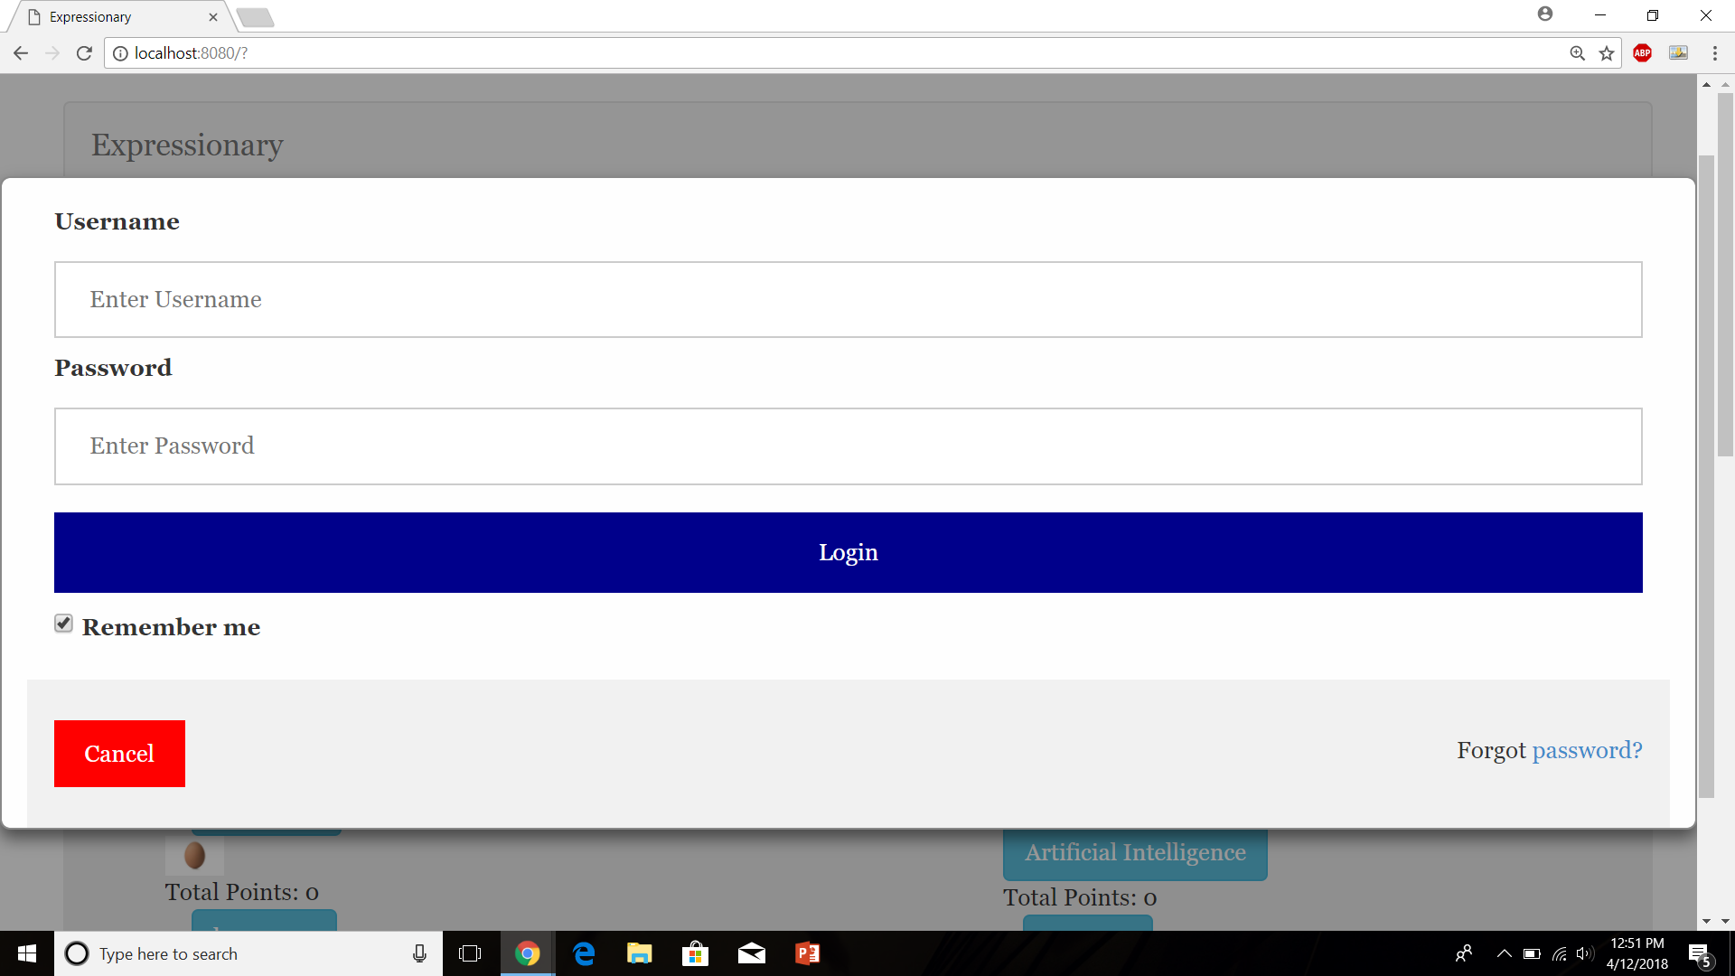

Enter Invalid Username

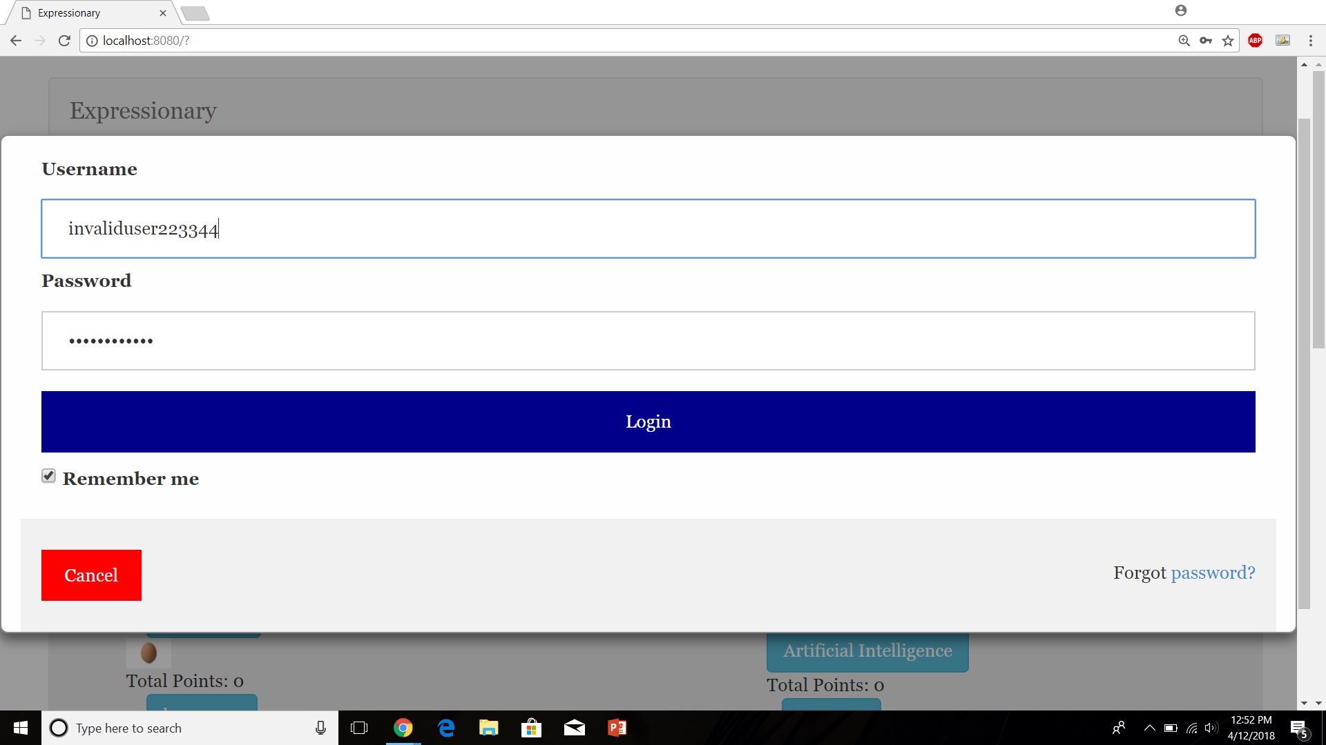

Report the result

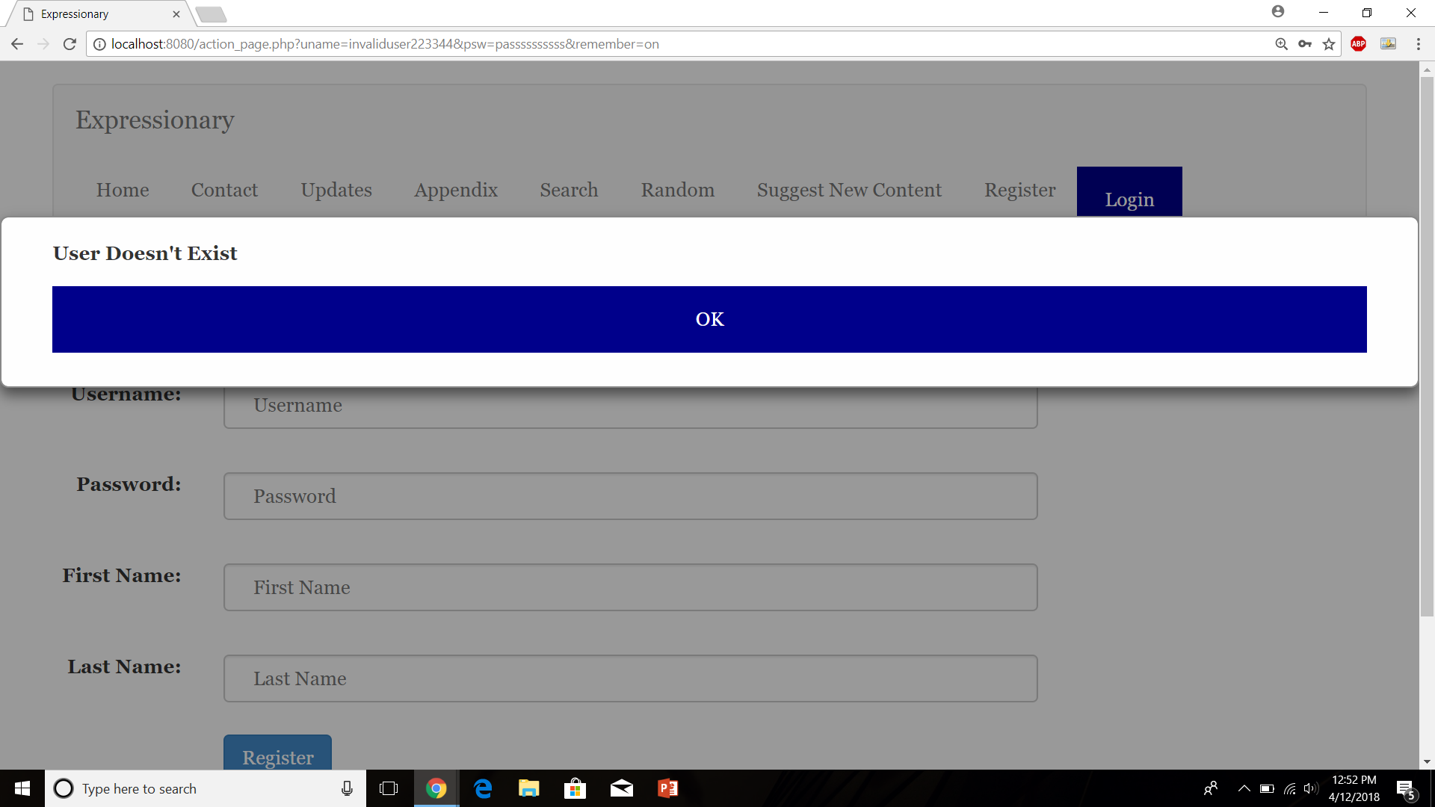

**Results:**

An error popup is shown when an invalid user is typed

**Test No.4**

Error Popup for logging in when an invalid password is given

**Procedure:**

* Navigate to the home page of the website
* Press the login button
* Enter Invalid password but valid username
* Report the result

**Test**

Navigate to the home page



Press Login



Enter Invalid password but valid username

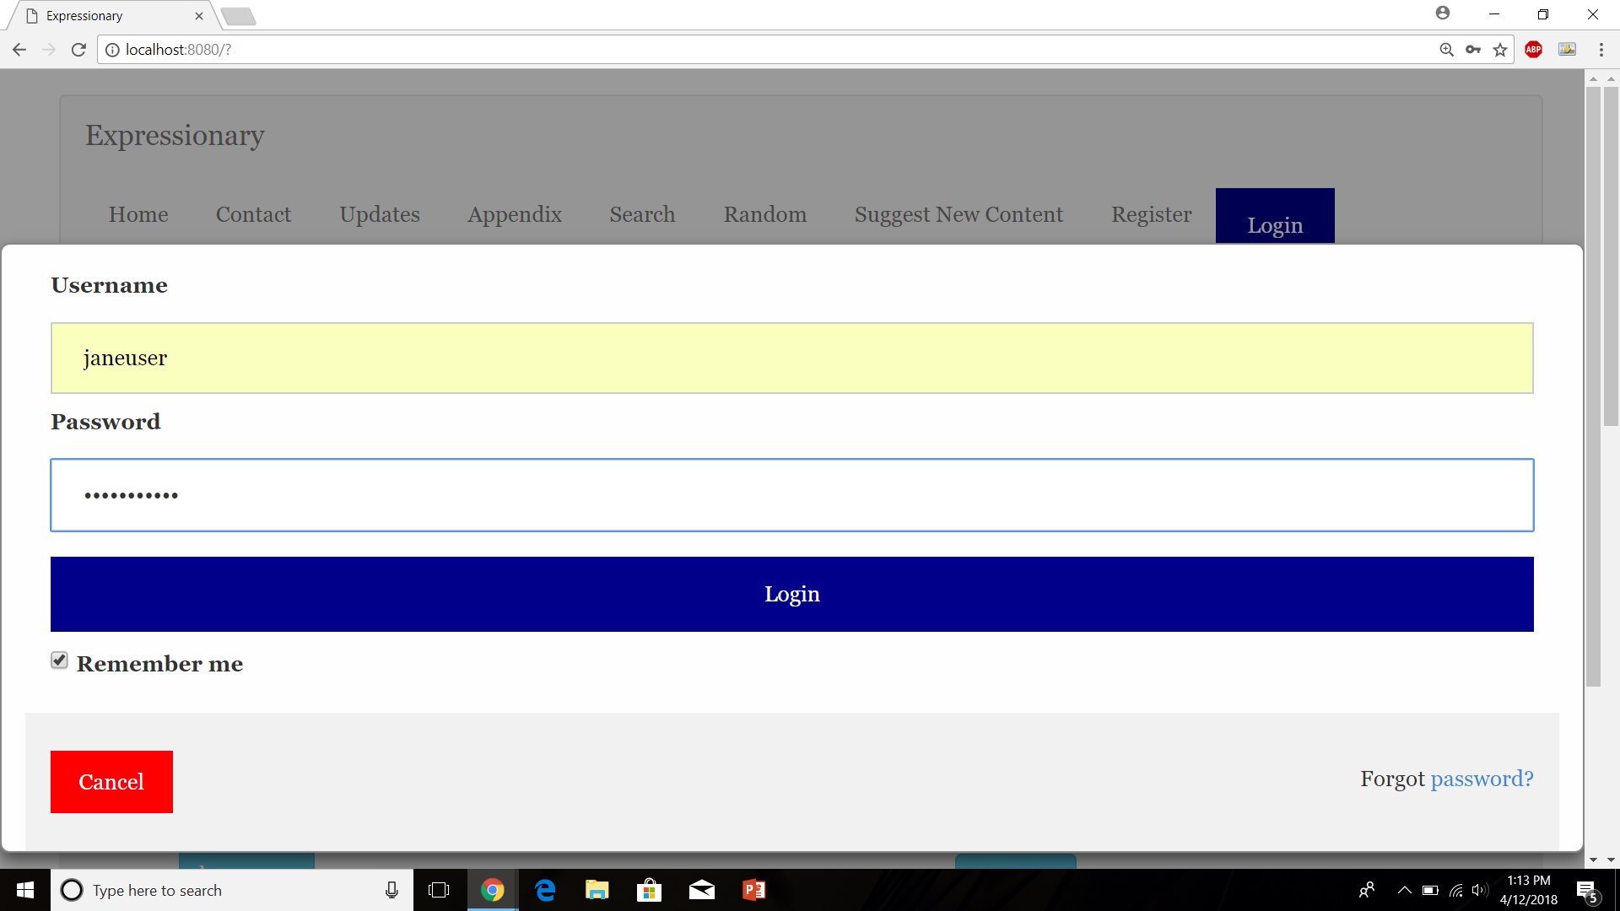

Report the result

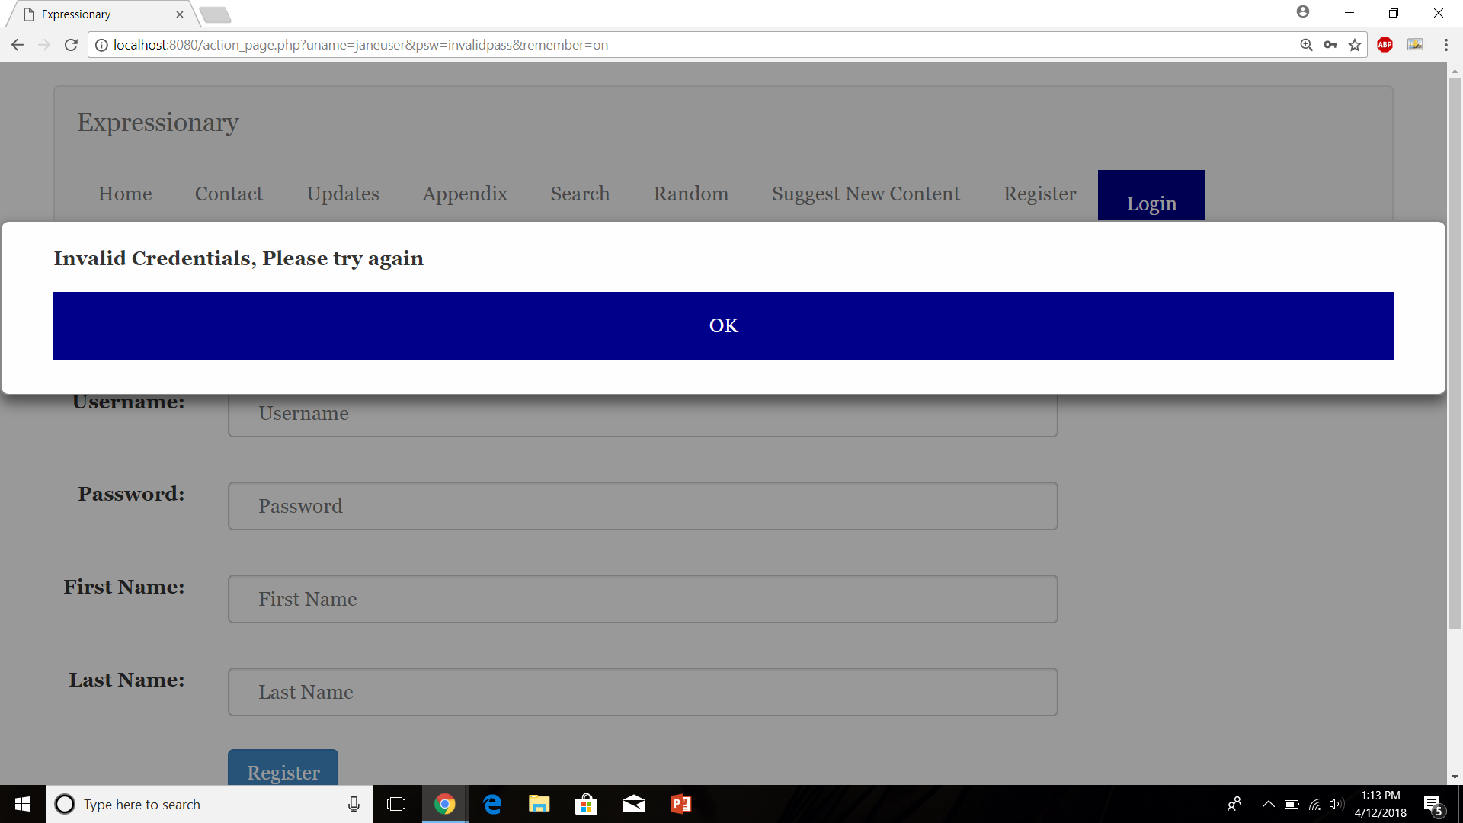

**Results:**

An error popup is shown when a valid user but invalid password is typed

**Test No.5**

Posting a definition without logging in

**Procedure:**

* Navigate to the home page of the website
* Navigate to a word by selecting random word
* Try posting a definition without logging in
* Validate the response

**Test**

Navigate to the home page



Press Random Word and Type a definition

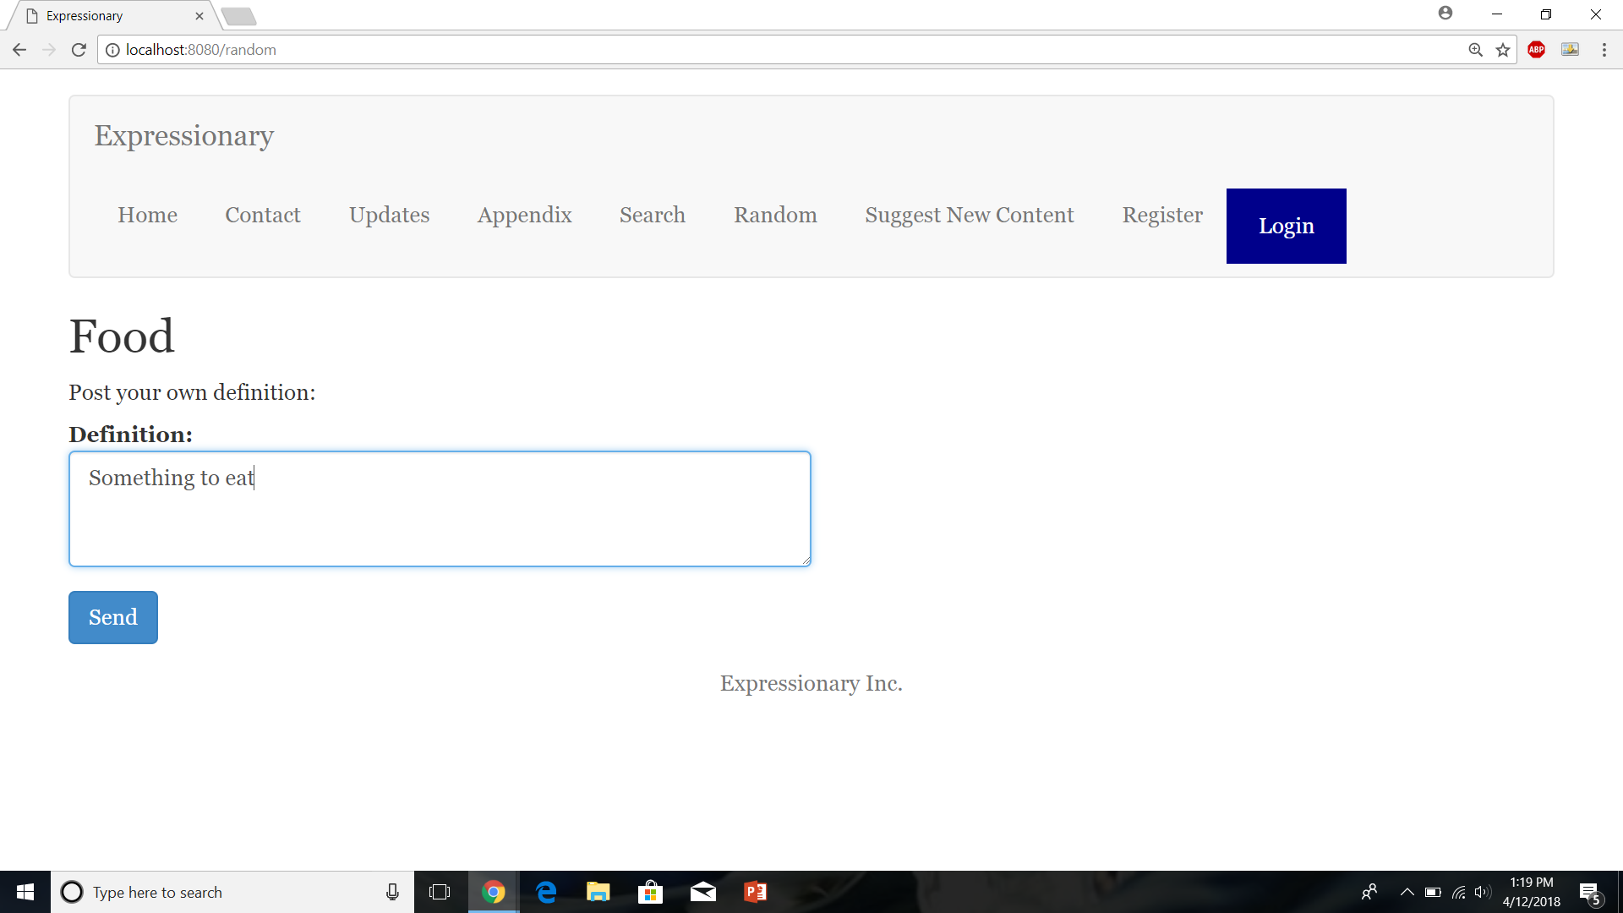

Press Send

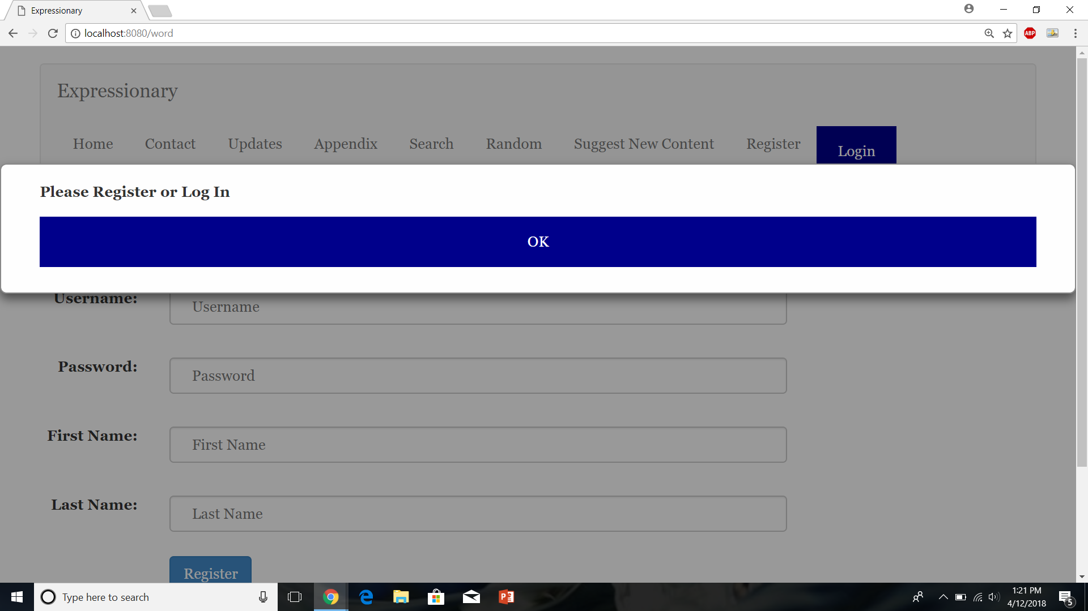

**Results:**

Expected result. Posting does not work without logging in first

**Test No.6**

Registering user with an empty username

**Procedure:**

* Navigate to the register page
* Fill in all the fields except for username
* Press Register
* Validate the response

**Test**

Navigate to the register page

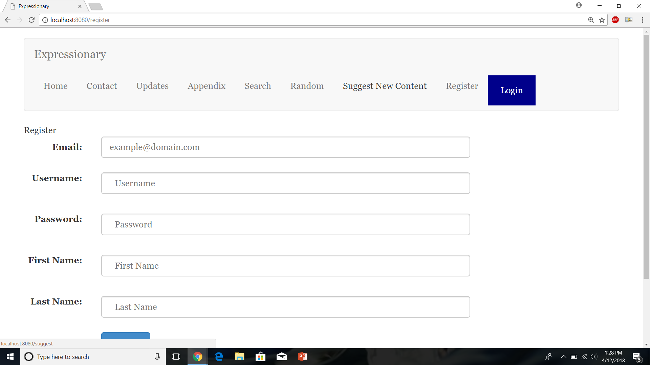

Fill in all the fields except for username

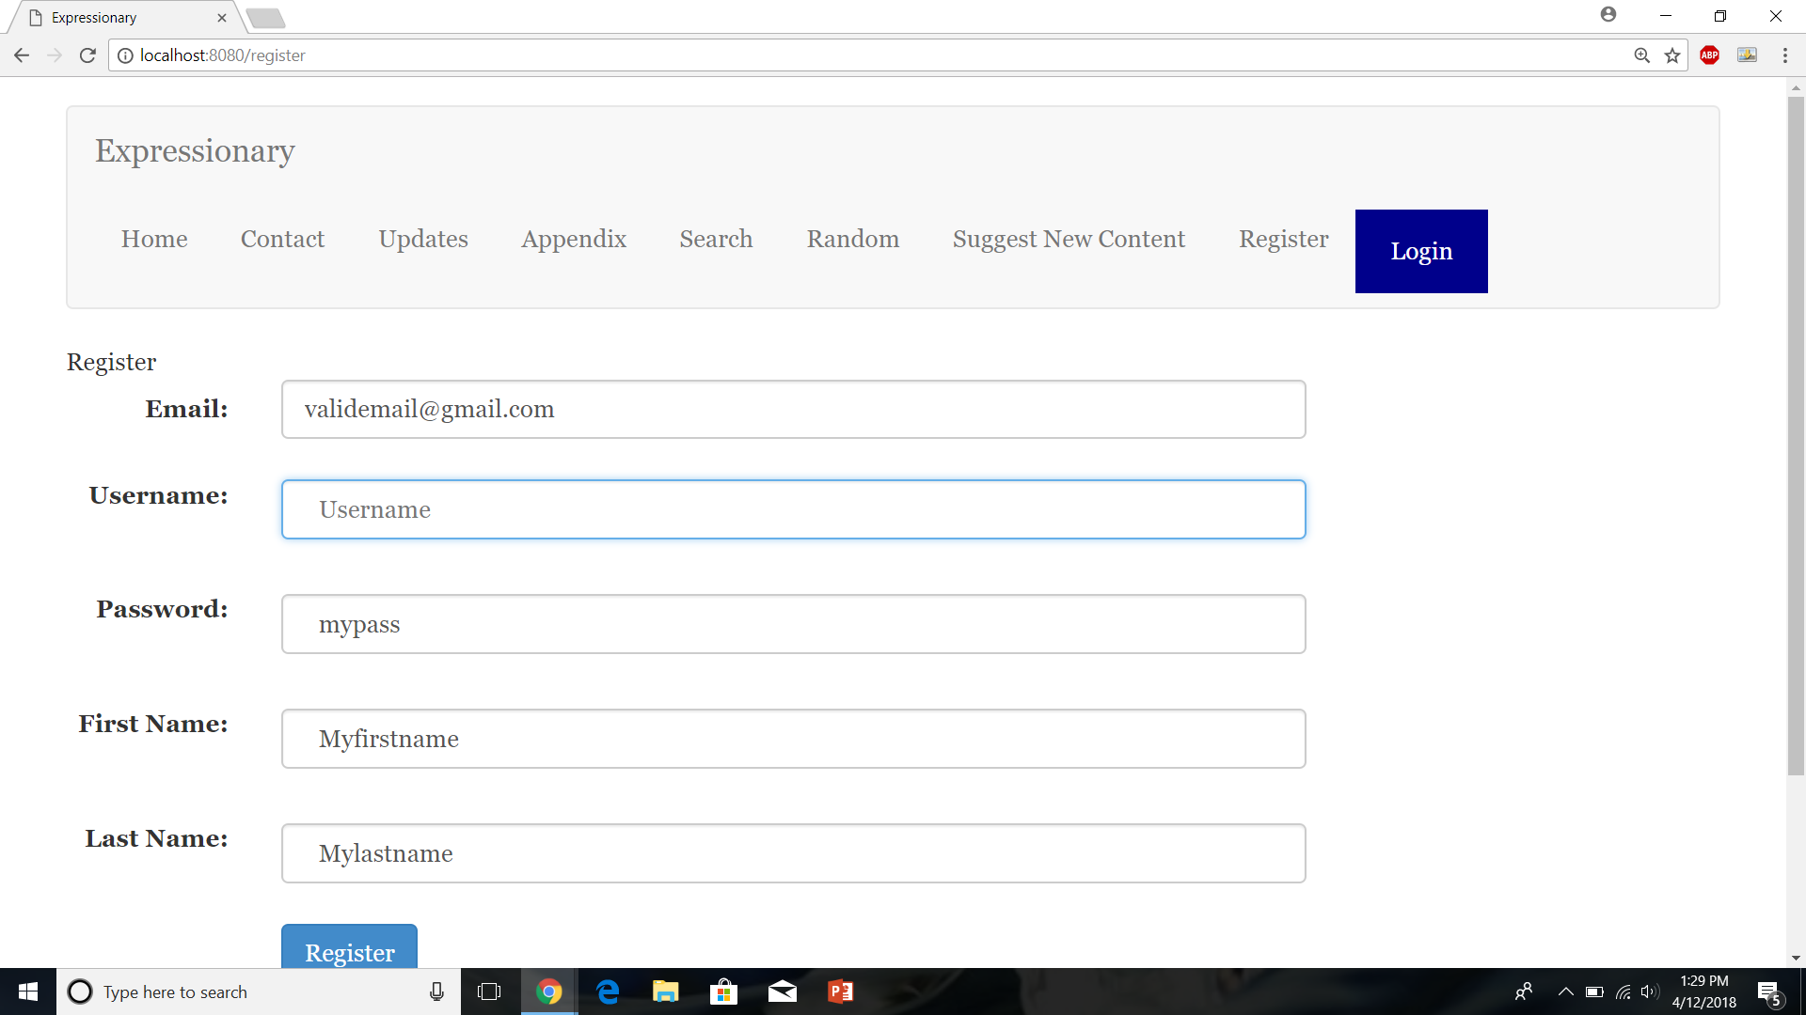

Press Register

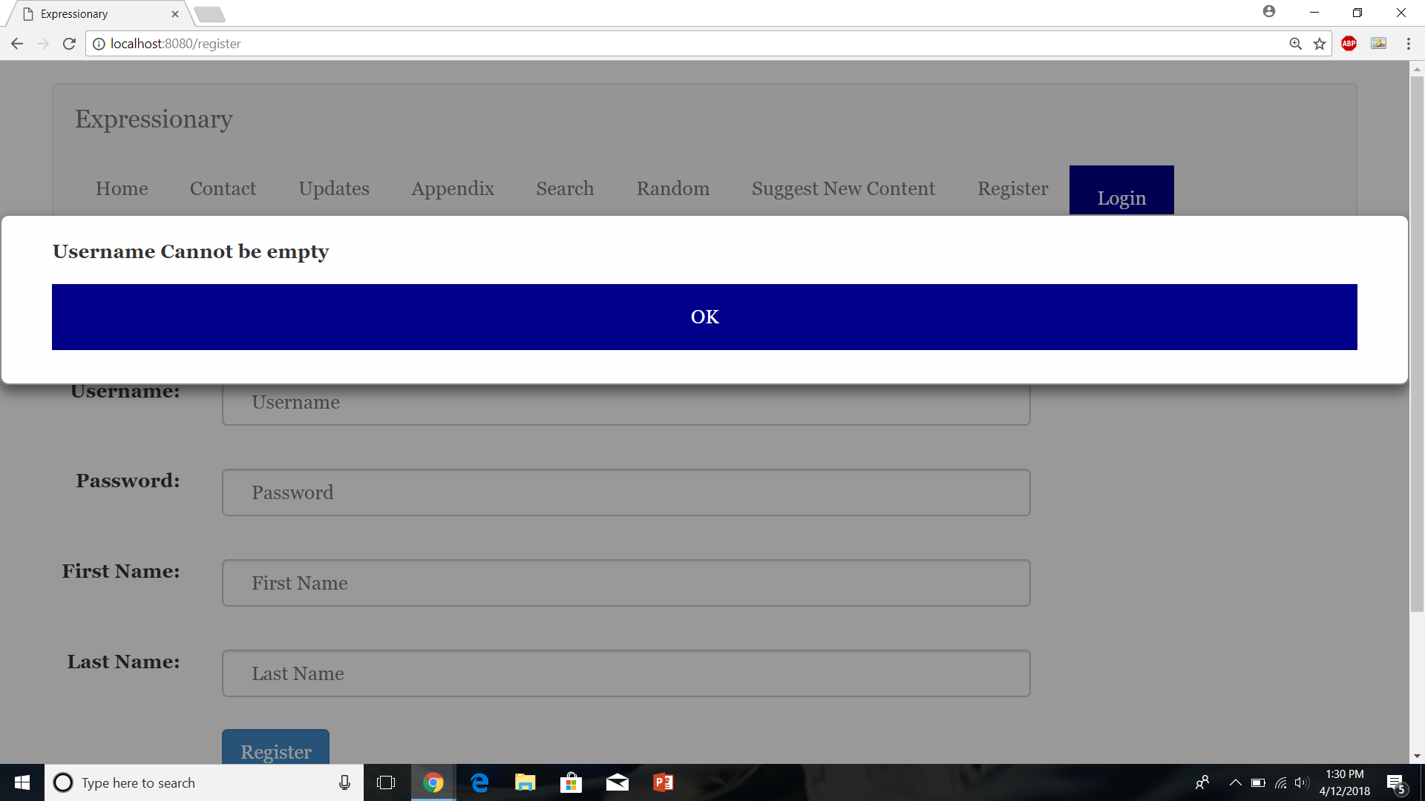

Report the response

**Results:**

Registering User with invalid fields throws an error

**Test No.7**

Test with posting without logging in first

**Procedure:**

* Navigate to the home page of the website
* Click Random word without logging in
* Try posting a definition for any content type
* Report the response

**Test**

Navigate to the home page



Navigate to random without logging in

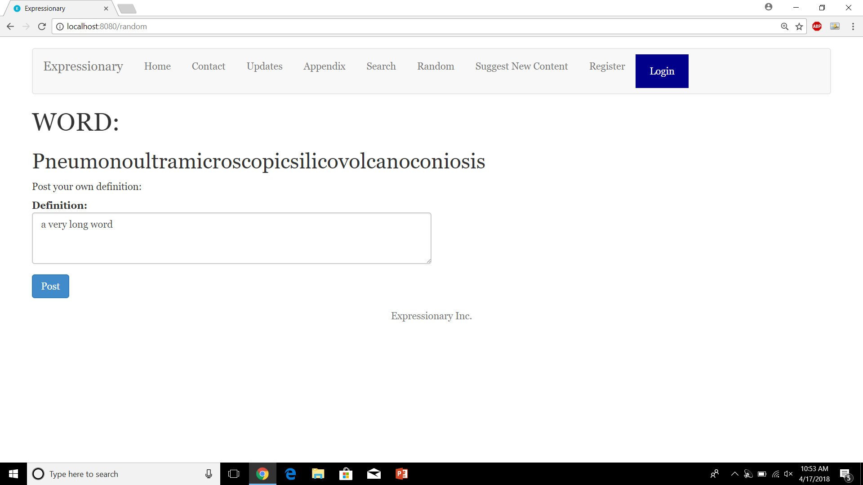

Press post and report the response

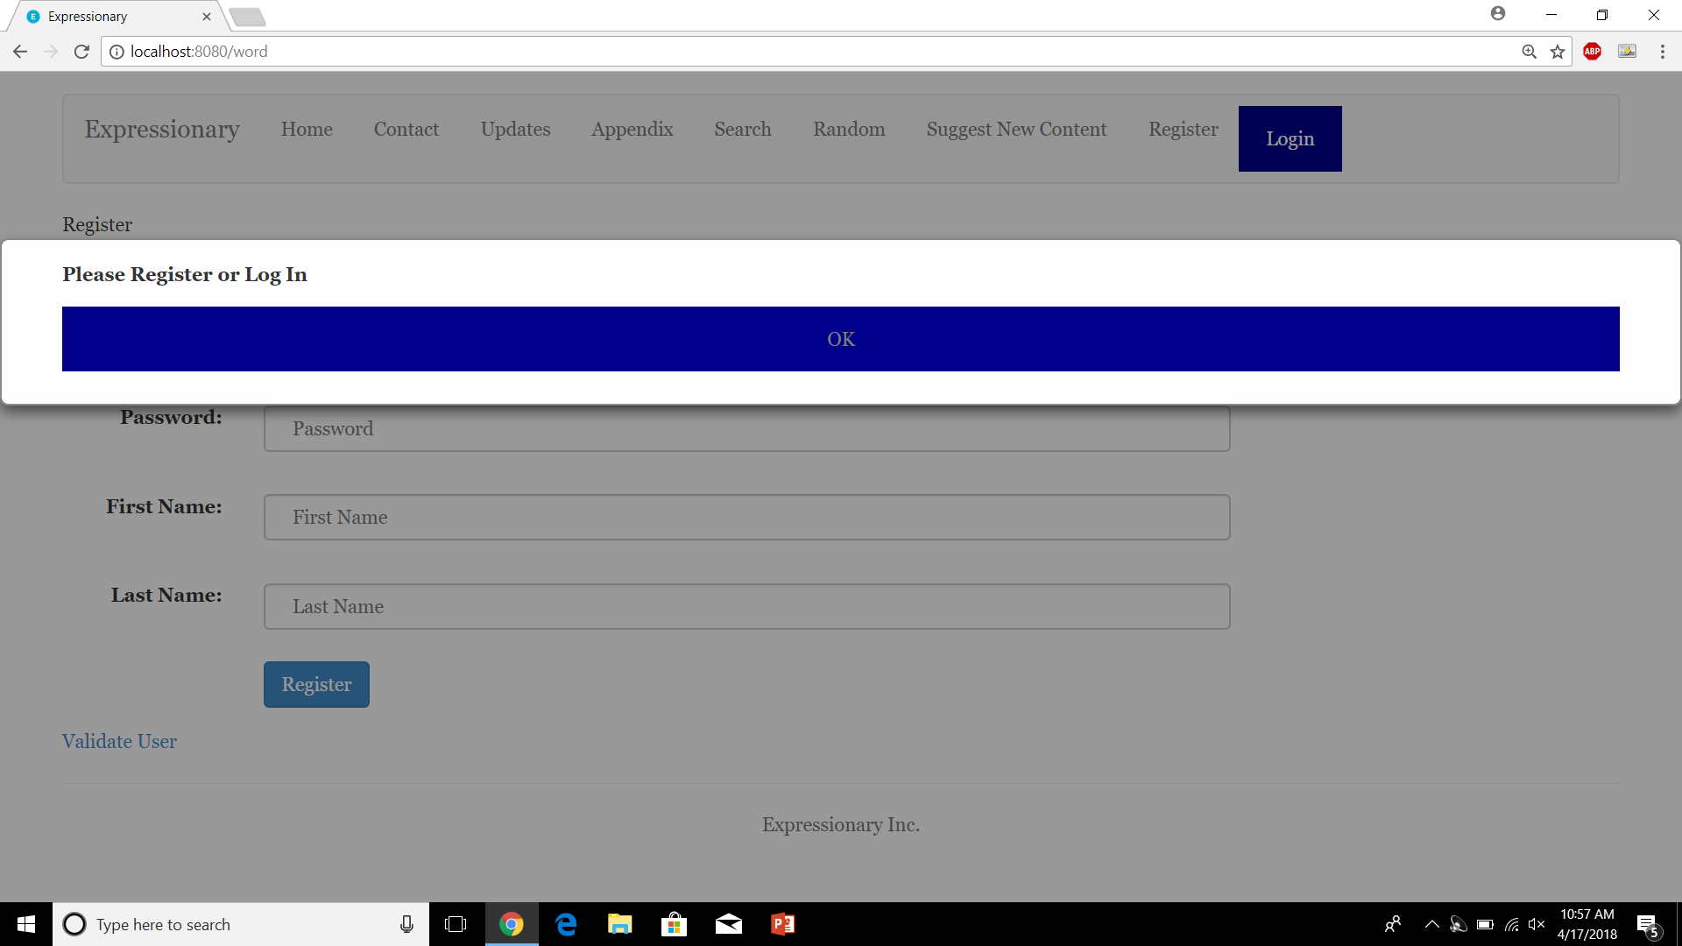

**Results:**

Unauthorized posts throw and error and user is unable to post without logging in first.

**Test No.8**

Test to check if an error is shown if user tries to vote on subjects without logging in first

**Procedure:**

* Navigate to the home page of the website
* Navigate to a word with posts
* Try to add a point without logging in
* Report the response

**Test**

Navigate to the home page



Navigate to a word with definitions

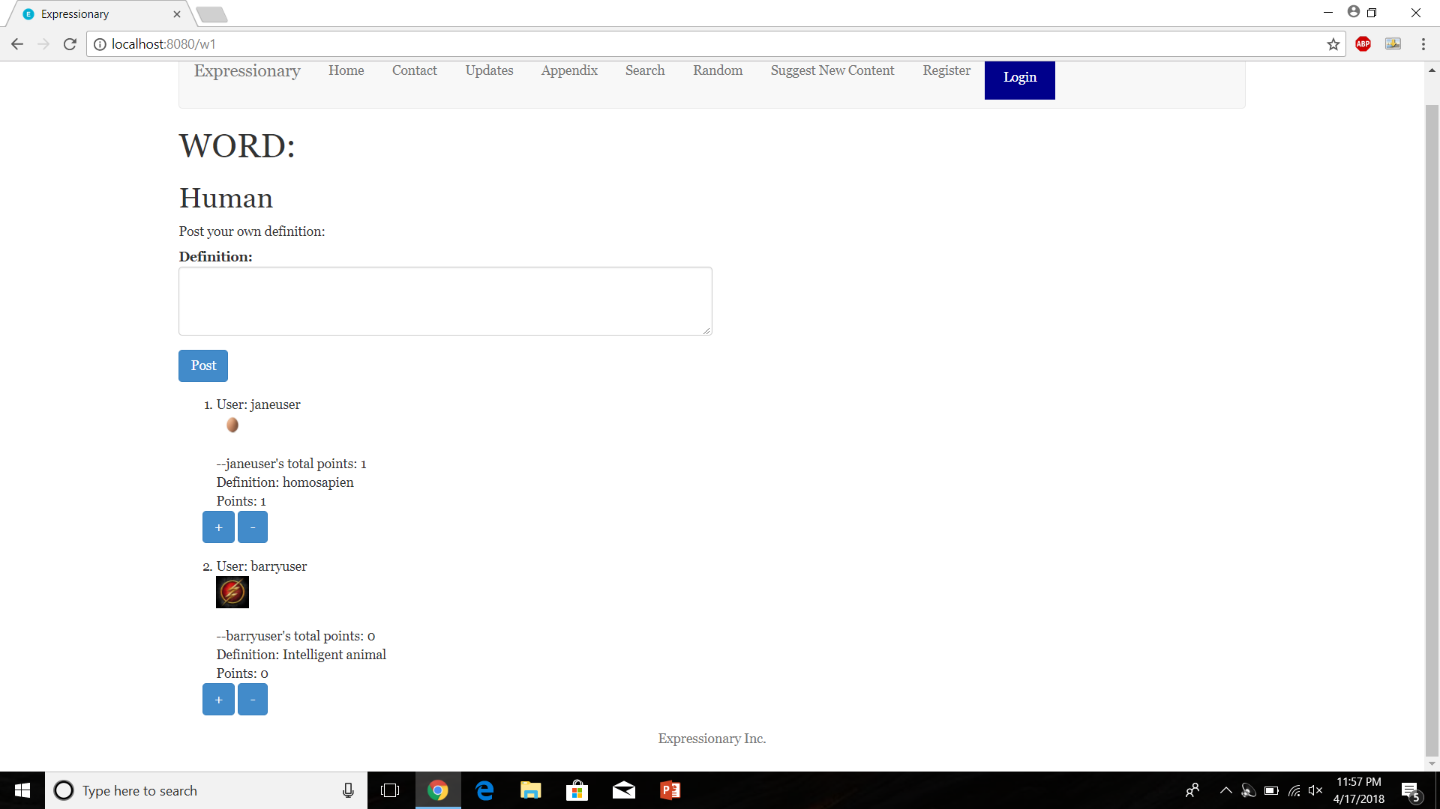

Try to add a point and report the response

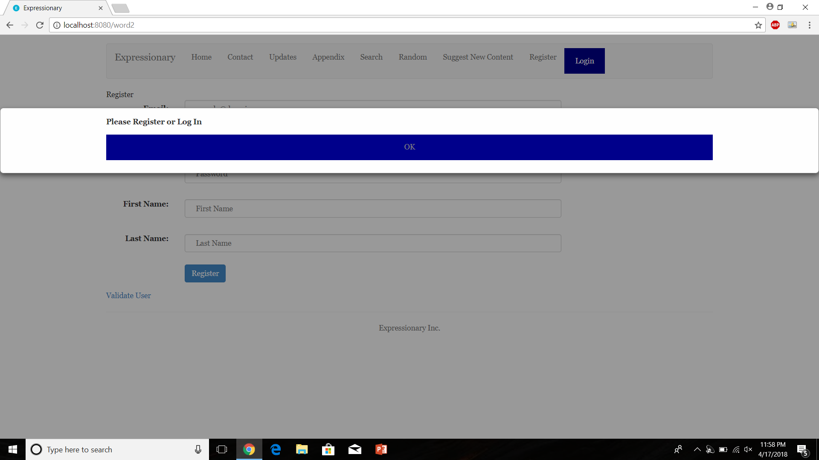

**Results:**

Trying to add a point without logging in is illegal and an error is thrown.

**USER STORY # 2**

**Test No.1**

Registering a new user should require validation

**Procedure:**

* Navigate to the register page
* Register with valid information
* Validate the response

**Test**

Navigate to the register page and enter valid information

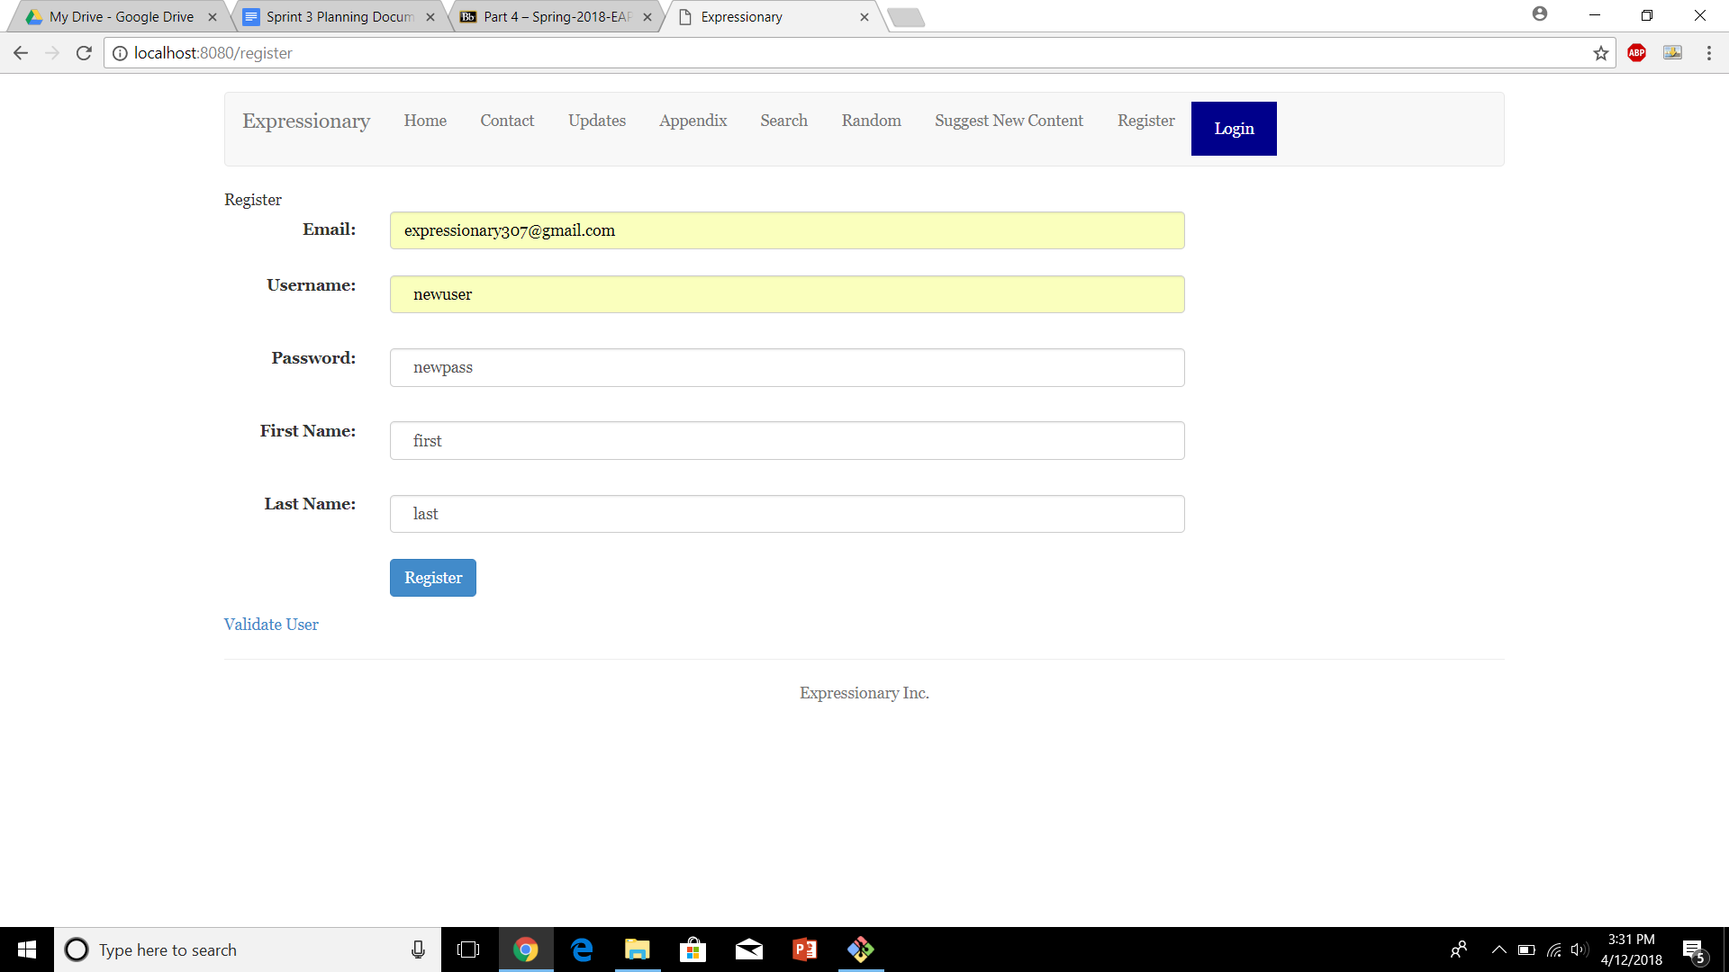

Press the Register button and report the response

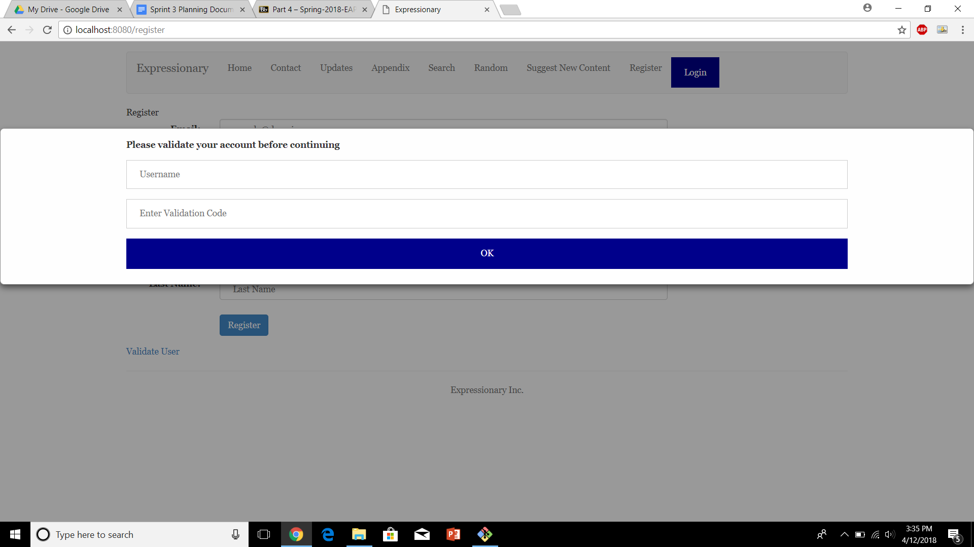

**Results:**

The website doesn’t let you register unless the account has been validated

**Test No.2**

Email should be sent to the provided email

**Procedure:**

* Register with valid email
* Check your email to see if validation code was received

**Test**

Navigate to the register page and enter valid information



Check your email to ensure email was recieved

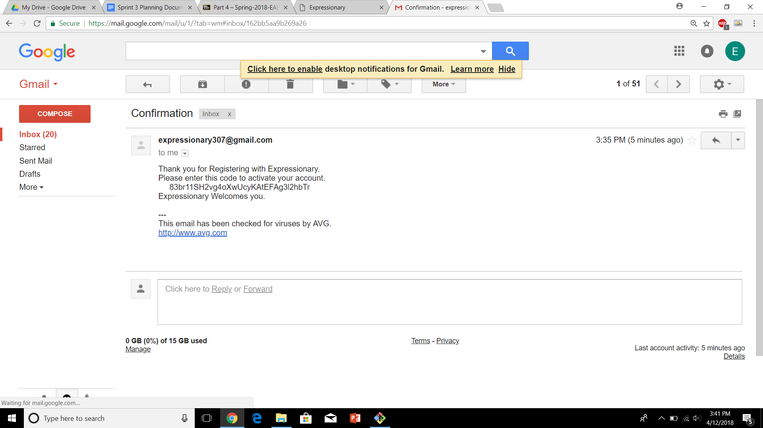

**Results:**

Provided a valid email, the server can send a randomized string (Validation Code) to the email to proceed with registration

**Test No.3**

A validation Popup can be accessed anytime so User doesn’t have to validate right after they register

**Procedure:**

* Navigate to the register page
* Look for the Validate User button
* Report the response

**Test**

Navigate to the register page and look for the validate user button

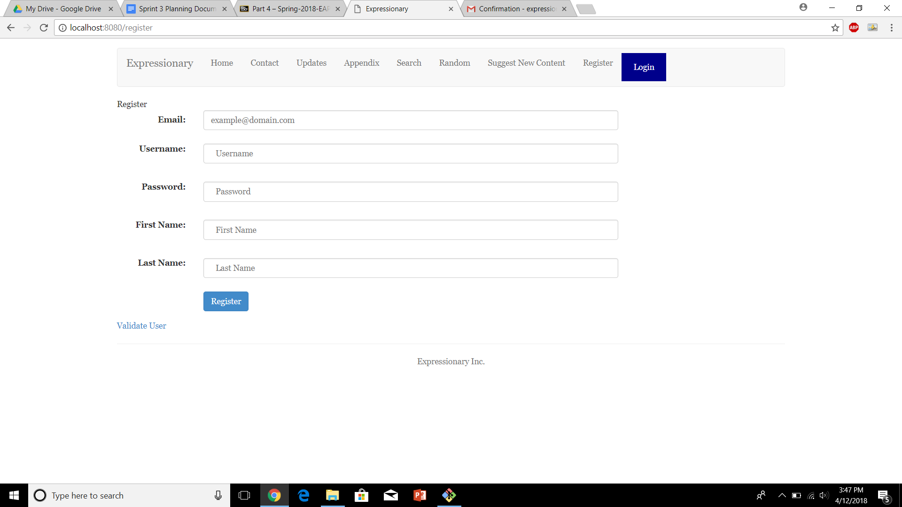

Press the validate user button and report the response



**Results:**

The same popup is displayed again, in case someone wants to come back and validate their account.

**Test No.4**

User should not be able to log in without validating their account

**Procedure:**

* Navigate to the home page
* Press login and enter user’s information that has not yet been verified
* Try logging in
* Report the response

**Test**

Navigate to the home page

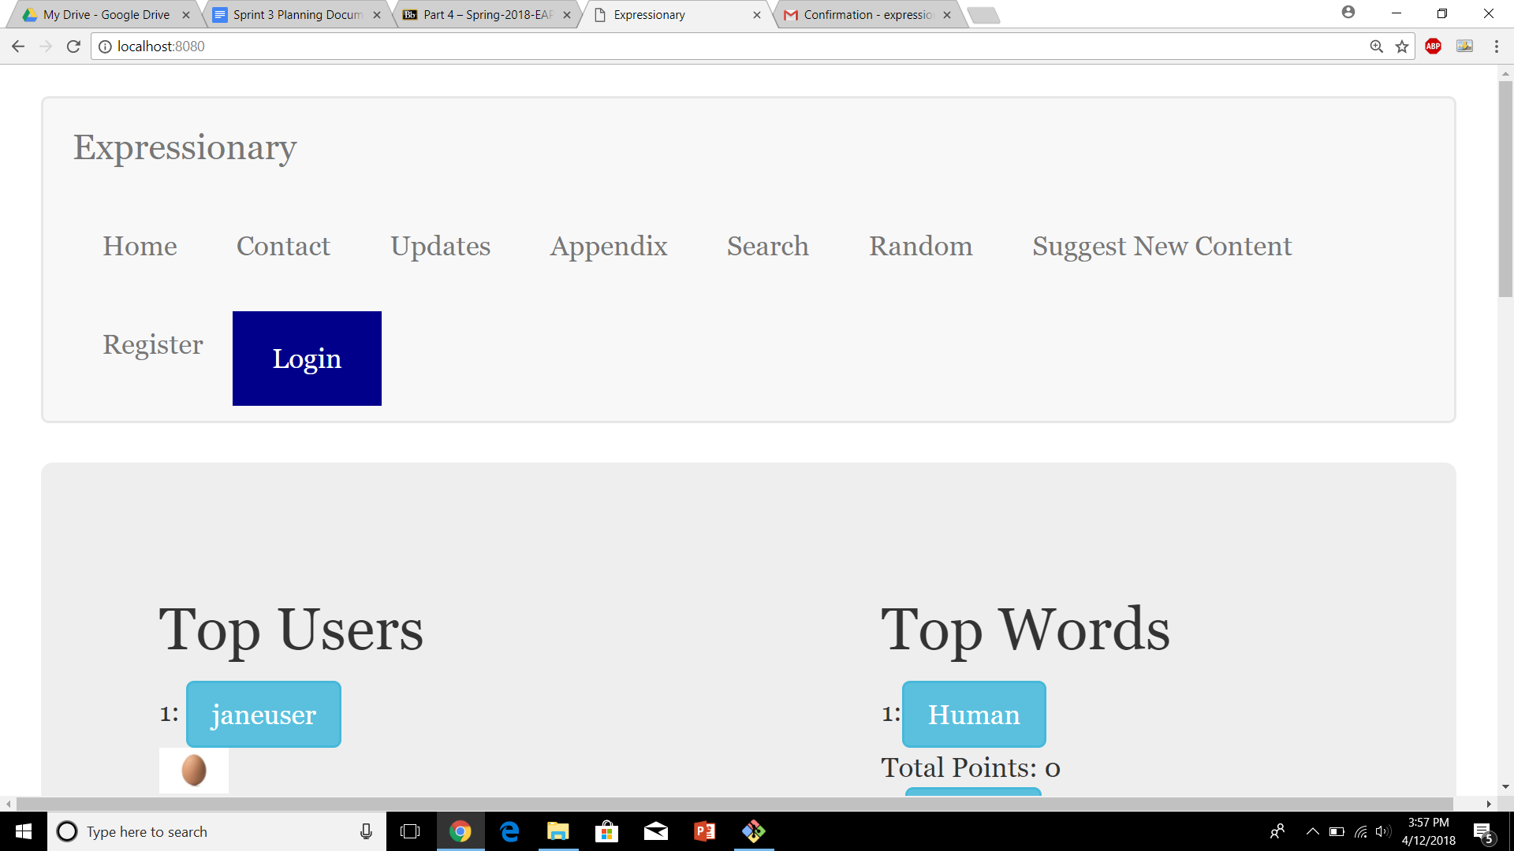

Press Login and enter valid information that has not yet been verified

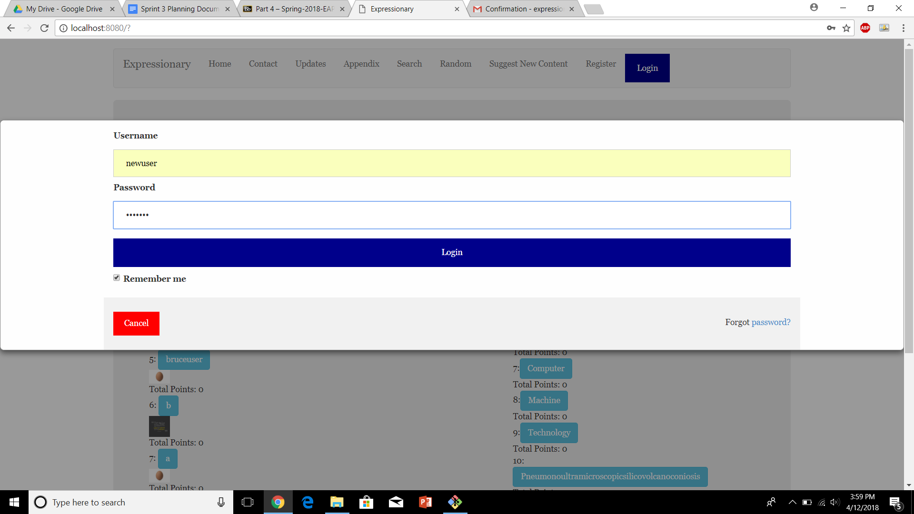

Report the response

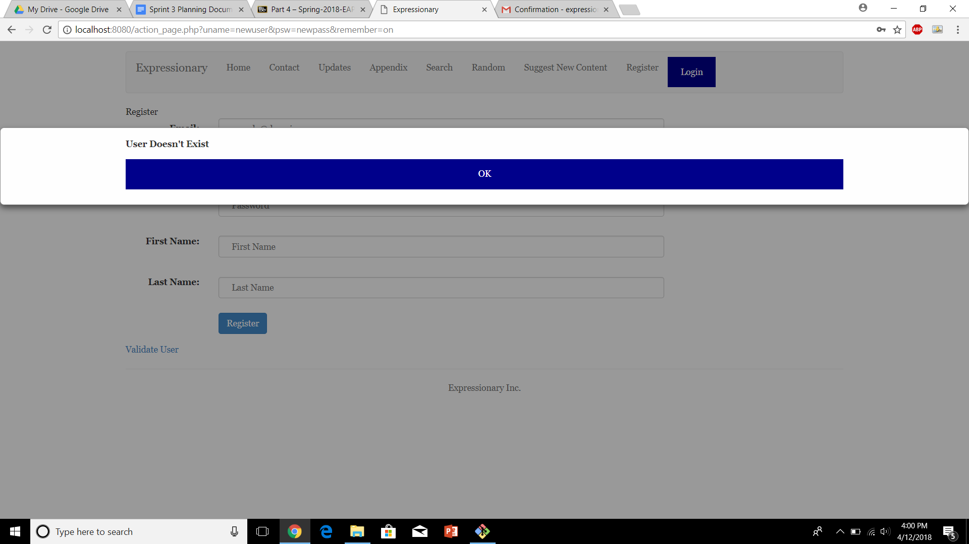

**Results:**

Logging into an account without validating first does not work as the registration process is not yet complete.

**Test No.5**

Entering the wrong username and correct validation code does not complete registration

**Procedure:**

* Navigate to the register page
* Press Validate user
* Enter invalid username but correct validation code
* Report the response

**Test**

Navigate to the register page and press validate account

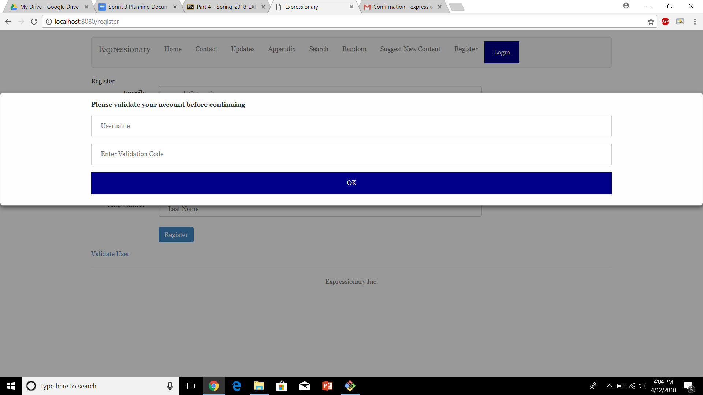

Enter invalid username with correct validation code

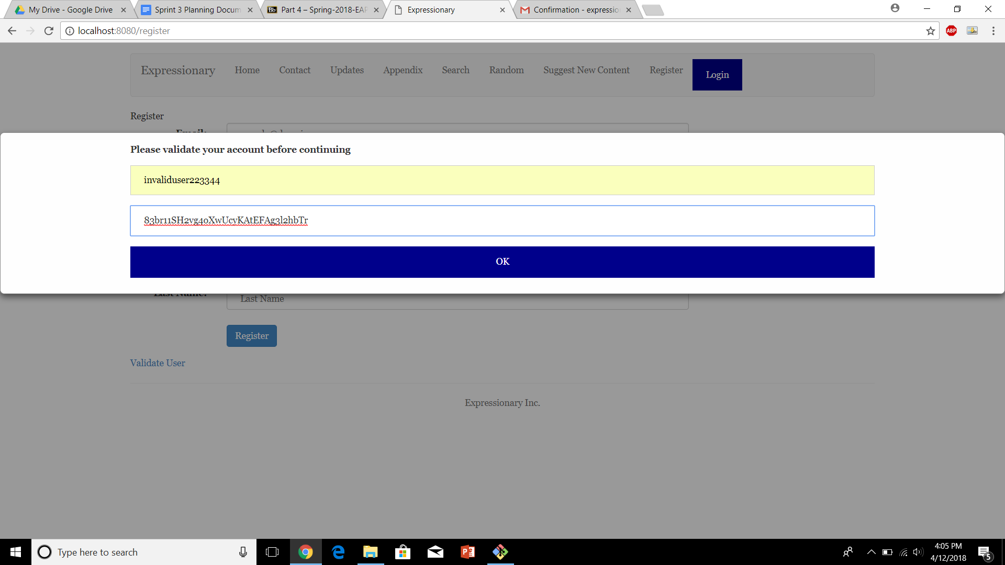

Report the response

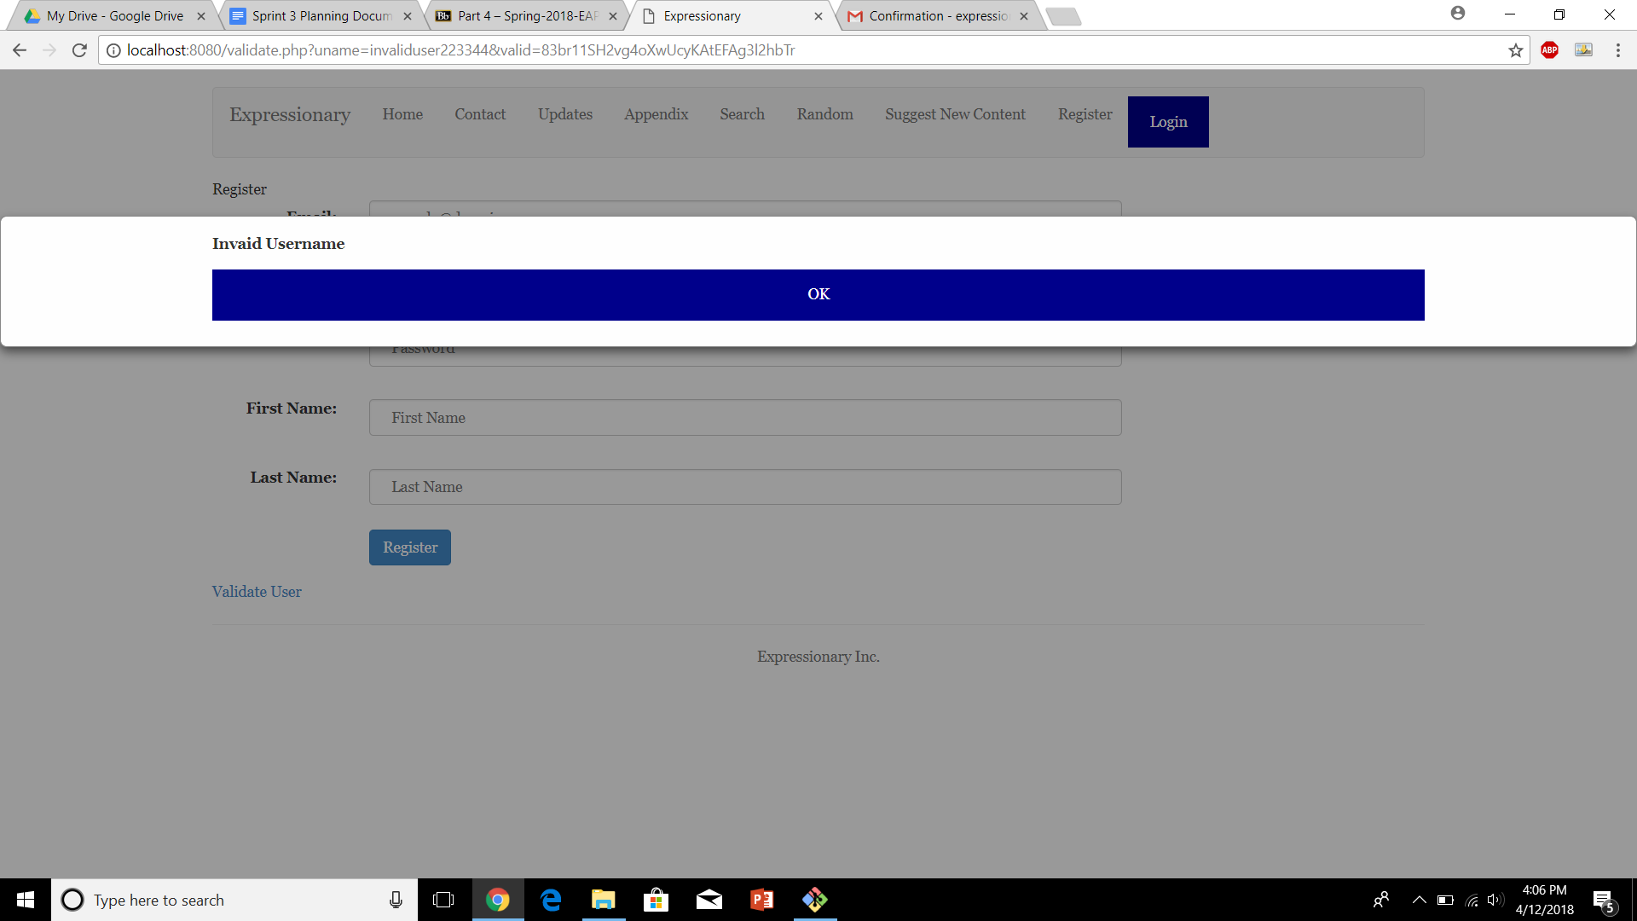

**Results:**

Username must be the same as the one provided at registration.

**Test No.6**

Entering the wrong validation code and correct username does not complete registration

**Procedure:**

* Navigate to the register page
* Press Validate user
* Enter invalid validation code but correct username
* Report the response

**Test**

Navigate to the register page and press validate account



Enter invalid username with correct validation code

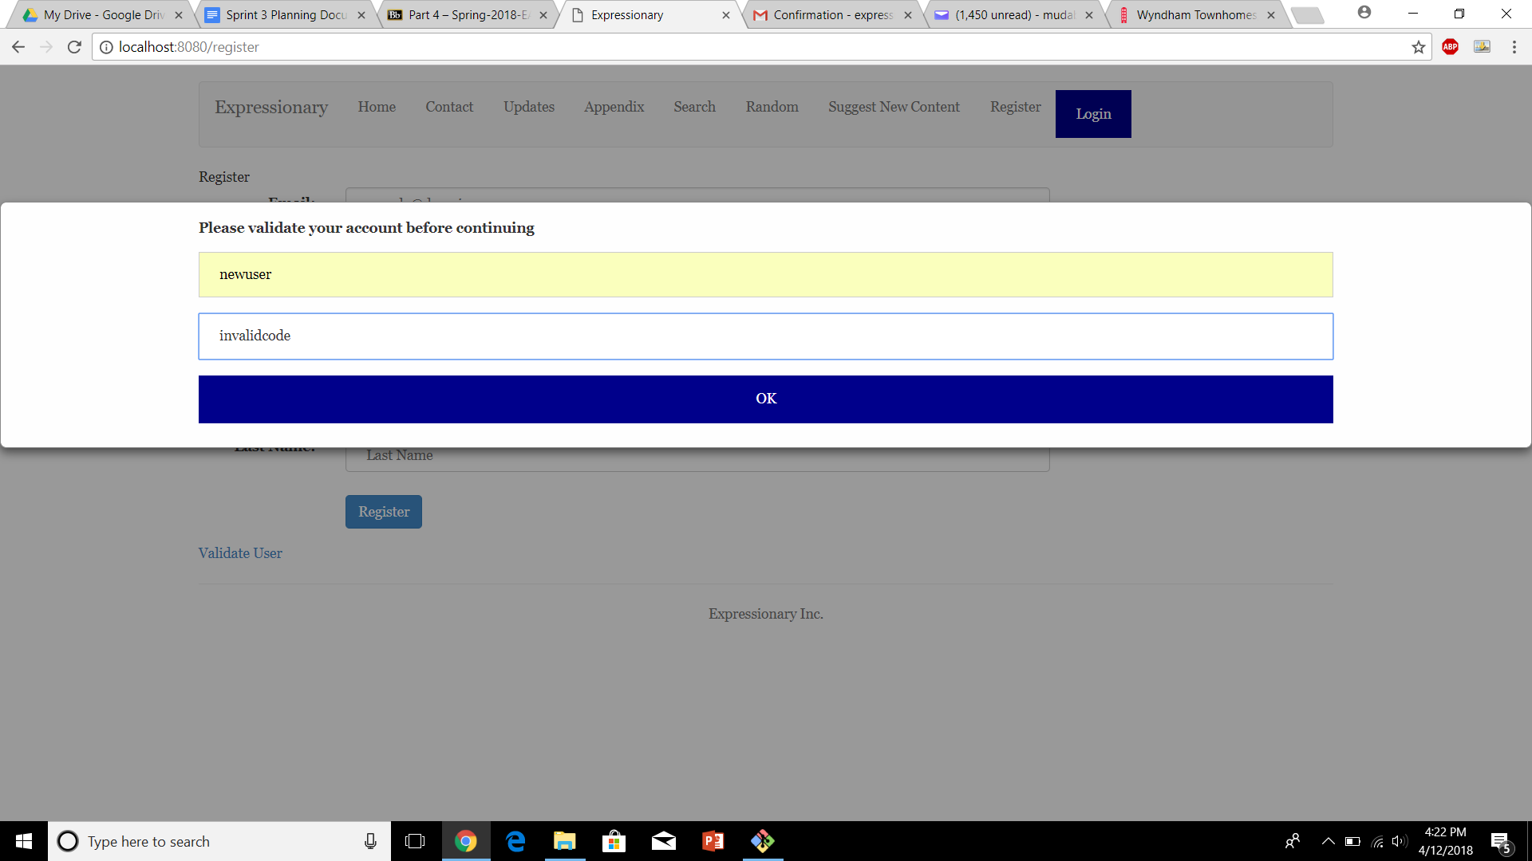

Report the response

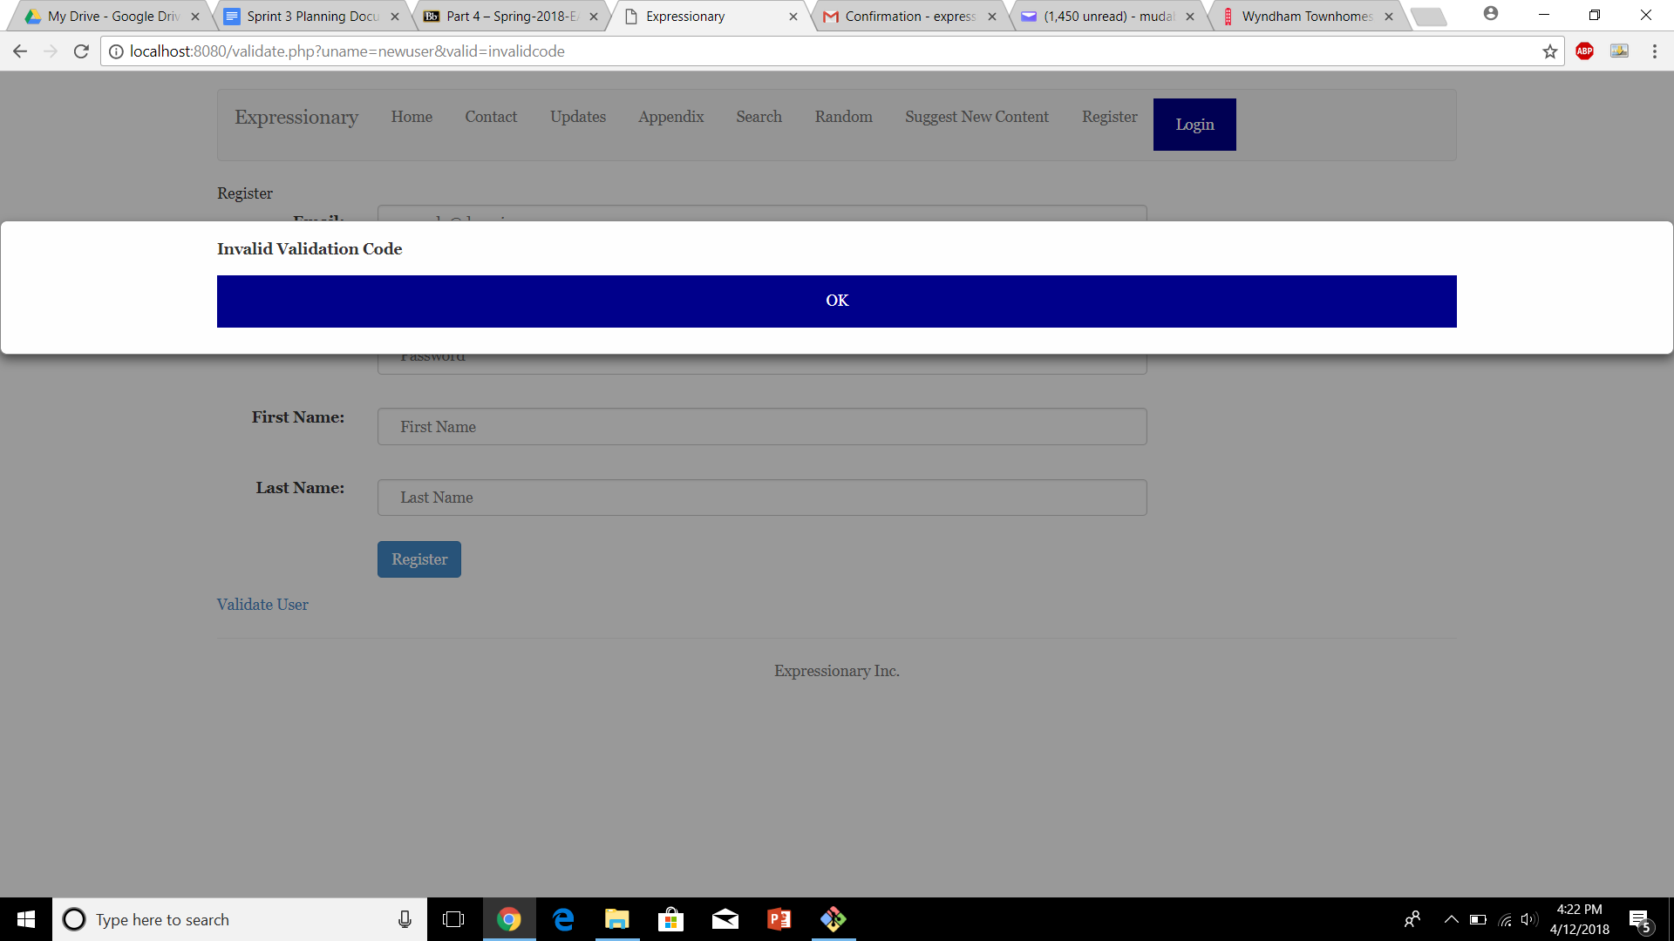

**Results:**

Validation code must be the same as the one that was sent to the user via email.

**Test No.7**

Registering via the correct username and validation code lets you register the user

**Procedure:**

* Navigate to the register page and press validate account
* Validate by providing valid information
* Report the response

**Test**

Navigate to the register page and press validate account



enter valid information

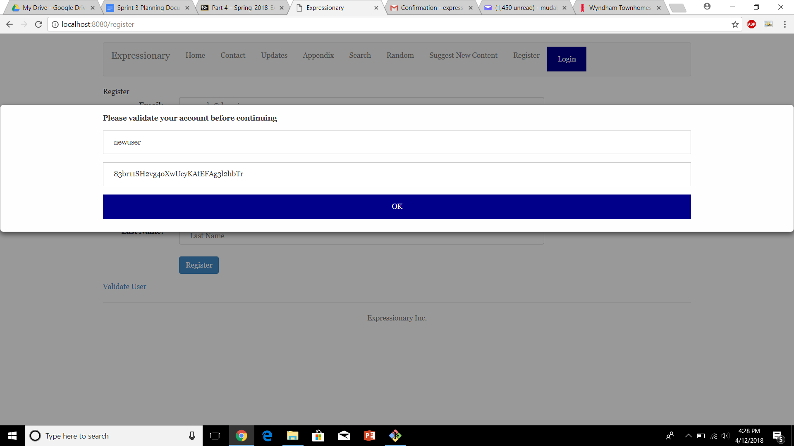

Report the Response

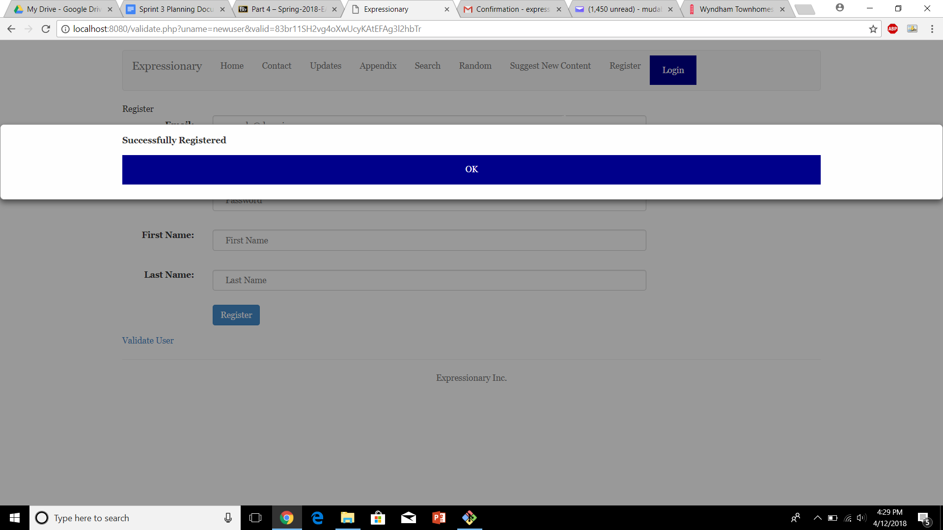

**Results:**

The website doesn’t let you register unless the account has been validated

**Test No.8**

Registered user should be able to log in

**Procedure:**

* Navigate to the Home page
* Click “Login” and enter the newly registered user’s credentials
* Validate the response

**Test**

Navigate to the home page and press login

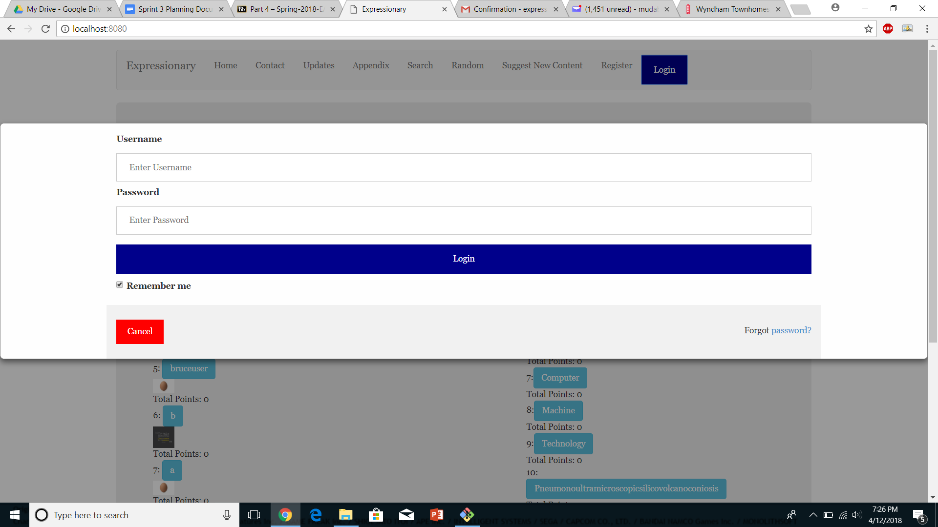

Enter the newly registered users credentials

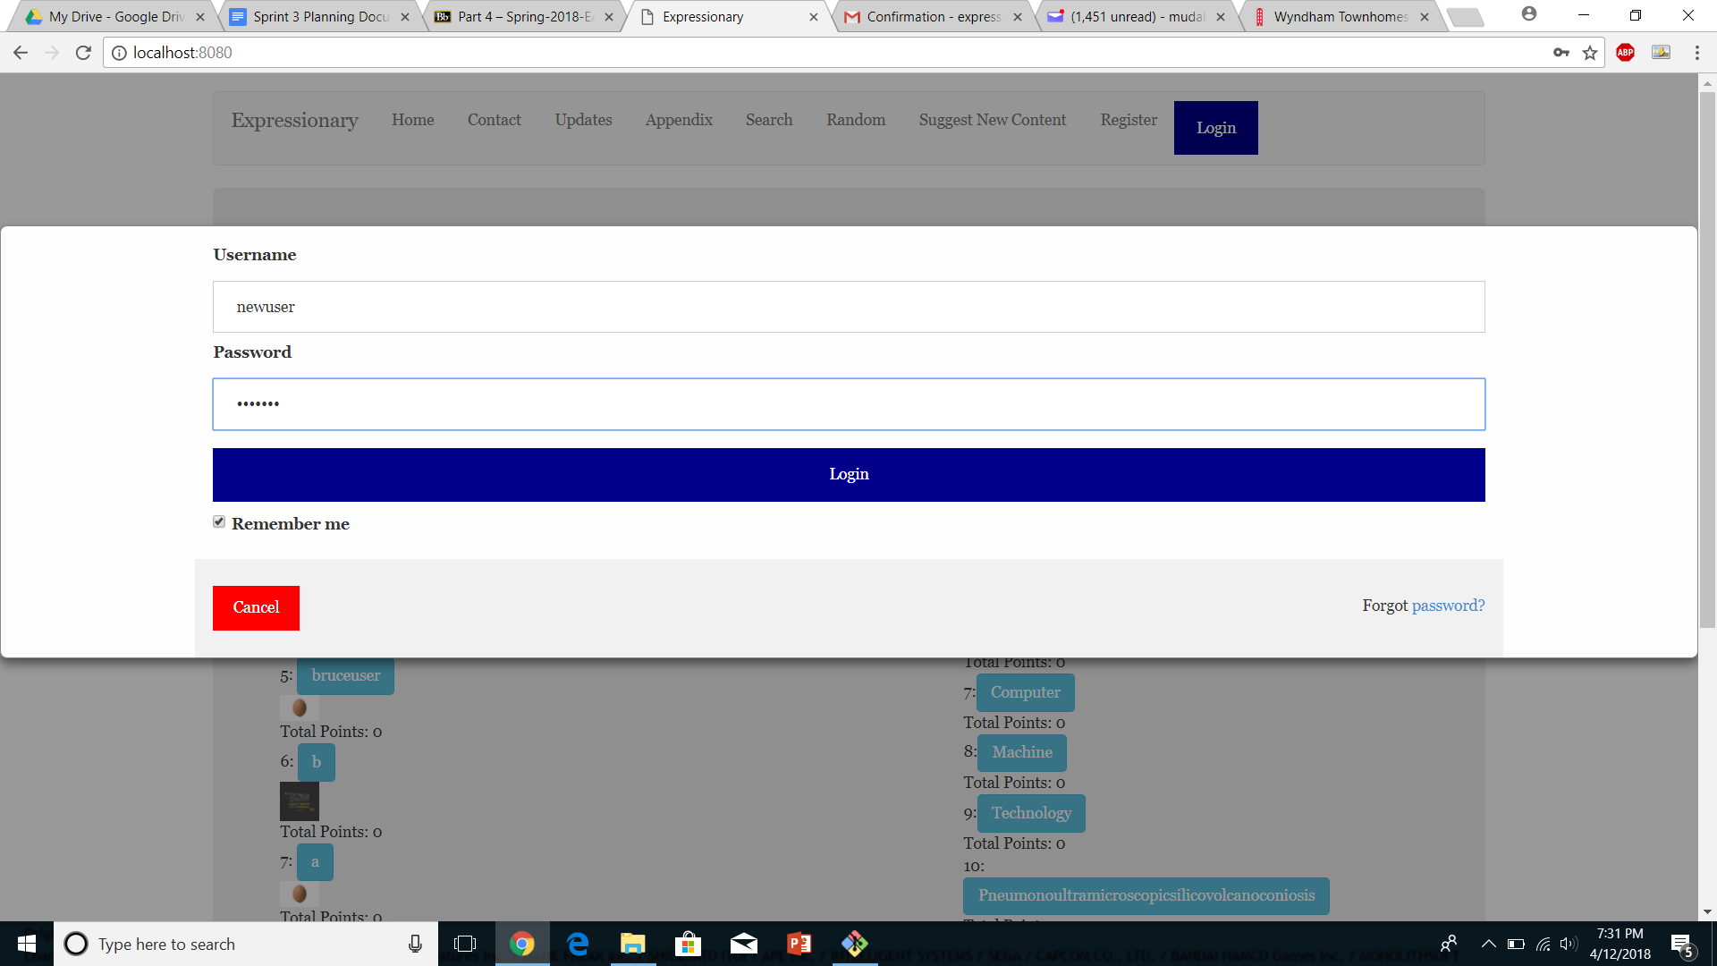

Report the response

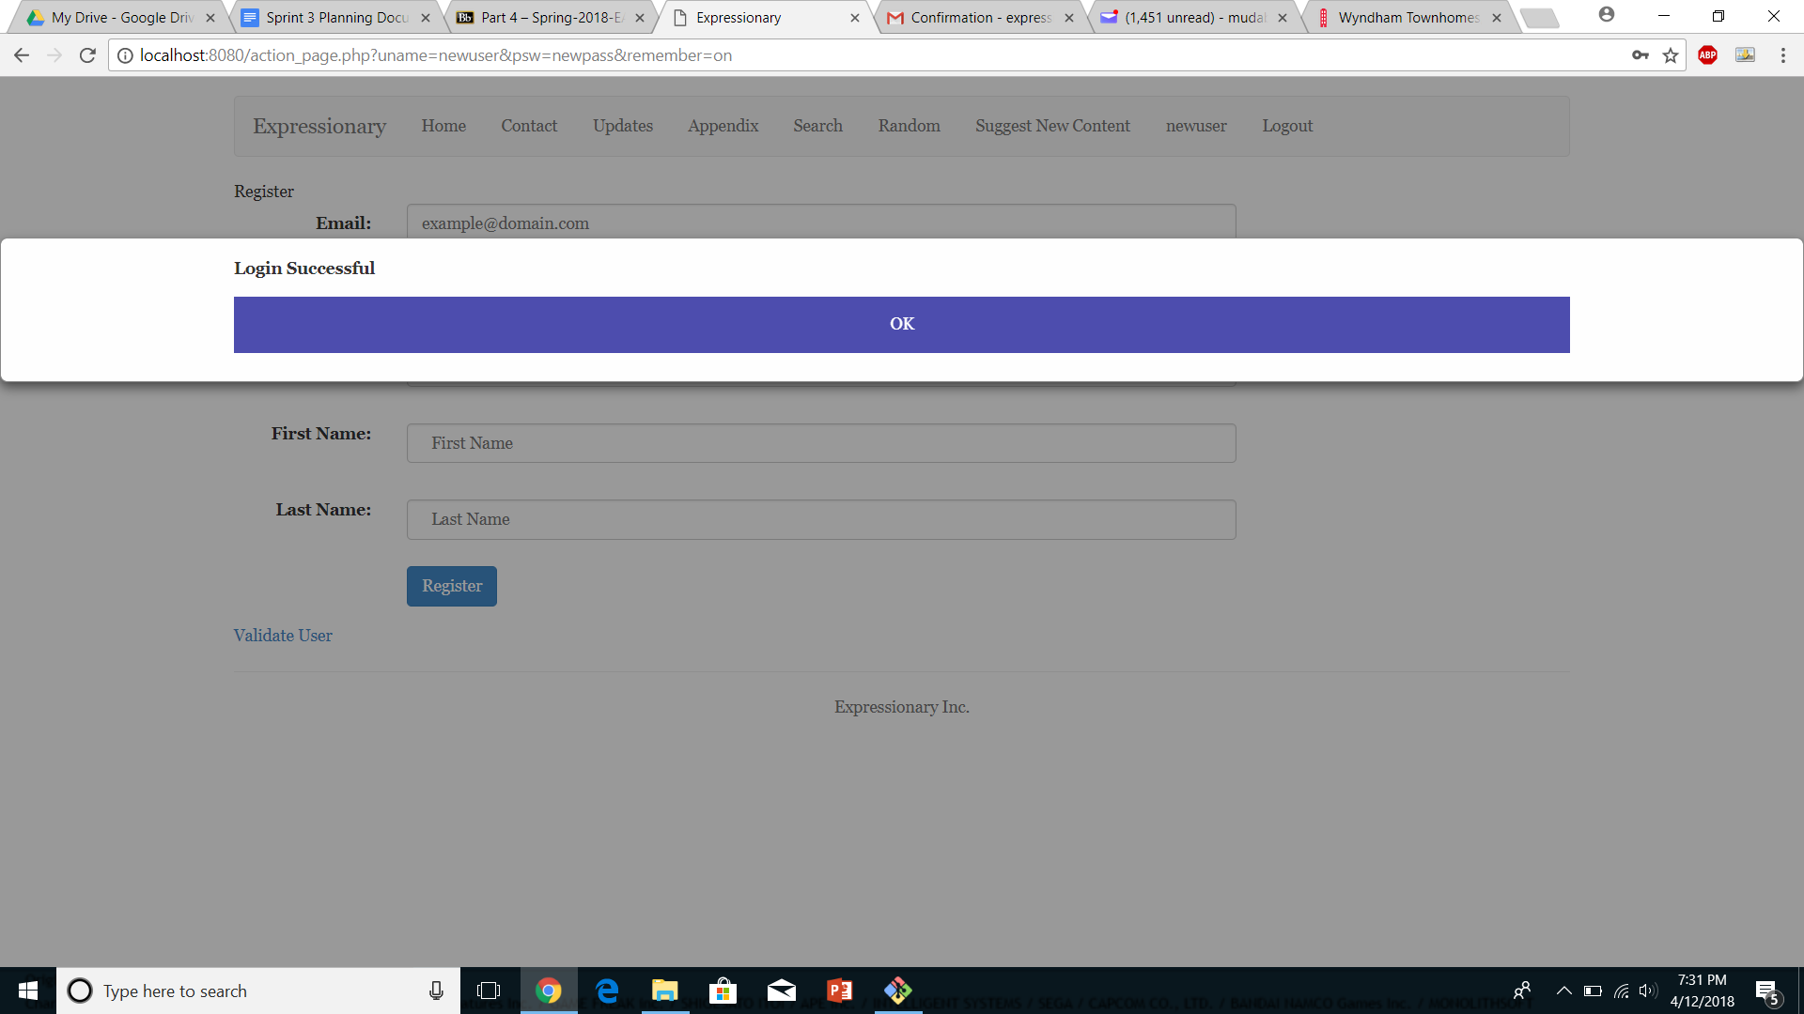

**Results:**

The user was able to login now, signifying that he was registered successfully after providing with the correct authentication.

**USER STORY # 3**

**Test No.1**

No logout button should be available if the user if not logged in

**Procedure:**

* Navigate to the home page
* Check for the logout button
* Login and Check again
* Report the response

**Test**

Navigate to the home page and check for logout button

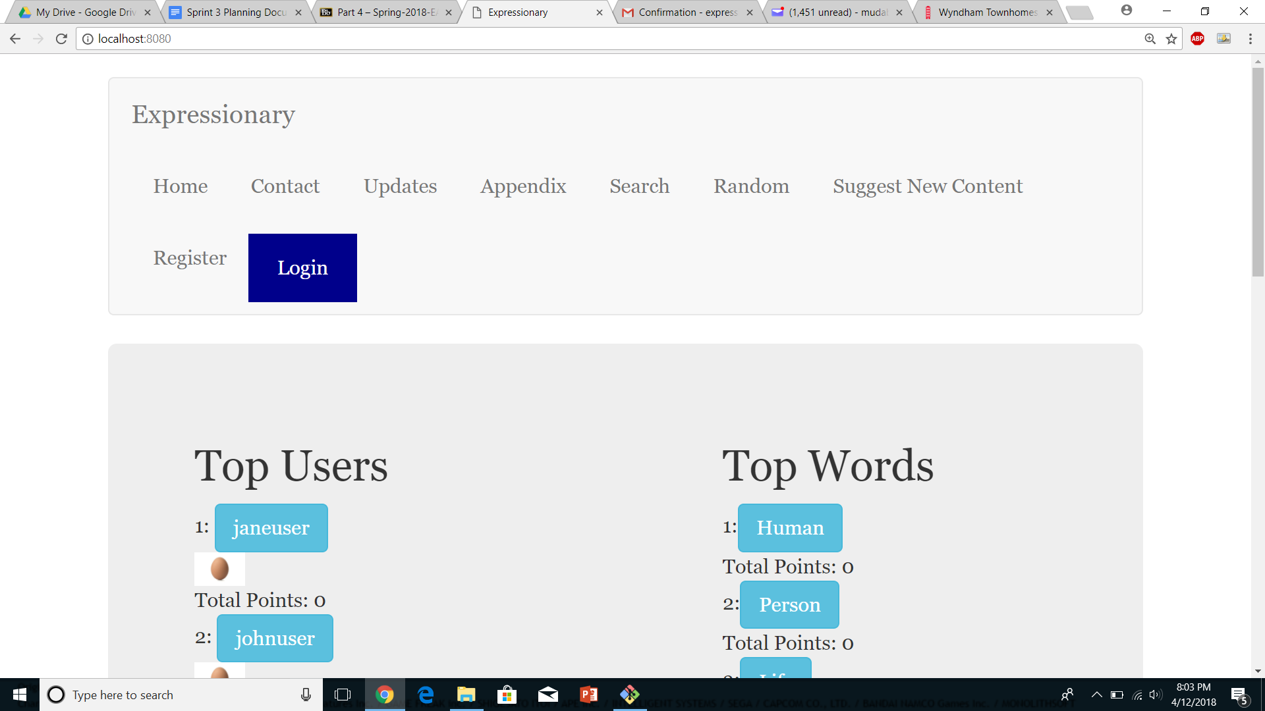

Login and check again

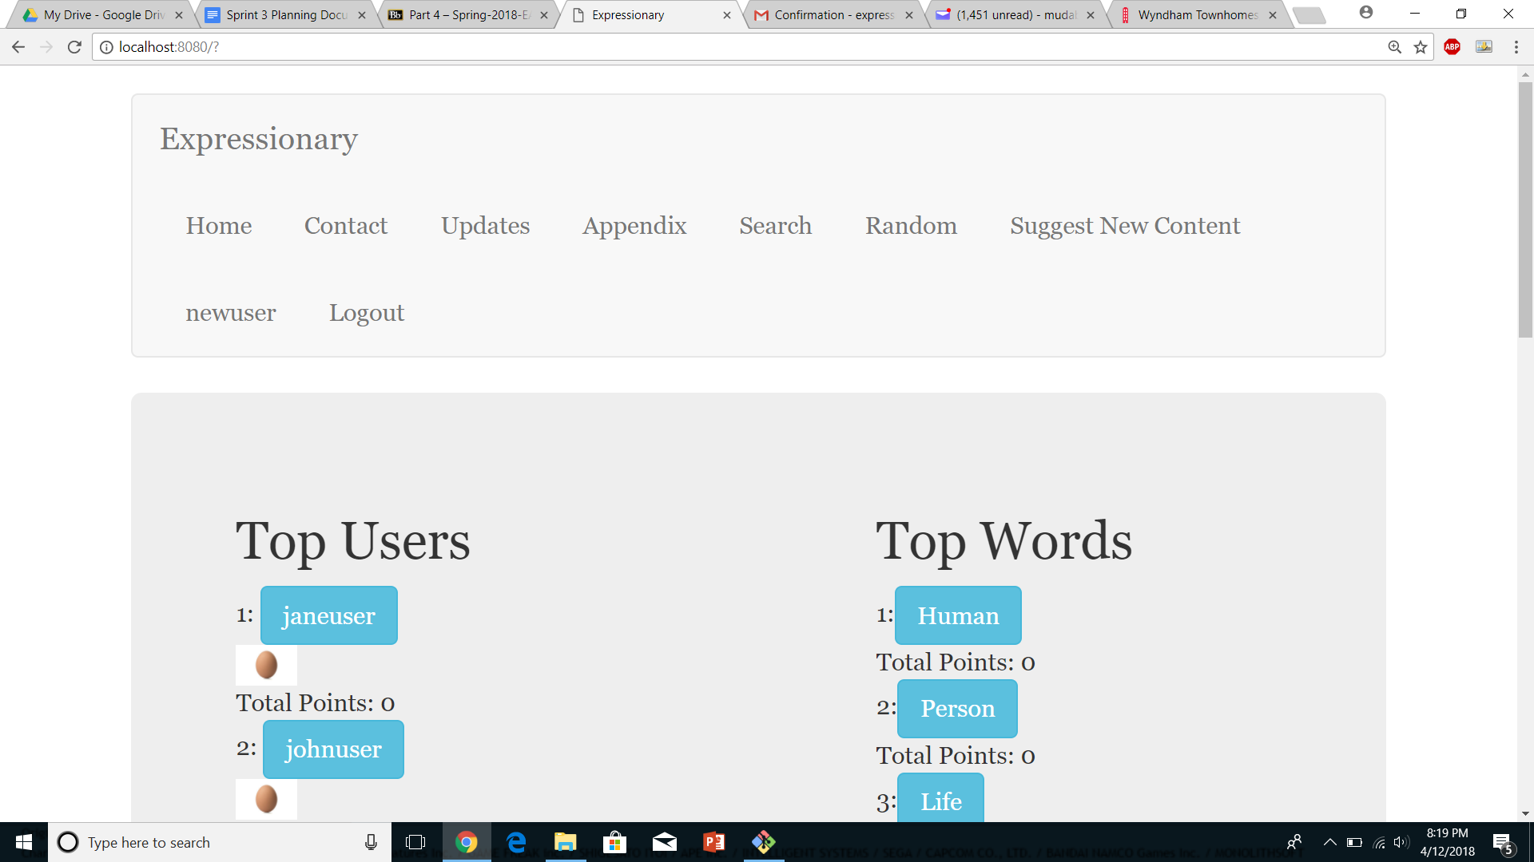

Report the response

**Results:**

There is no logout button visible since the user is not logged in, the button appears after the user if logged in

**Test No.2**

Clicking the logout button changes the users status back to logout, logout button goes away, login shows up

**Procedure:**

* Navigate to the home page
* Login with valid credentials
* Click on the logout button
* Report the response

**Test**

Navigate to the home page login



Click on the logout button



Report the response

**Results:**

After logging out, login button show up again and user is logged out

**Test No.3**

Logged out user cannot perform logged in functions

**Procedure:**

* Navigate to a word
* Log out if currently logged in
* Try posting a word
* Try adding a point
* Report the response

**Test**

Navigate to a word page and enter a definition

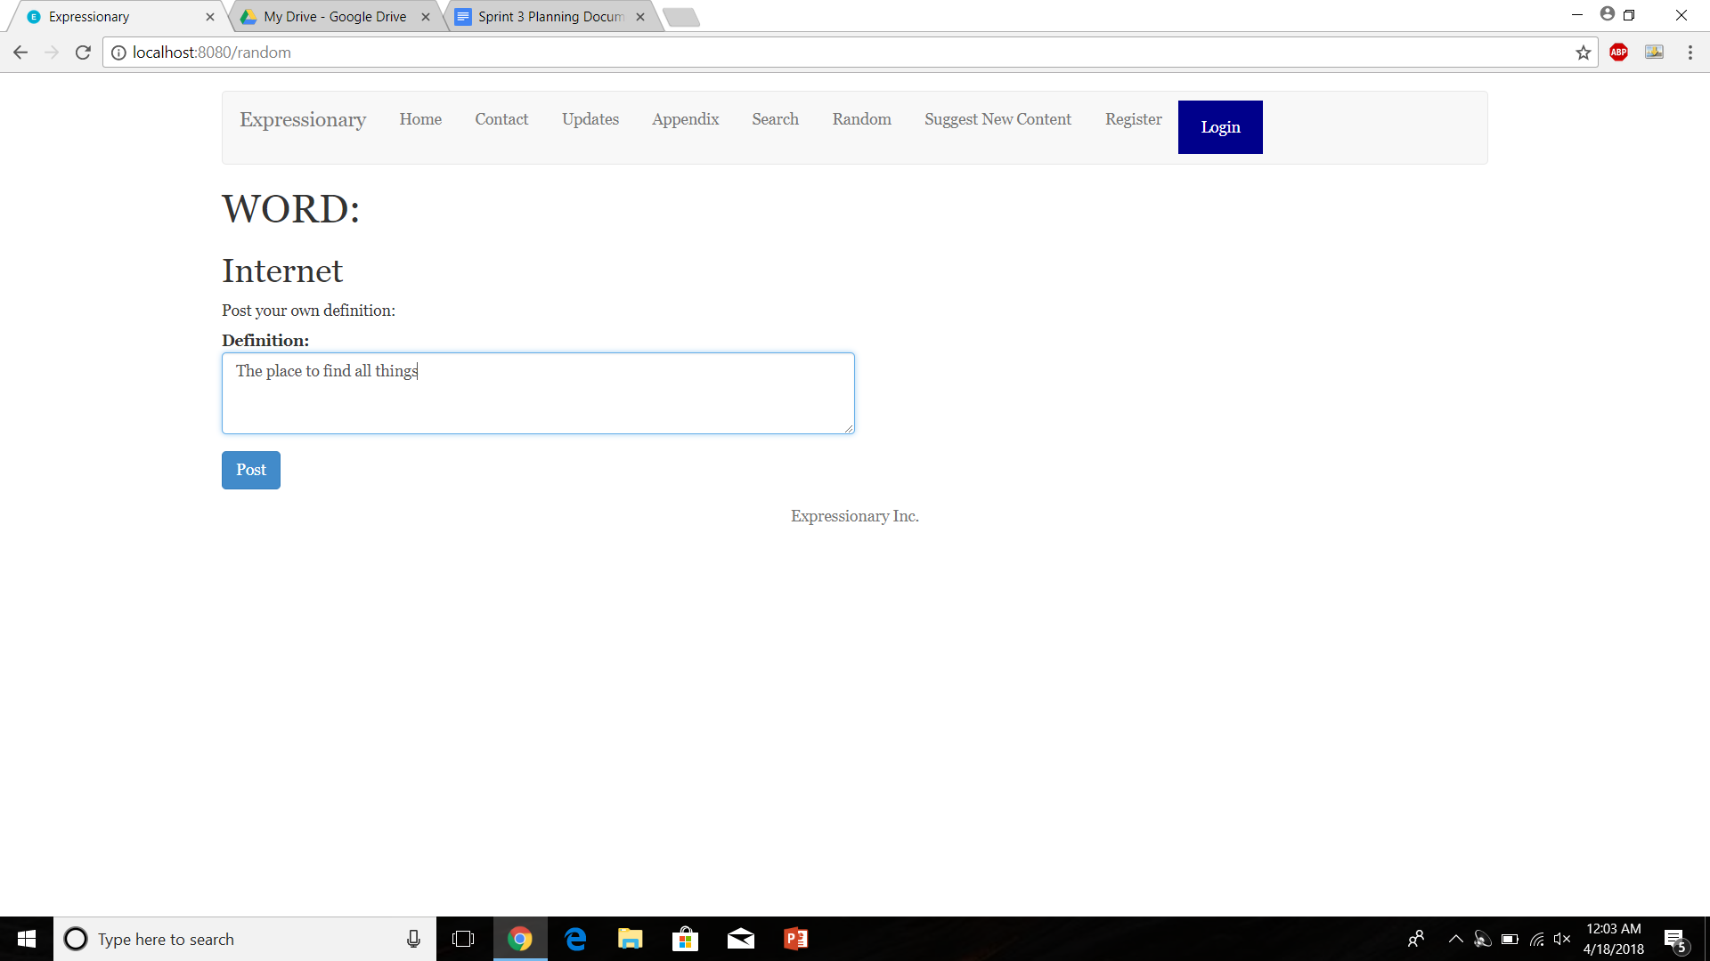

Try posting the definition

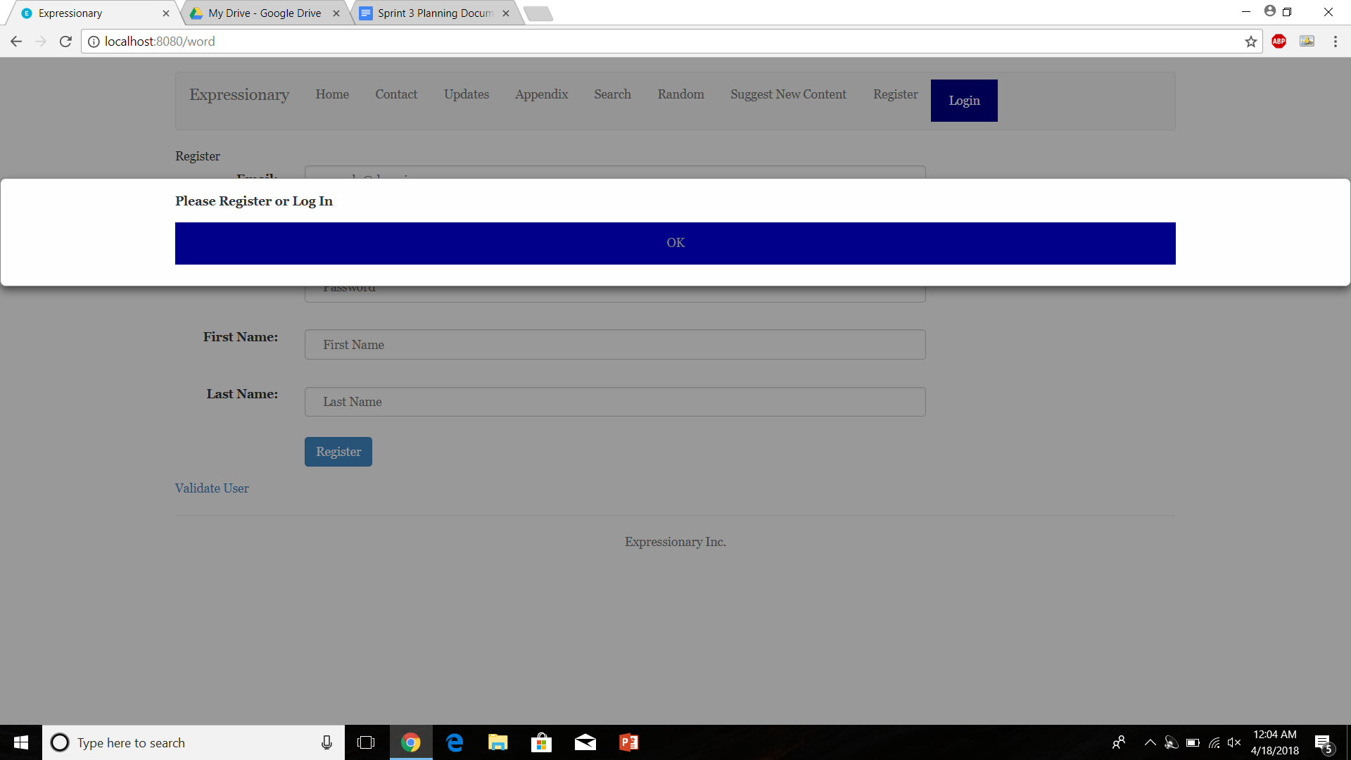

Navigate to a word with existing posts and try adding a point

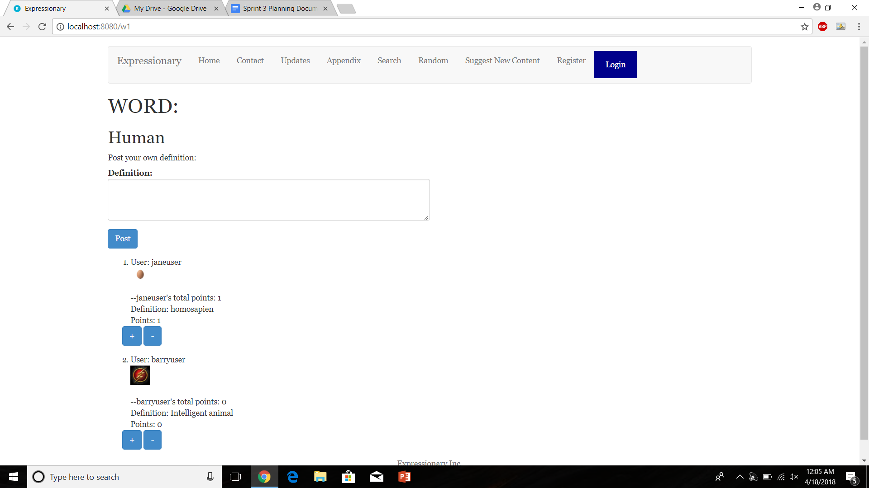

Report the response

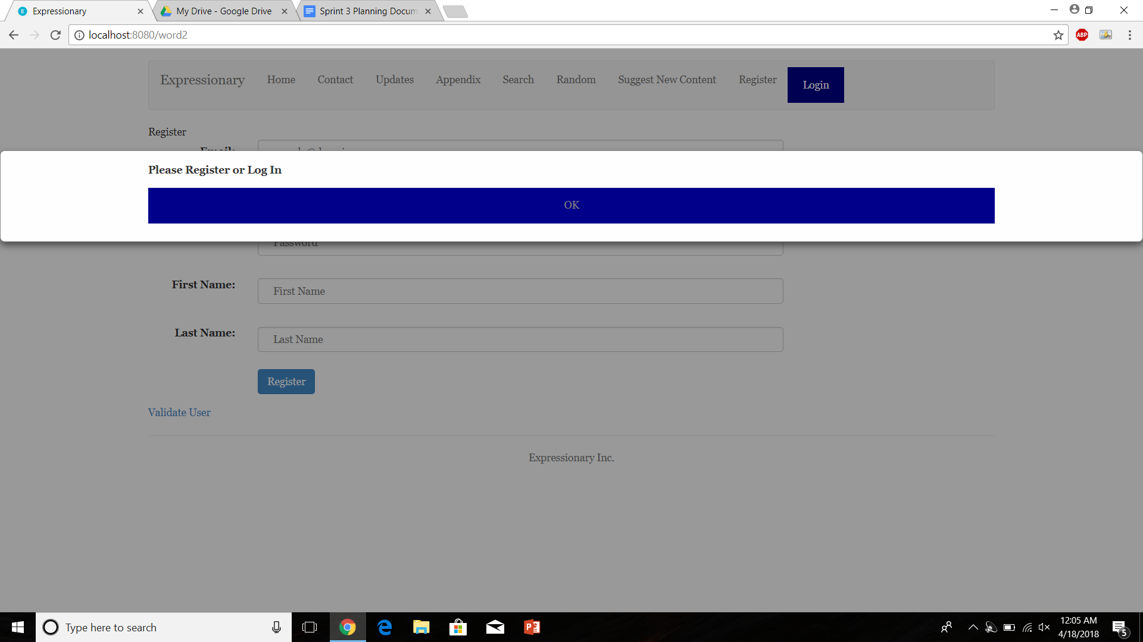

**Results:**

There is no logout button visible since the user is not logged in

**Test No.4**

Sending multiple logout messages after the user has already logged out does not break the program

**Procedure:**

* Navigate to the home page
* Put the “/logout” in the URL and press enter
* Repeat multiple times
* Report the response

**Test**

Navigate to the home page and check for logout button

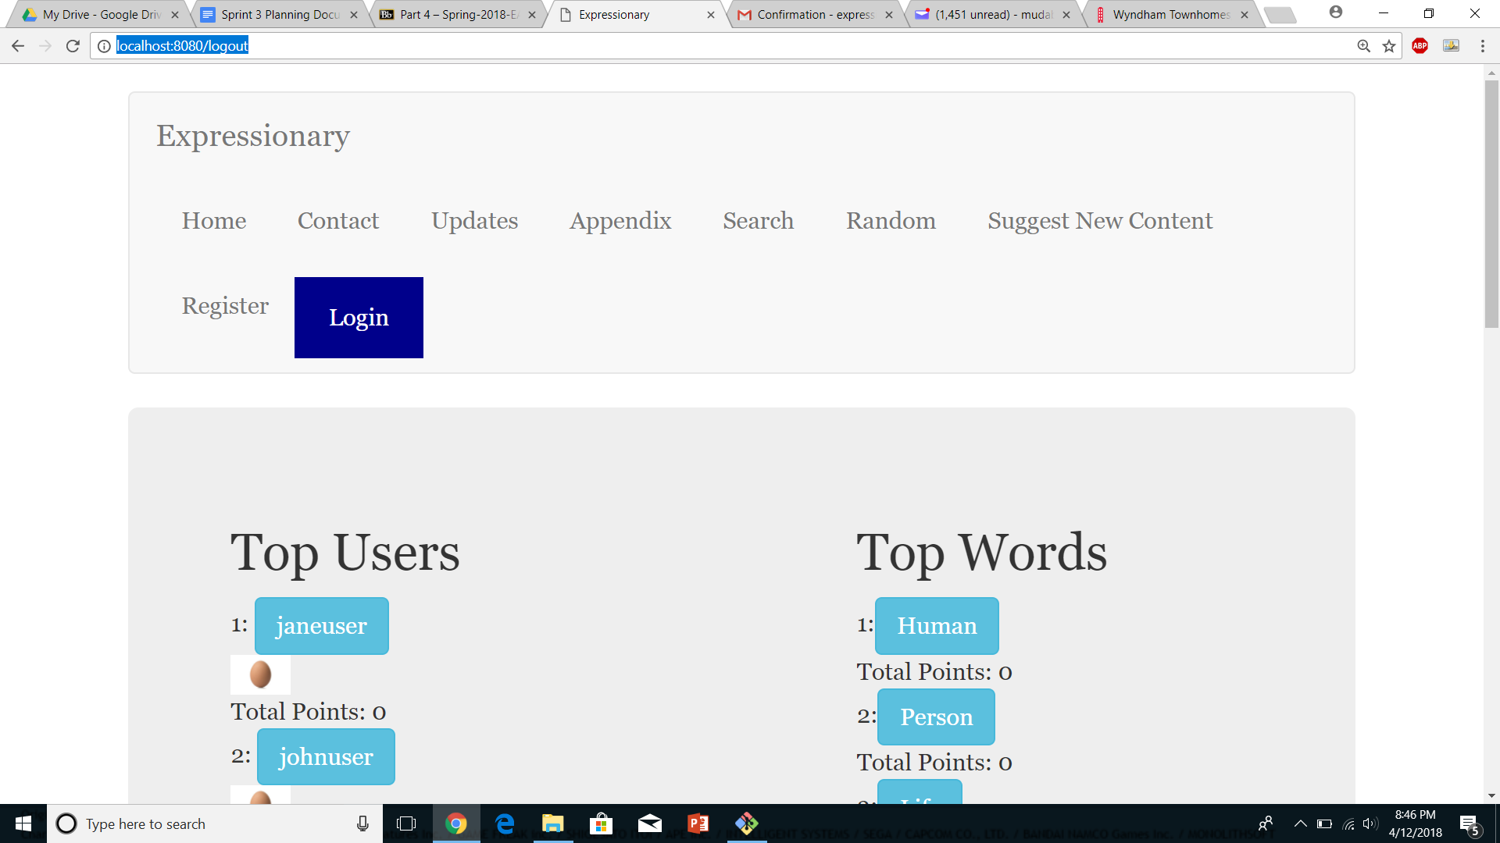

Press enter and repeat multiple times

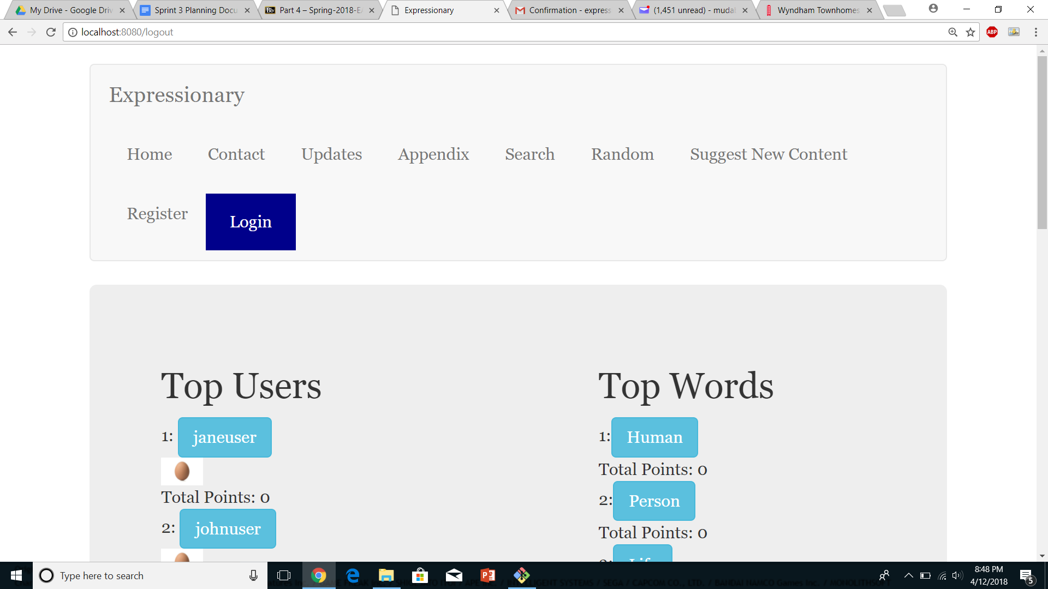

Report the response

**Results:**

The webpage just stayed the same and nothing happened, forcing logout when logout is not shown does not break the program.

**Test No.5**

Delete user button shows up in the user page for the logged in user

**Procedure:**

* Login and navigate to user page
* Check for the delete user button
* Report the response

**Test**

Login and navigate to user page

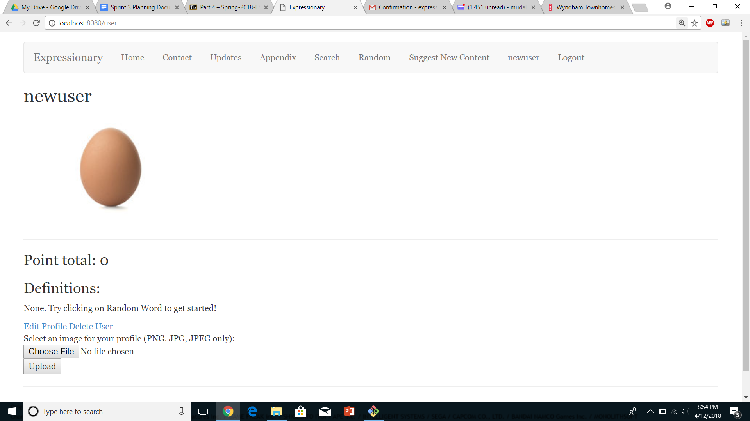

Check for delete user button and report the response

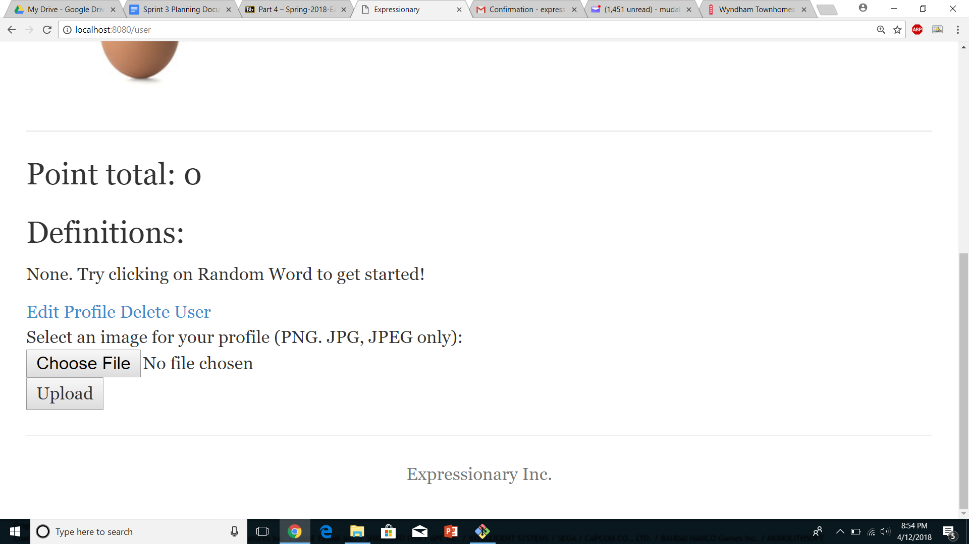

**Results:**

There is a delete user button in the users personal profile page

**Test No.6**

Delete User button is not available while browsing some other users profile page (non-personal profile page)

**Procedure:**

* Navigate to the home page
* Navigate to any user via the leaderboard
* Check for delete user button
* Report the response

**Test**

Navigate to a different user’s page via home screen

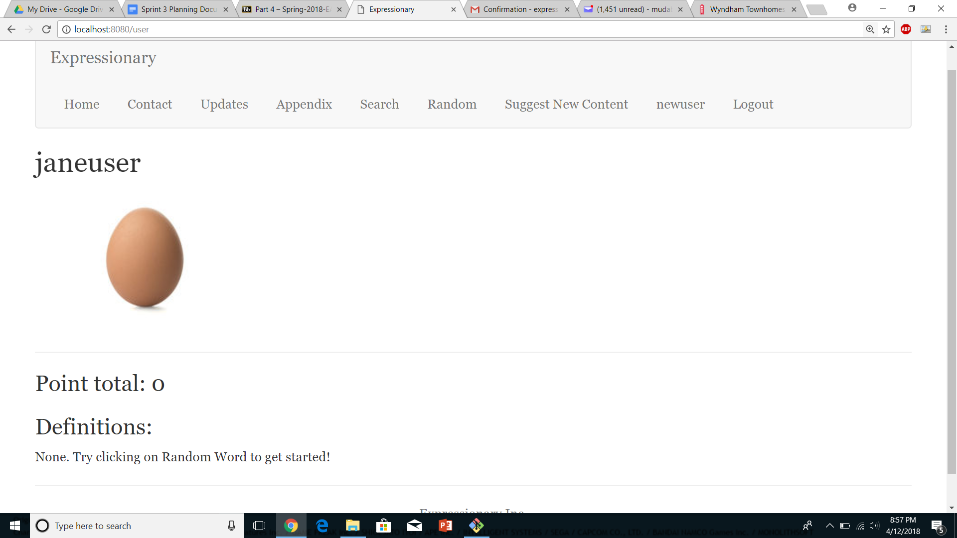

Check for the delete user button and report the response

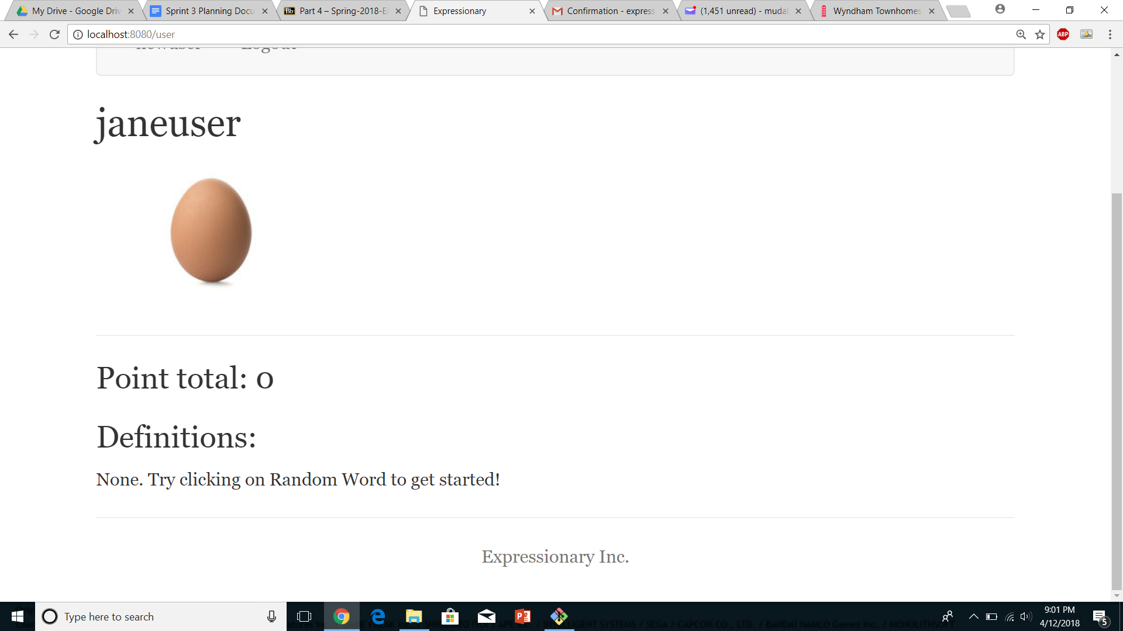

**Results:**

Delete User button does not show up when going to a non-personal profile page

**Test No.7**

Clicking on the delete User deletes the user from the webpage

**Procedure:**

* Navigate to the home page
* Notice the user in the leaderboard
* Delete the user from the profile page
* Notice the leaderboard again
* Report the response

**Test**

Navigate to the home page and check for the user in leaderboards

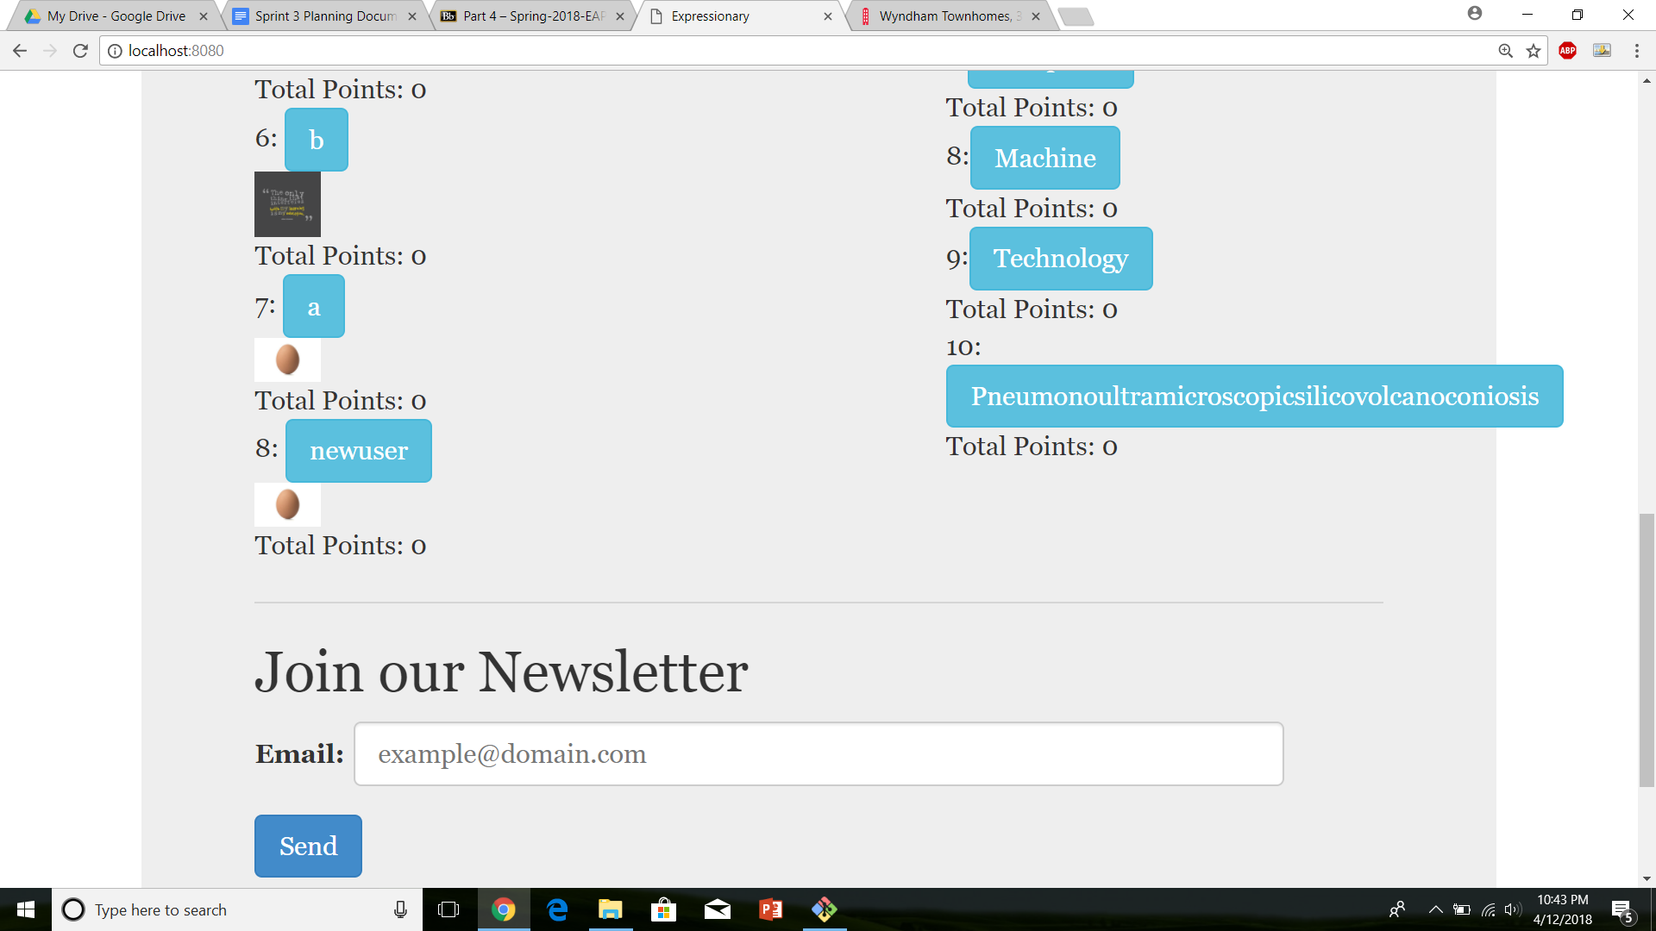

Go to the user’s personal page and delete the user

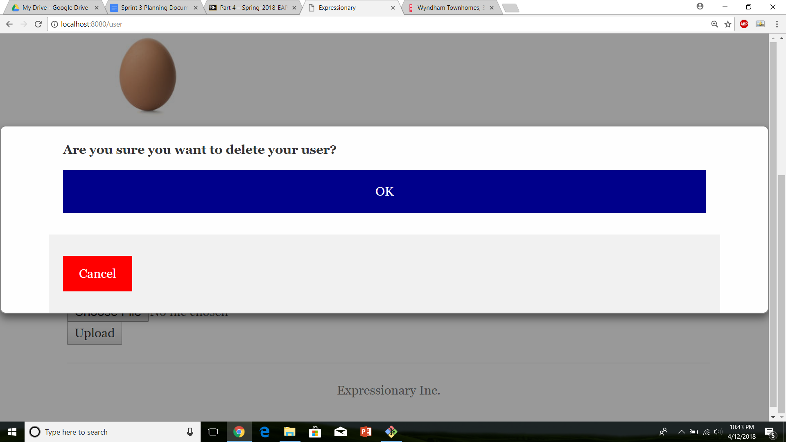

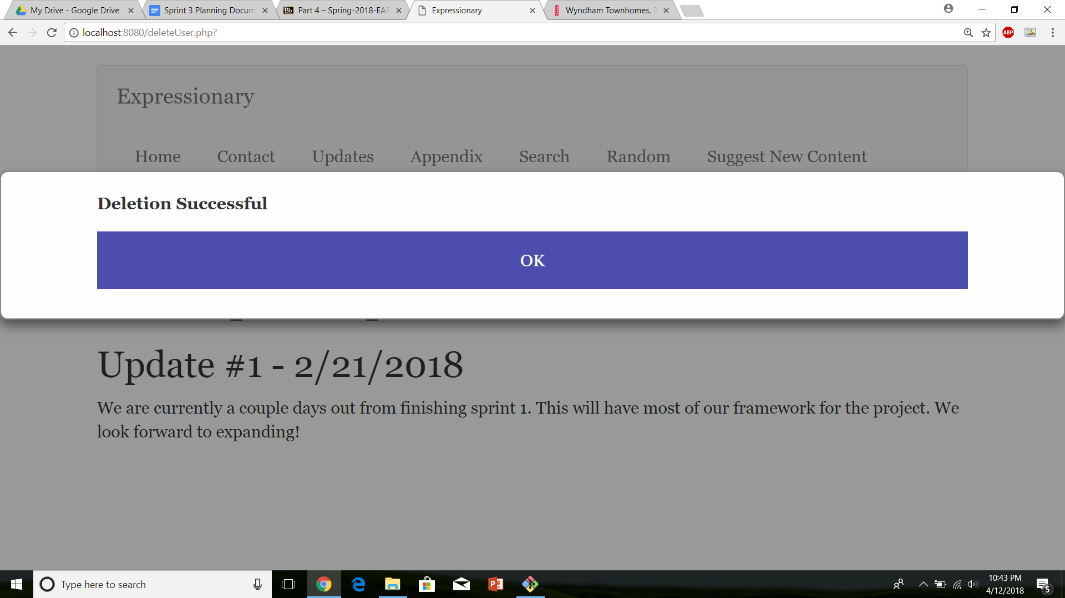

Navigate back to home page and report the response

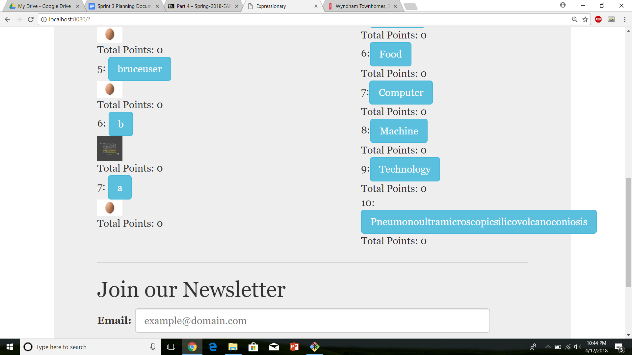

Report the response

**Results:**

The user “new user” appeared in the leaderboards, however, after deletion the user was not there anymore. Therefore, the deletion of the user appears to work perfectly fine.

**Test No.8**

Deleted user is unable to log in

**Procedure:**

* Navigate to the home page
* Attempt login with the deleted user’s credentials
* Report the response

**Test**

Navigate to the home page and login with deleted user’s credentials

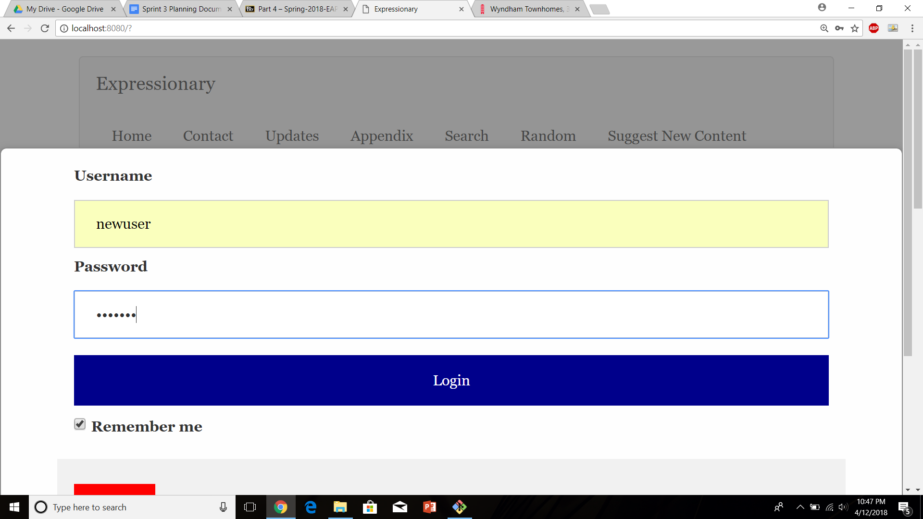

Press Login and report the response



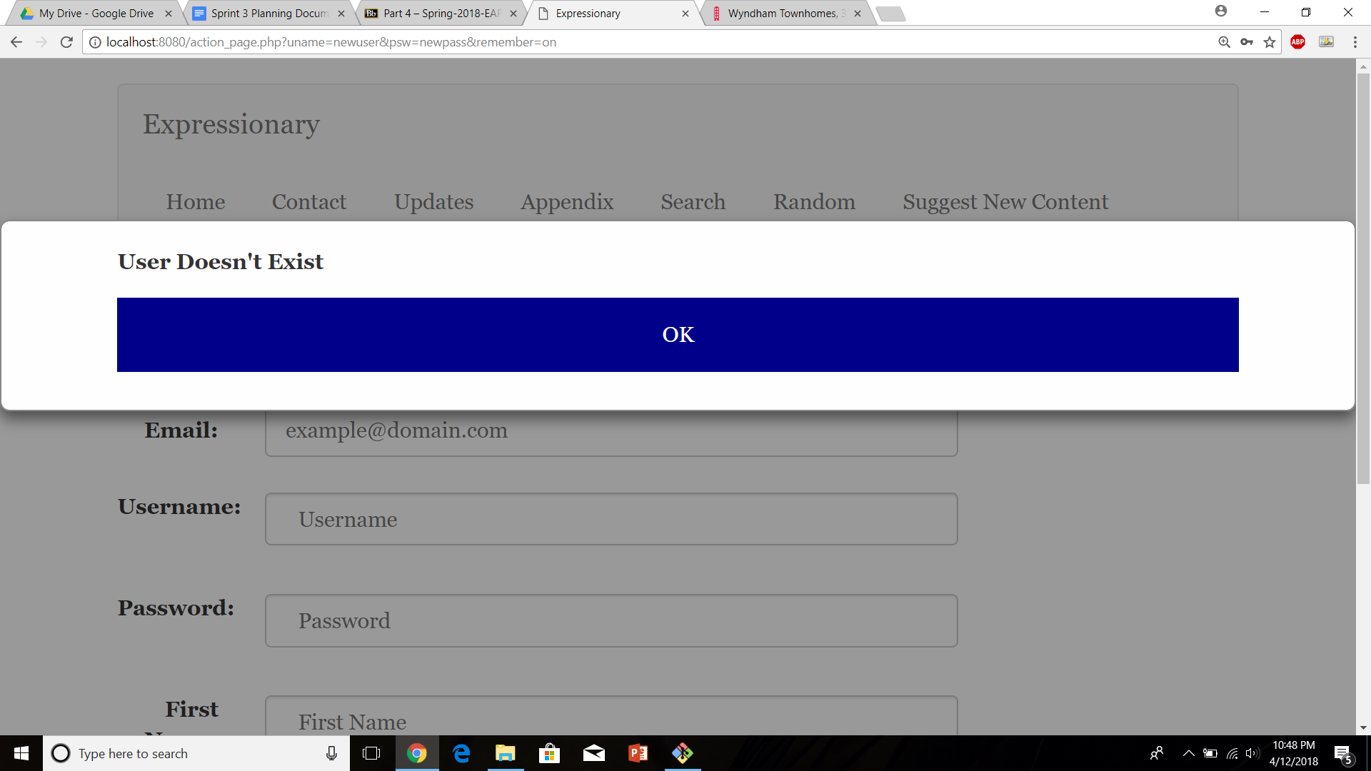

**Results:**

The webpage saying the user does not exist tells us that the user can’t login after being deleted as the user doesn’t exist anymore.

**Test No.9**

Verify if the profile page has an option to upload a new image

**Procedure:**

* Login with valid credentials
* Navigate to the user’s personal page
* Check for upload image option
* Report the response

**Test**

Login with valid credentials

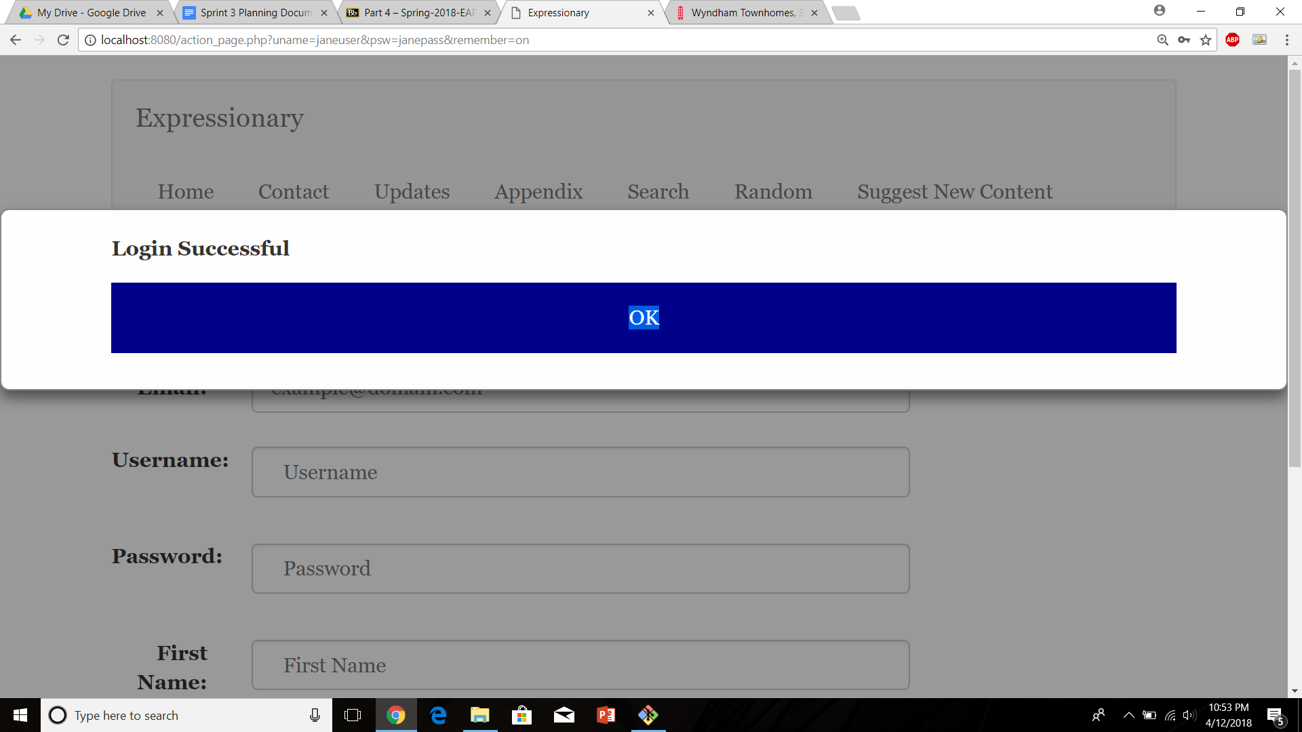

Navigate to user’s personal page and look for uploading image options

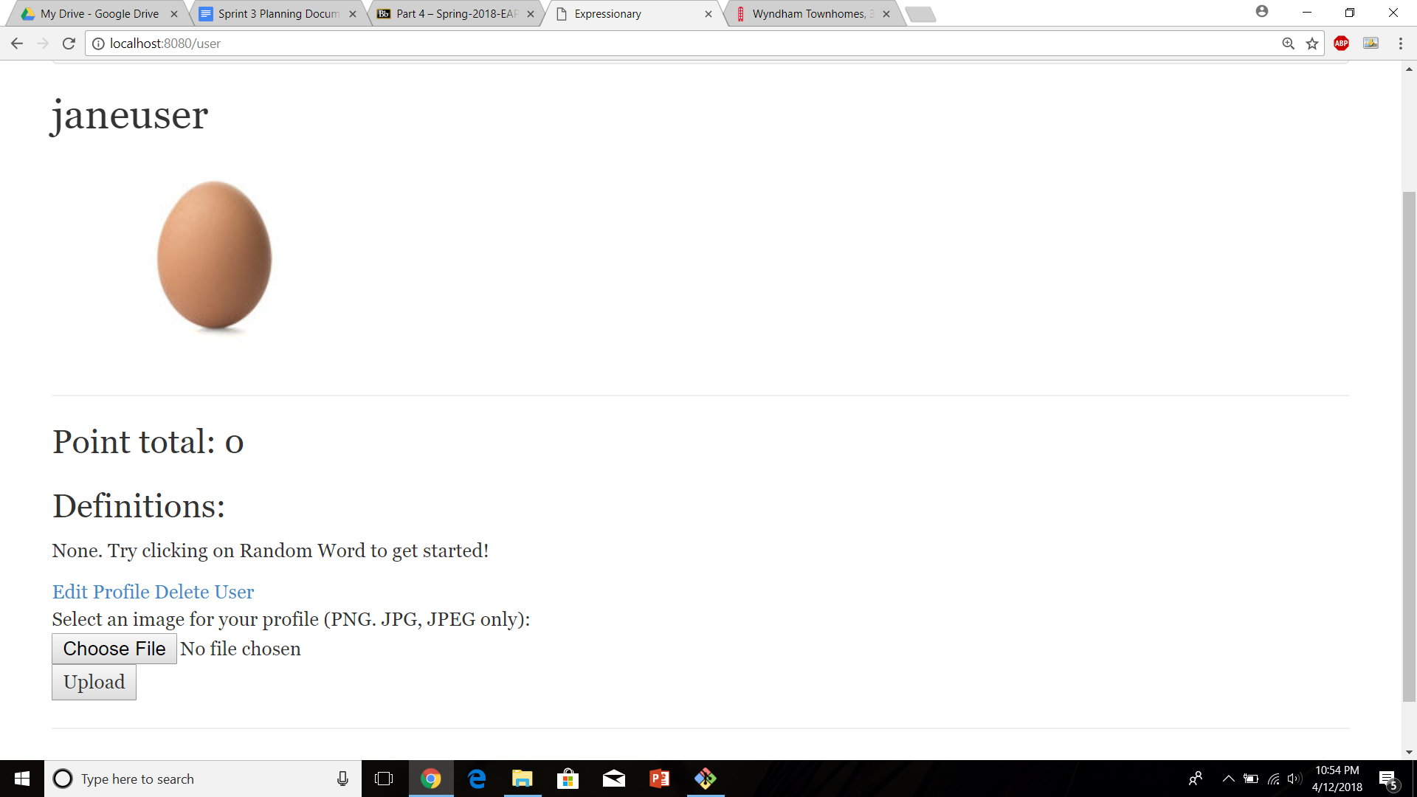

Report the response

**Results:**

There is a choose file and upload option which lets the user upload a new profile image

**Test No.10**

Edit profile image option does not show up unless it is user’s personal page

**Procedure:**

* Navigate to a different (non-personal) users profile
* Check for uploading image options
* Report the response

**Test**

Navigate to a different (non-personal) users profile

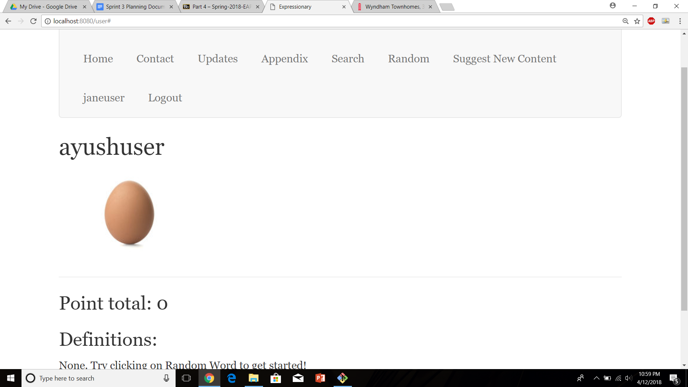

Check for uploading image options

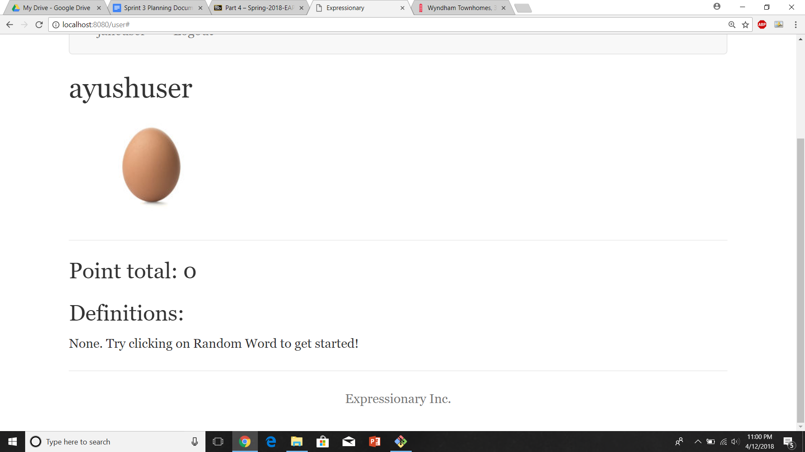

Report the response

**Results:**

Uploading image options do not show up if the user is not on his own page

**Test No.11**

User should be able to change their profile picture to any picture

**Procedure:**

* Log in and navigate to the user’s personal page.
* Click on the
* Login and Check again
* Report the response

**Test**

Log in and navigate to user’s personal page

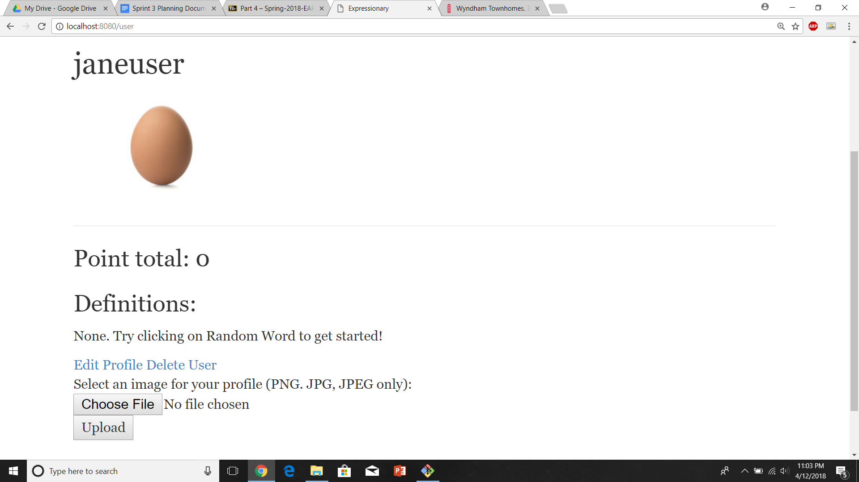

Click on choose file, choose a new image from you computer and then press upload

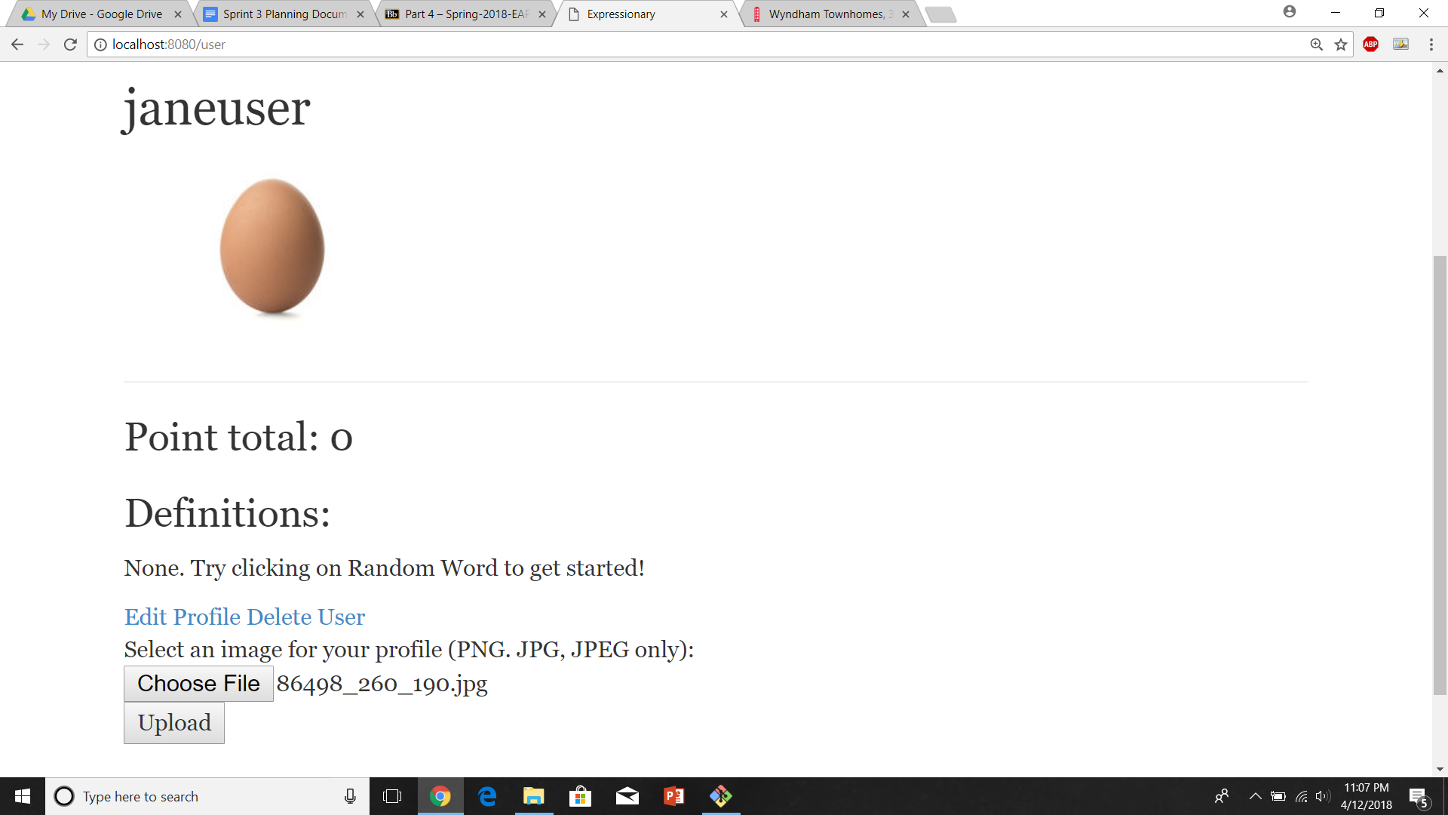

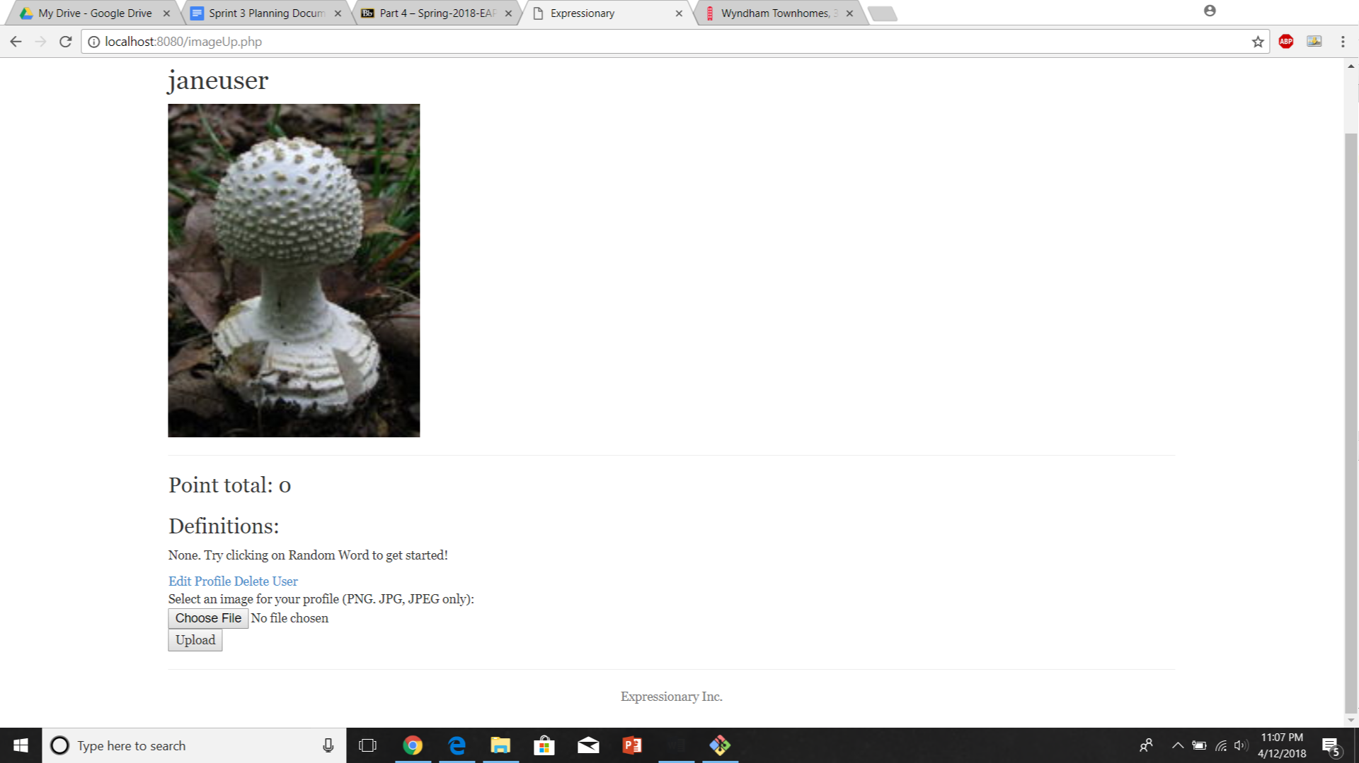

Report the response

**Results:**

The Users profile page was updated with the new image after updating the image

**Test No.12**

Profile picture is updated across the website and logging out and logging back in preserves the changes

**Procedure:**

* Log out and log back in as the previous user
* Check profile picture on the home page
* Check profile picture on personal page
* Report the response

**Test**

Log out and log back in

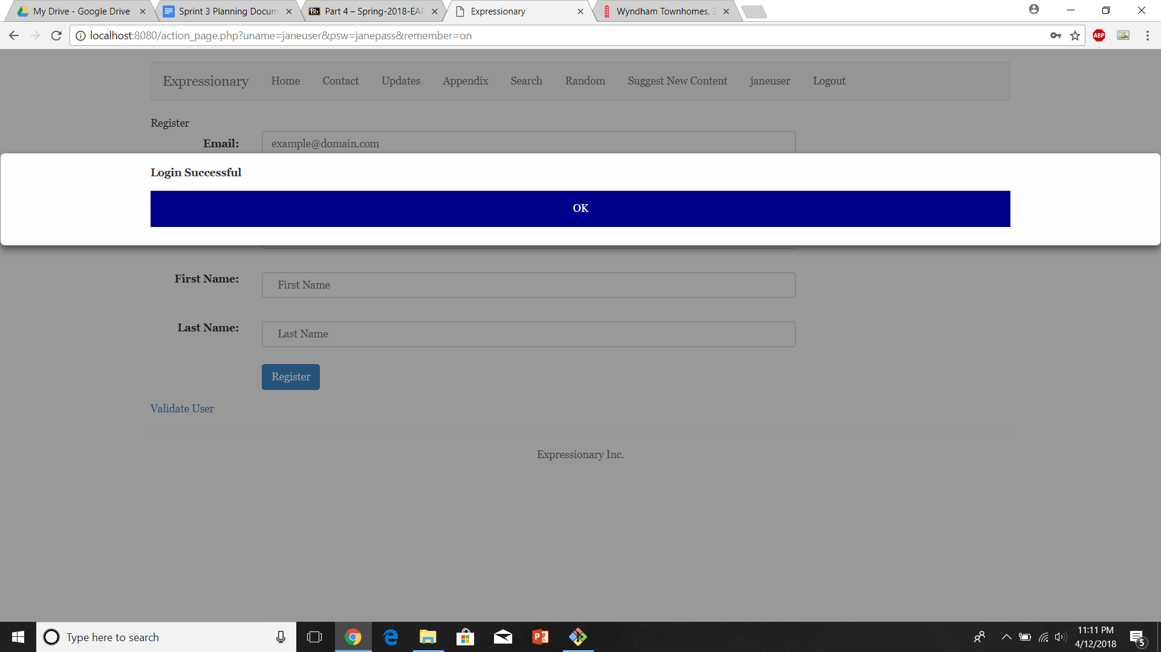

Navigate to leaderboard and report the response for the image

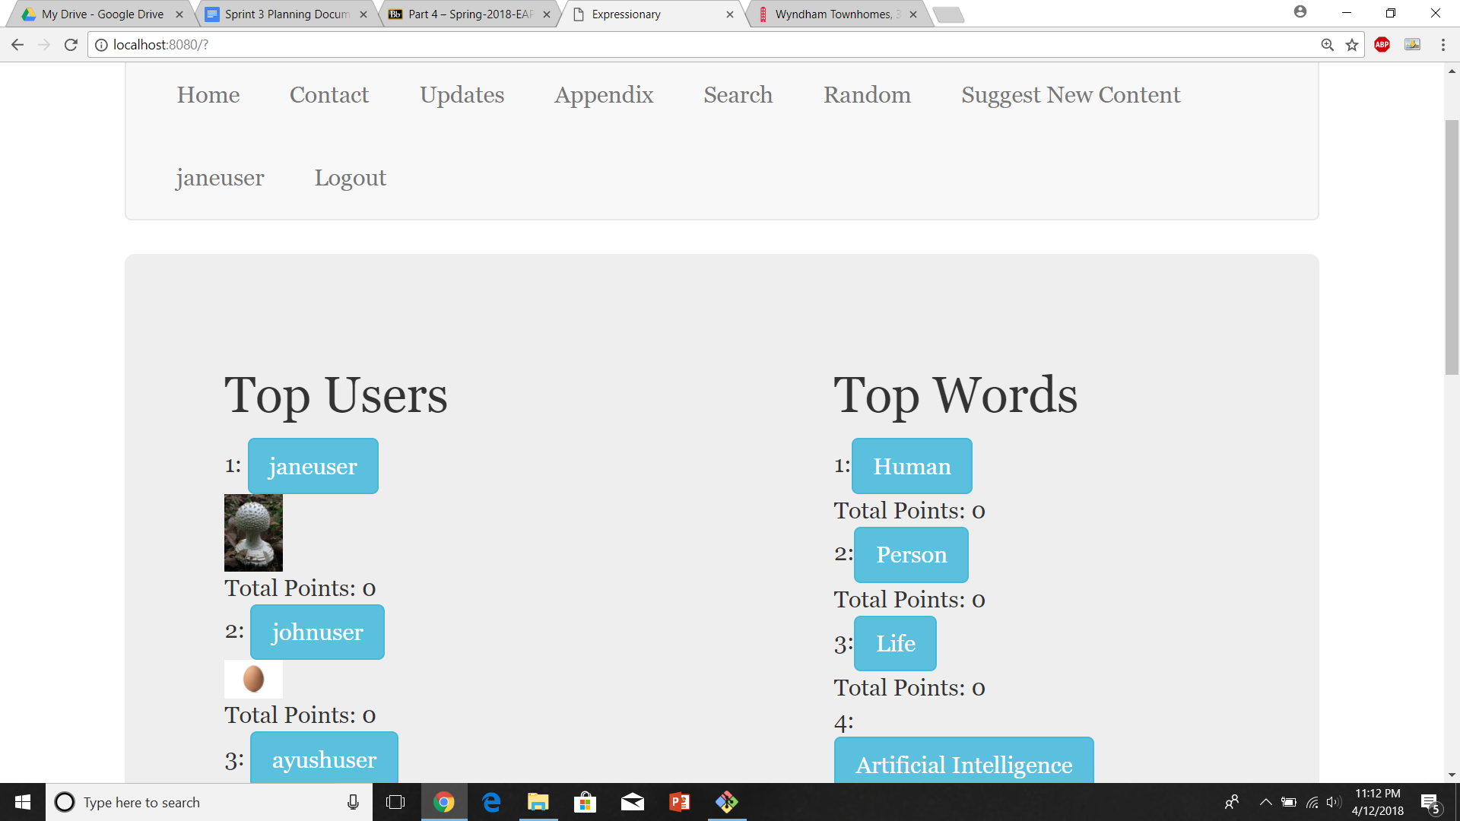

Navigate to personal profile page and report the response



**Results:**

Logging out and logging in preserves changes as well as the profile picture was updated across the website.

**USER STORY # 4**

**Test No.1**

Verify that the website holds content type more than just images

**Procedure:**

* Navigate to the home page
* Check for a leaderboard other then word and user leaderboard
* Report the response

**Test**

Navigate to the home page and check the leaderboard

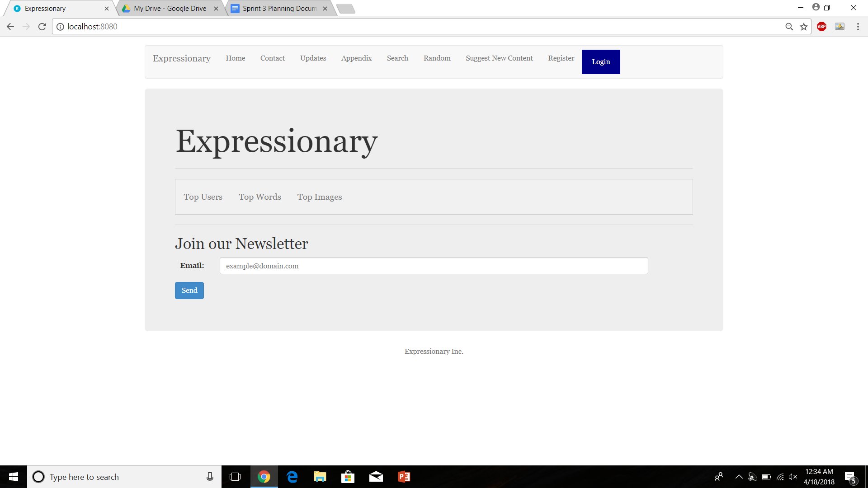

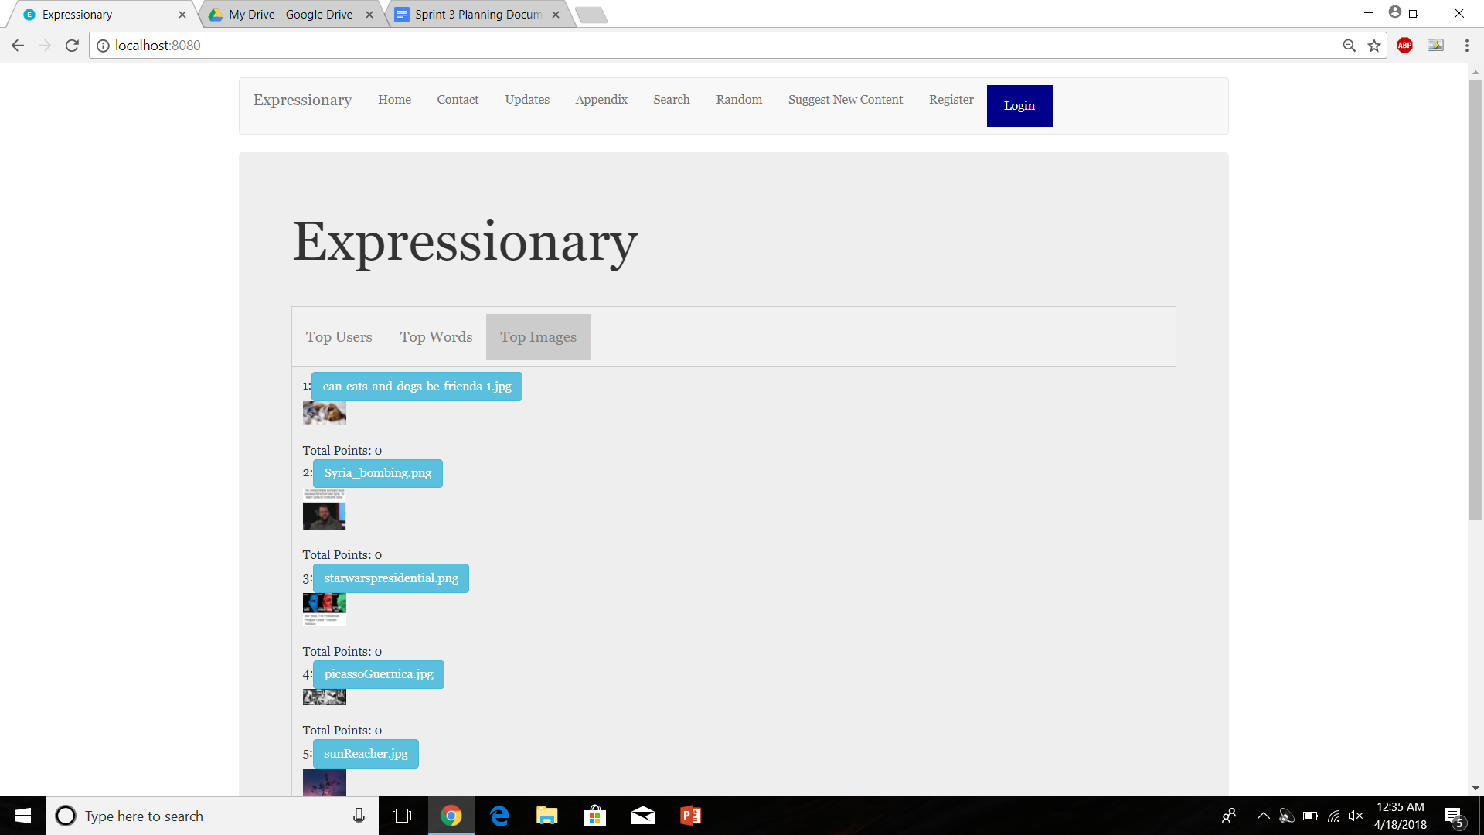

Report the response

**Results:**

The leaderboard contains image entries as well as word entries

**Test No.2**

Check if images can be accessed by pressing random

**Procedure:**

* Navigate to the home page
* Press Random a few times
* Report the response

**Test**

Navigate to the home page and check the leaderboard



Press Random a few times

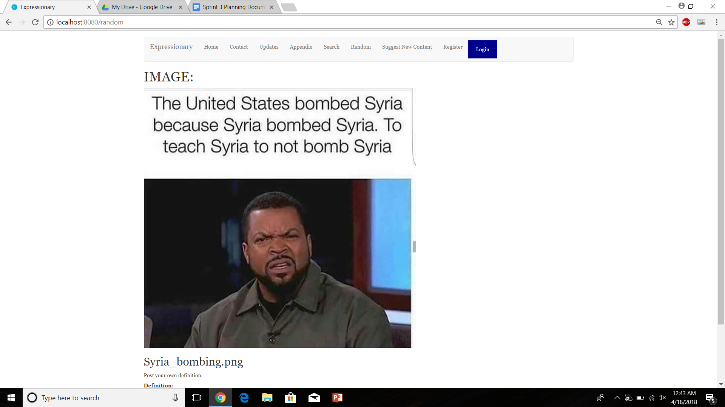

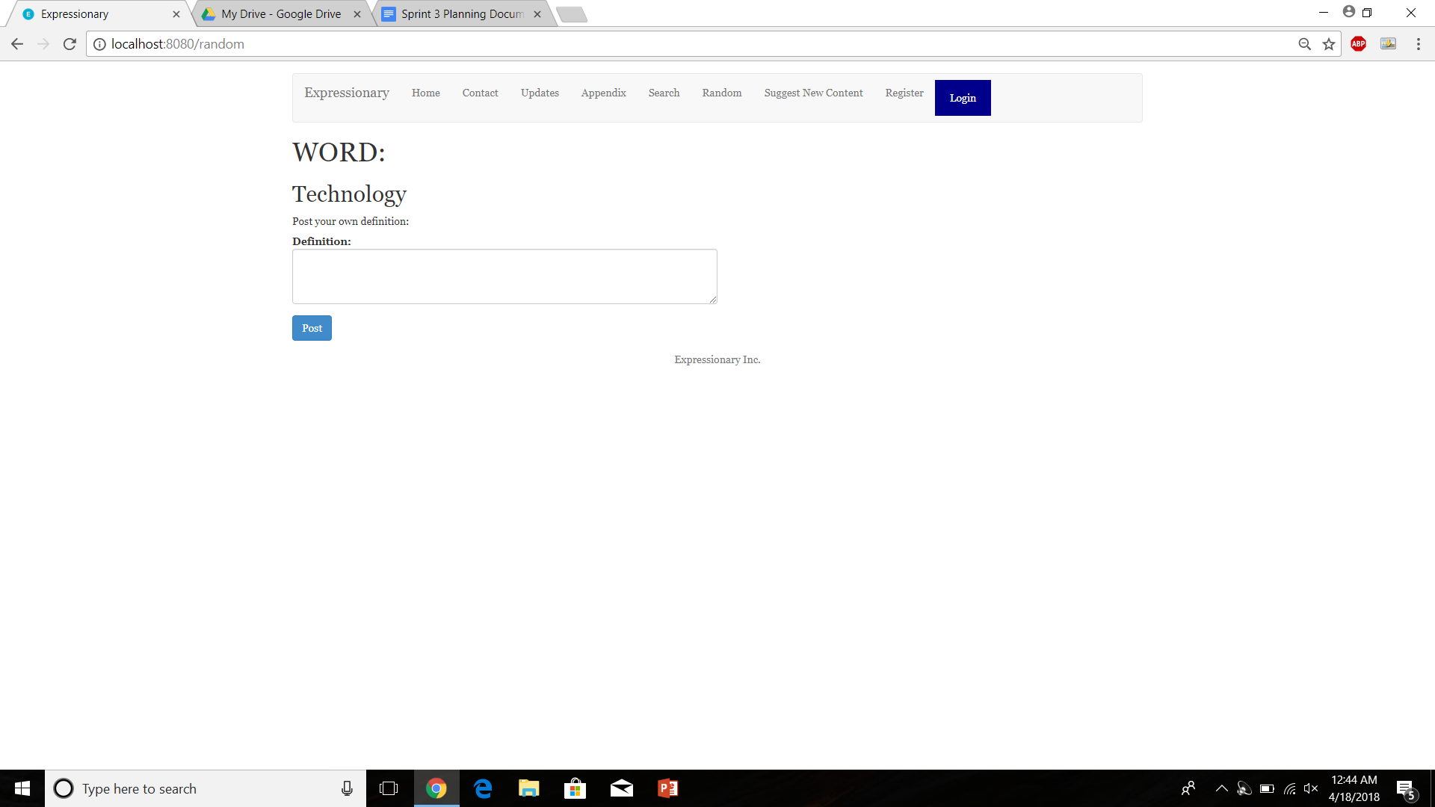

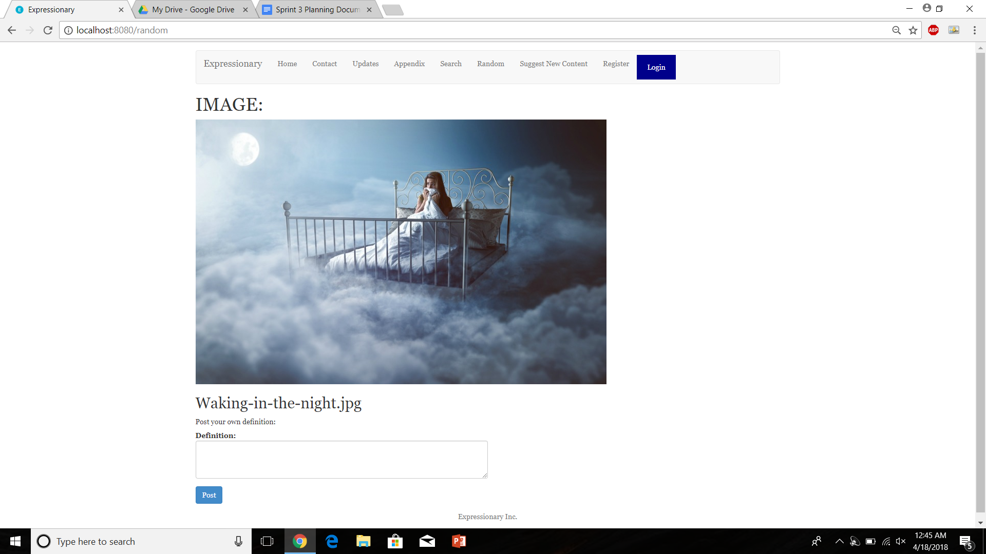

Report the response

**Results:**

The new content(images) can be accessed by pressing random

**Test No.3**

Verify if the new content has fields for posting definition and adding points

**Procedure:**

* Navigate to an image page
* Check if posting is available
* Check if voting is available
* Report the response

**Test**

Navigate to the home page and check the leaderboard

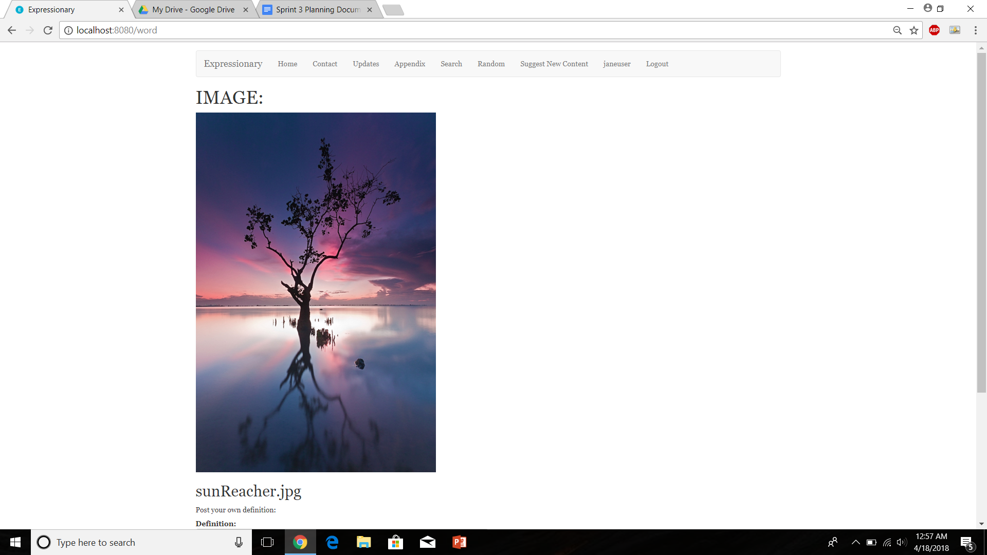

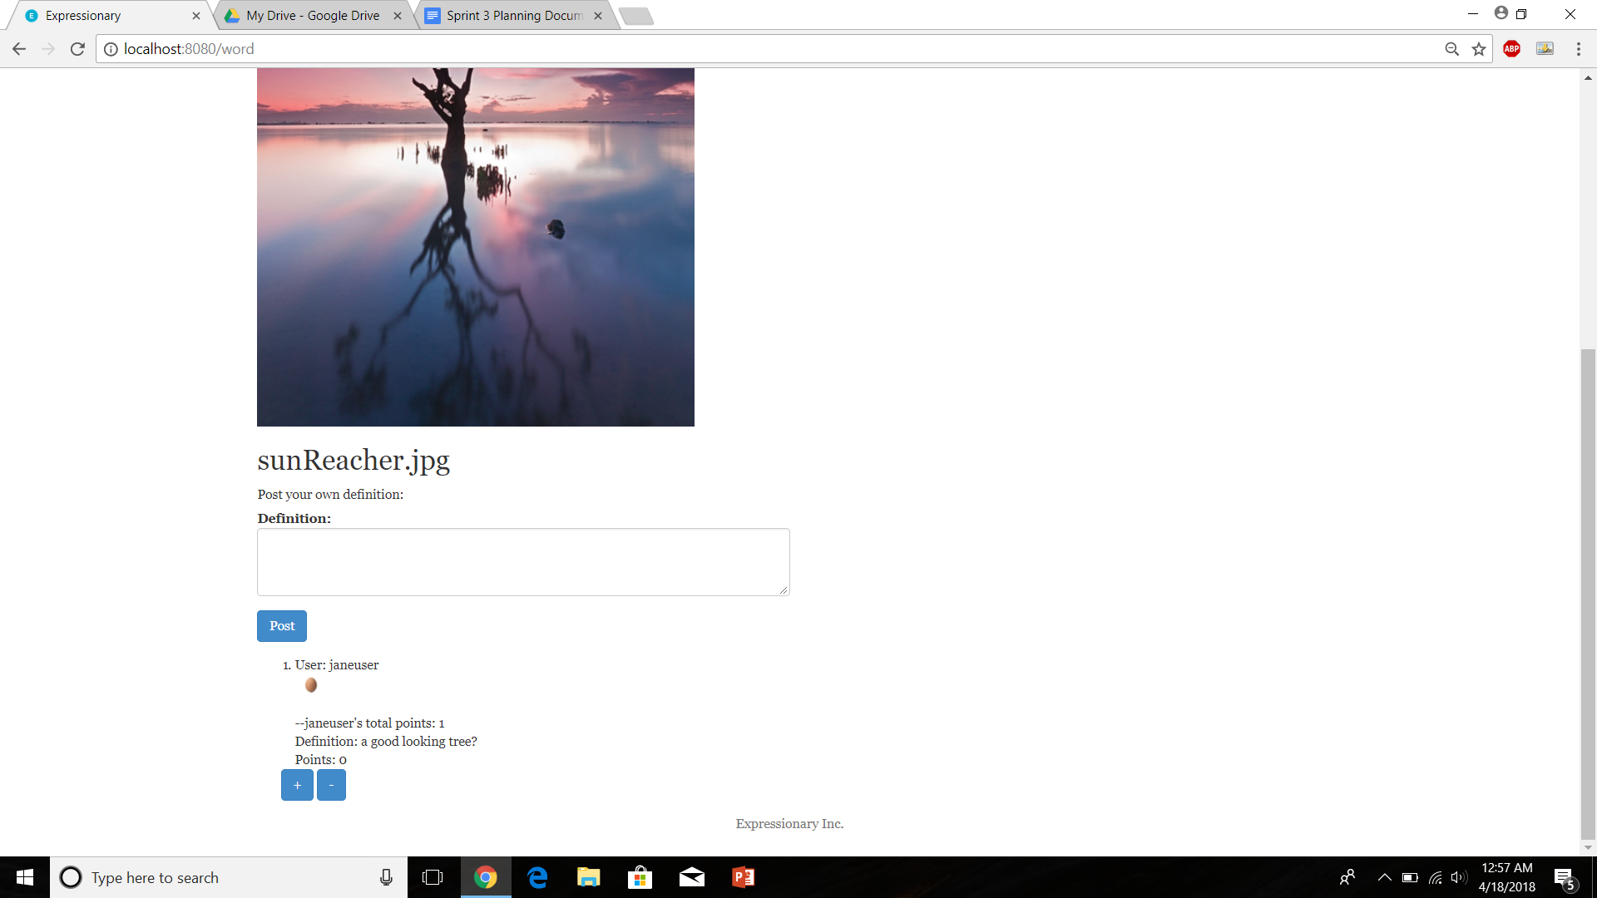

Report the response

**Results:**

The image page has fields for posting definitions as well as voting on the new content.

**Test No.4**

Check to see if non-logged in users cannot post definitions on the new content

**Procedure:**

* Navigate to an image page
* Log out if user is currently logged in
* Try posting a definition
* Report the response

**Test**

Navigate to an image page

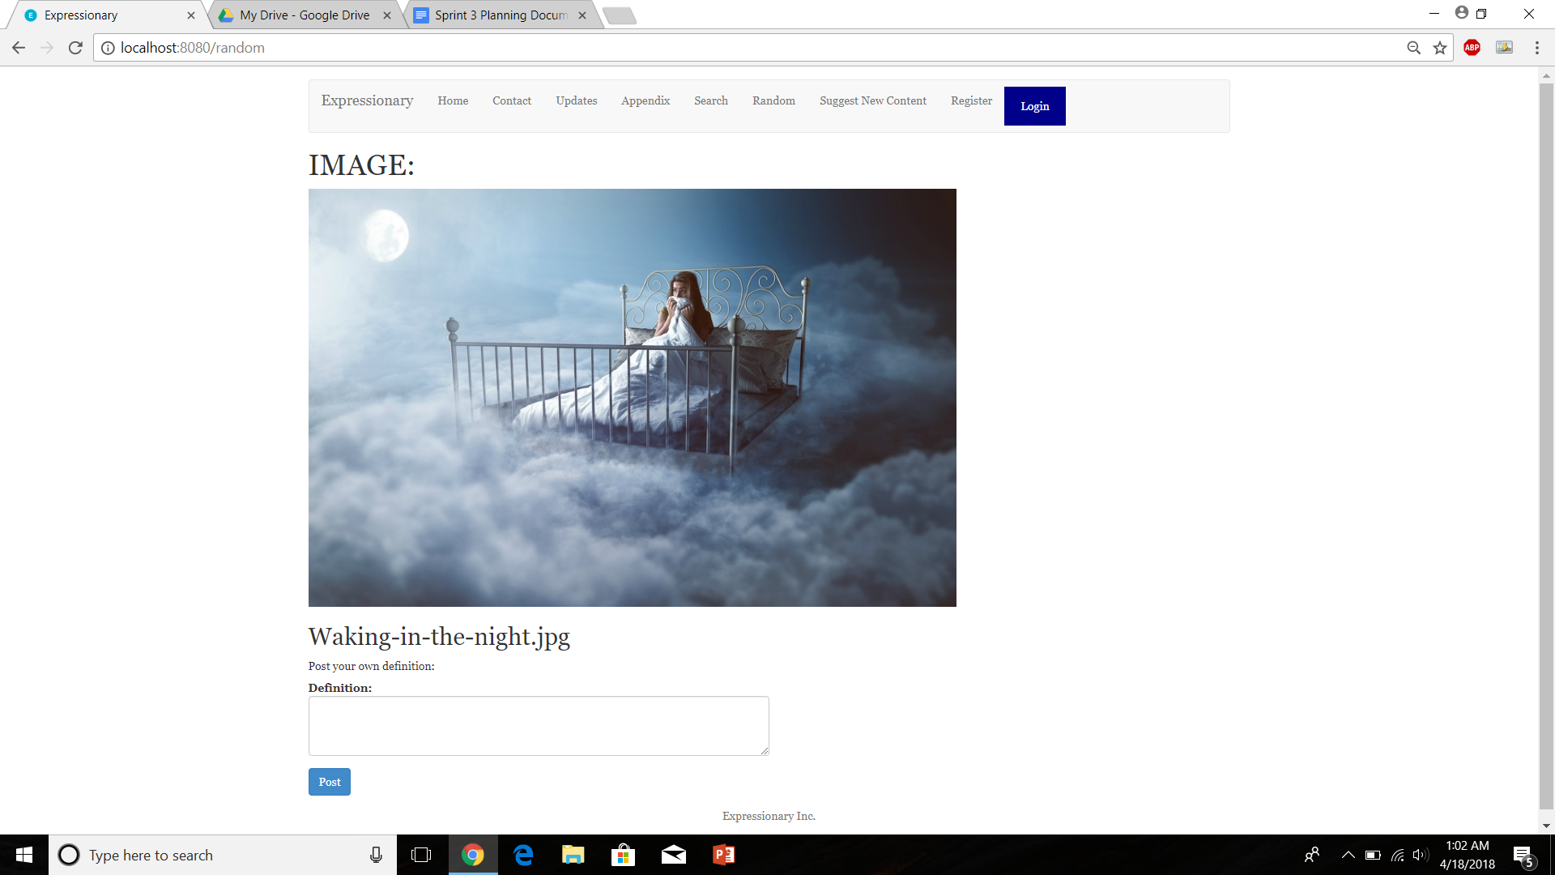

Ensure user is logged out and try posting a definition

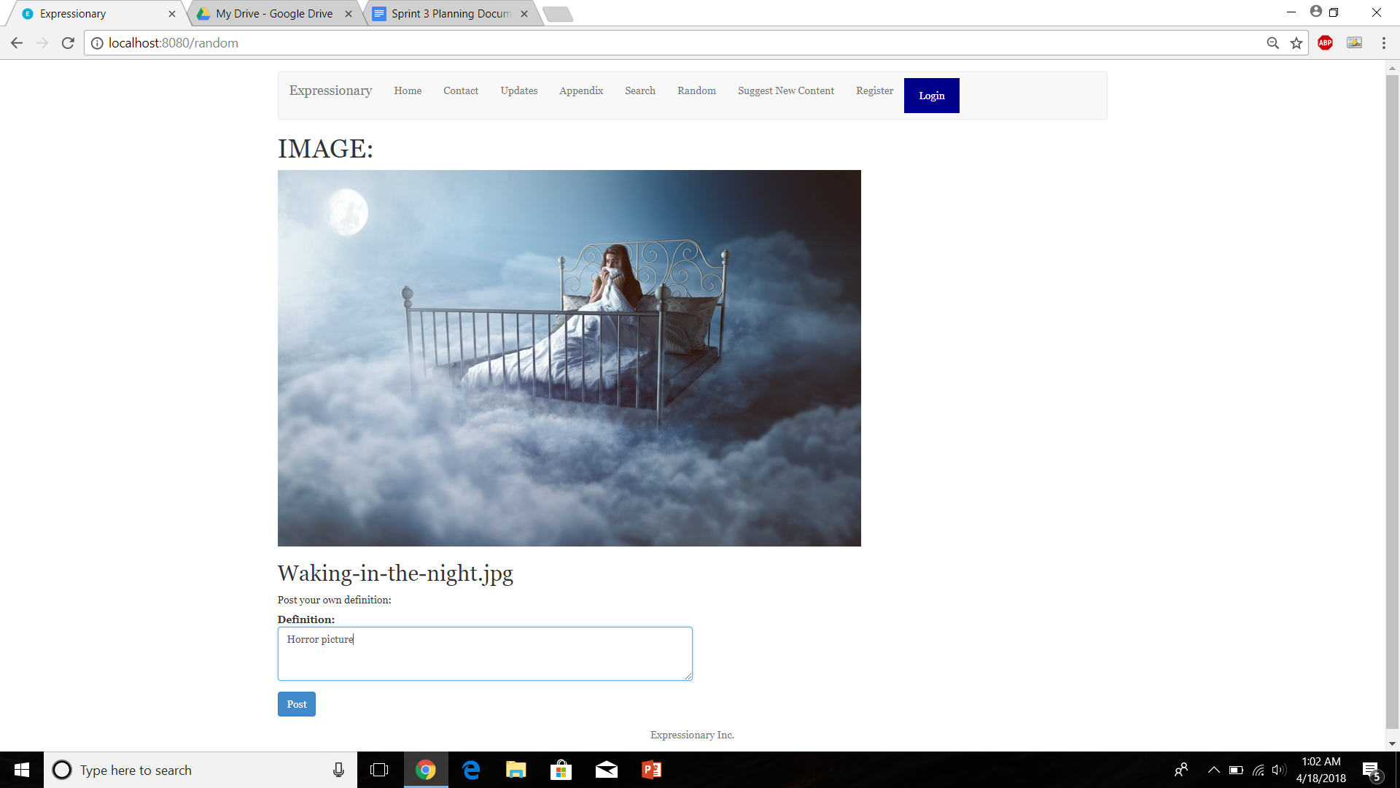

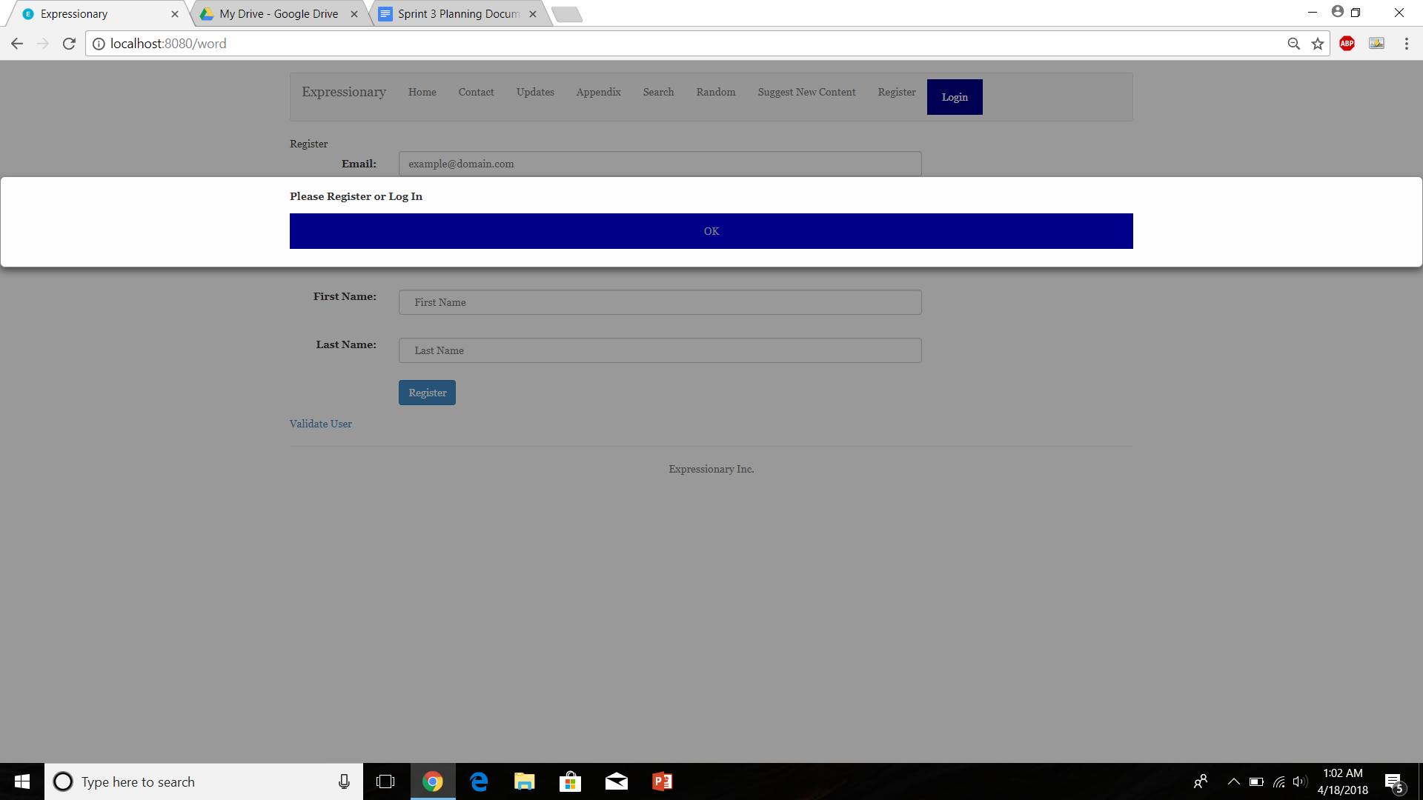

Report the response

**Results:**

Non-logged in users cannot post definitions on new content

**Test No.5**

Check to see if non-logged in users cannot vote definitions on the new content

**Procedure:**

* Navigate to an image page
* Log out if user is currently logged in
* Try voting on a definition
* Report the response

**Test**

Navigate to an image page

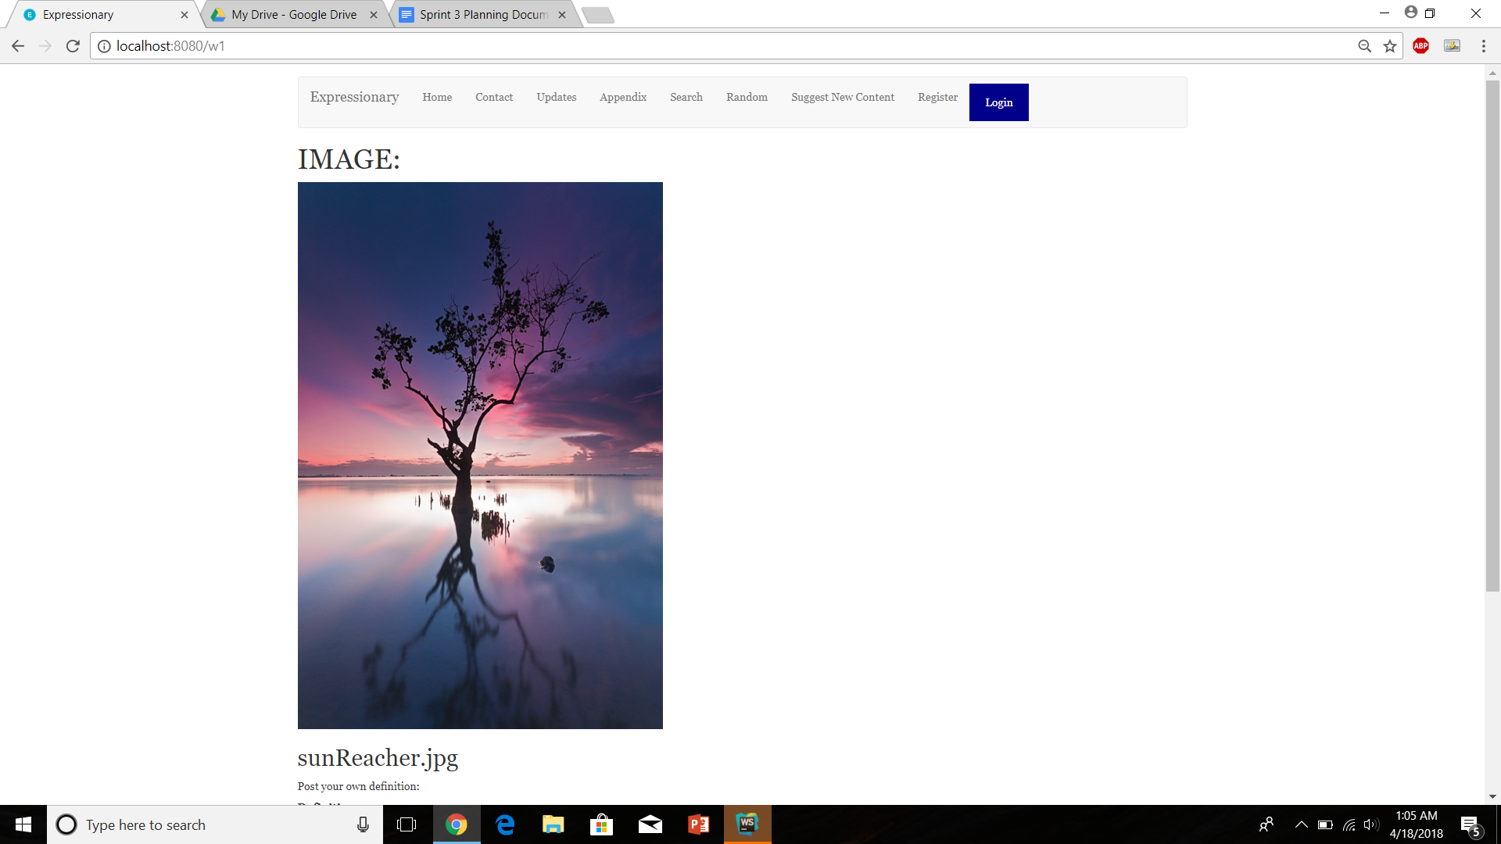

Ensure user is logged out and try voting on a definition

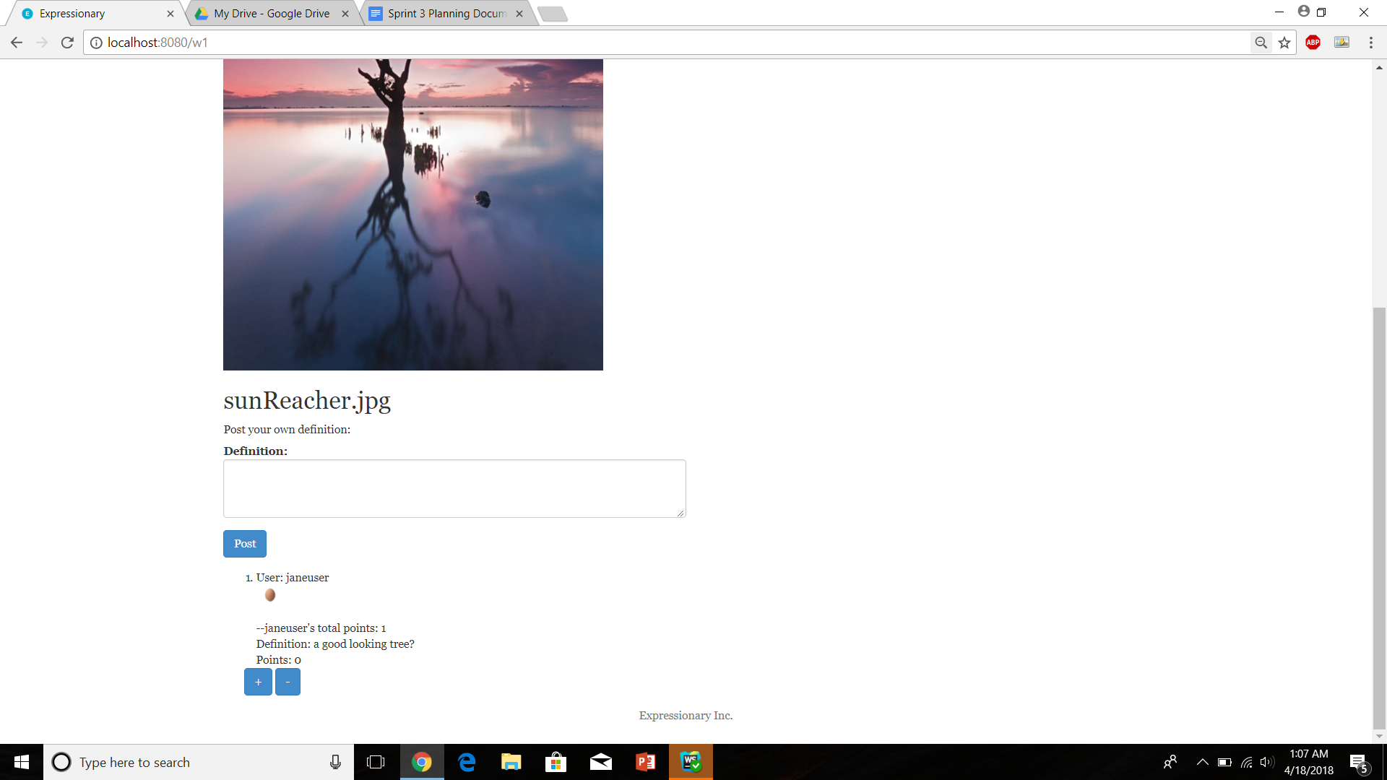

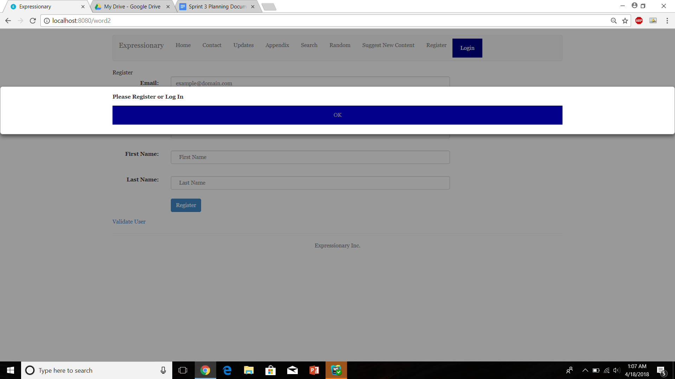

Report the response

**Results:**

Non-logged in users cannot post definitions on new content

**Test No.6**

Check to see if logged in users can post definitions on the new content

**Procedure:**

* Navigate to an image page
* Log in if user is currently logged out
* Try posting a definition
* Report the response

**Test**

Navigate to an image page



Ensure user is logged in and try posting a definition

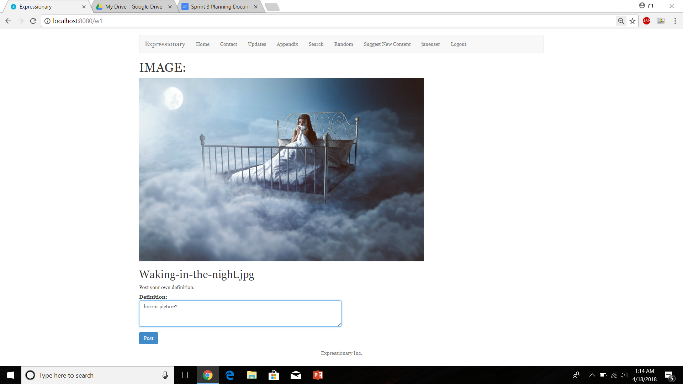

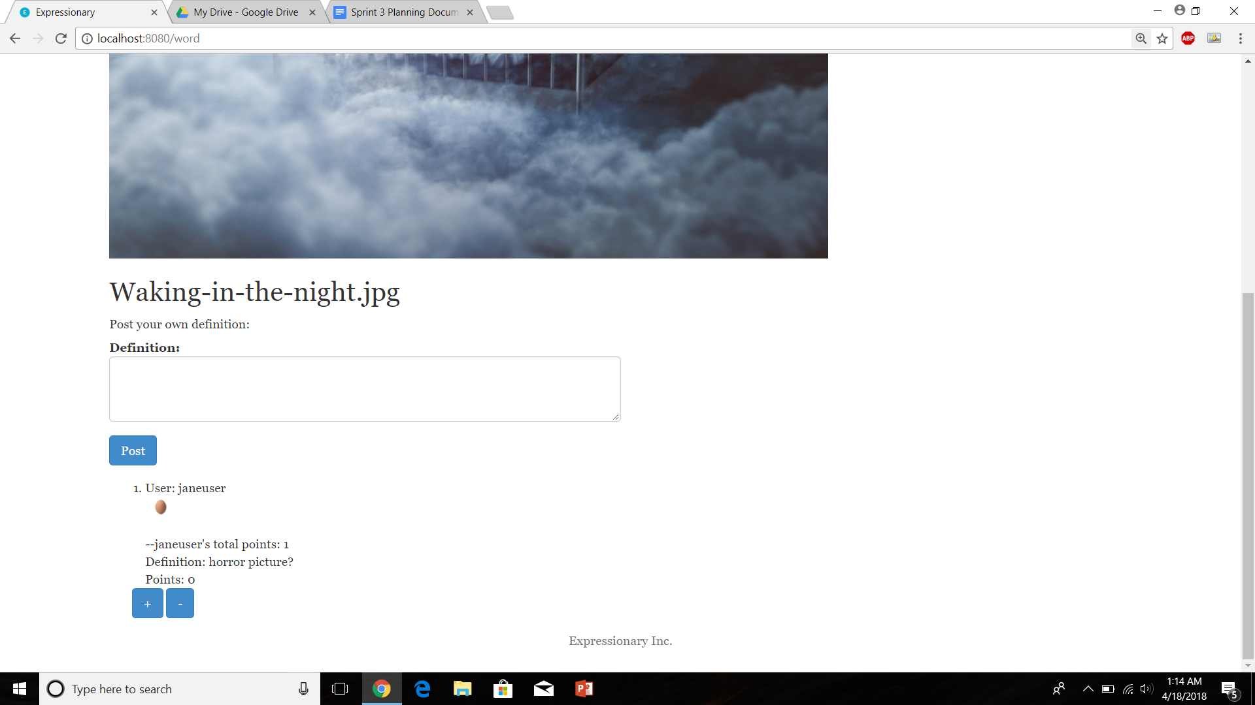

Report the response

**Results:**

logged in users can post definitions on new content

**Test No.7**

Check to see if logged in users can vote definitions on the new content

**Procedure:**

* Navigate to an image page
* Log in if user is currently logged out
* Try voting on a definition
* Report the response

**Test**

Navigate to an image page



Ensure user is logged in and try voting on a definition

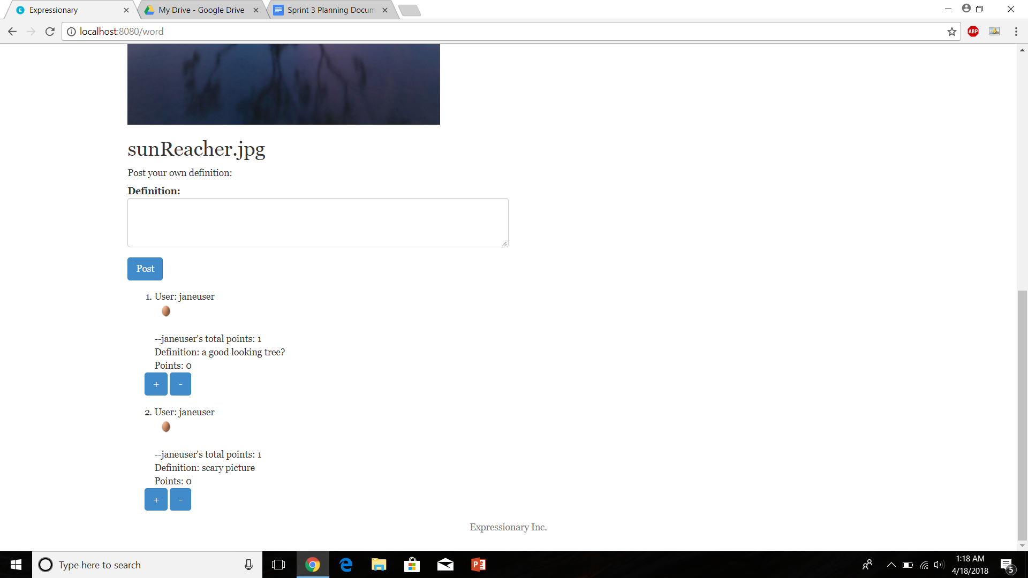

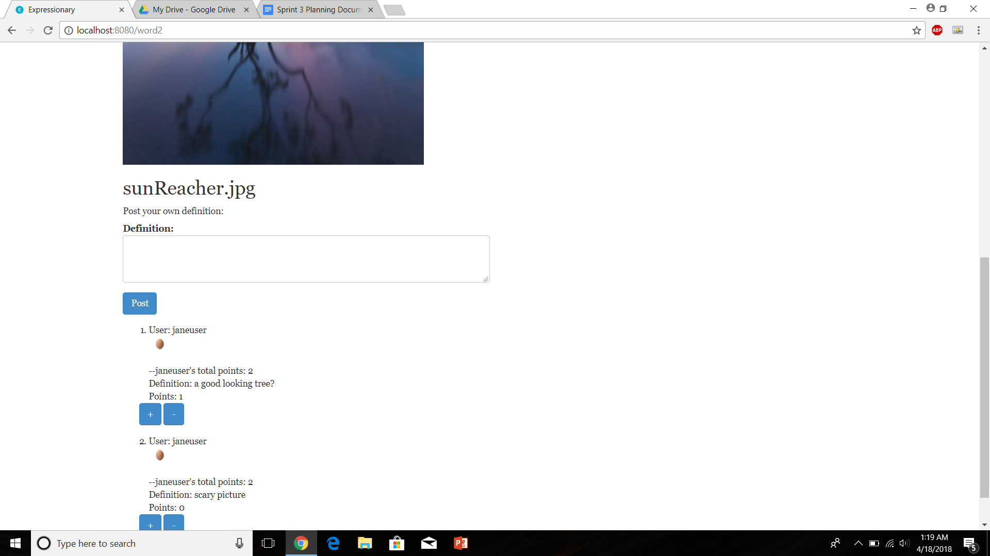

Report the response

**Results:**

Logged in users can vote on definitions for new content

**Test No.8**

Test to check if image leaderboard updates properly after points have been incremented

**Procedure:**

* Navigate to the home page
* Check for leaderboard before points are incremented
* Increment points
* Check leaderboard again
* Report the response

**Test**

Navigate to the home page and check the leaderboard

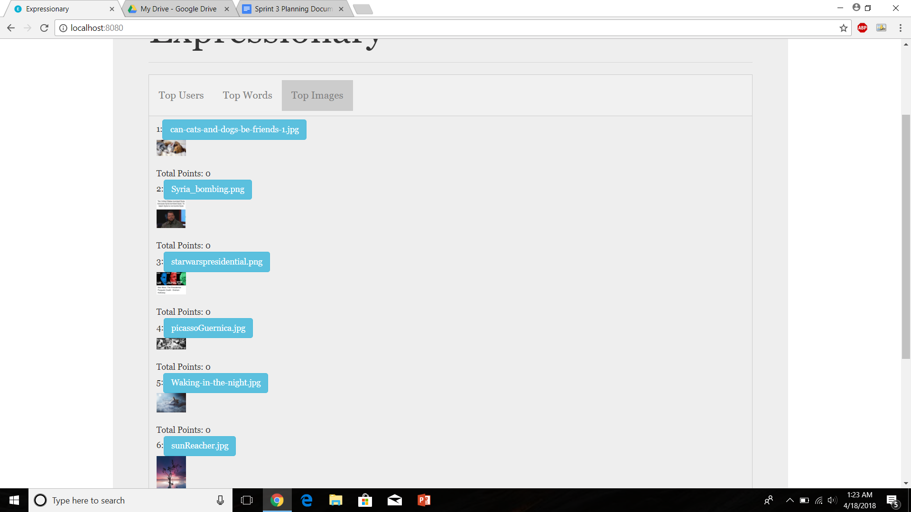

Increment points and check leaderboard again

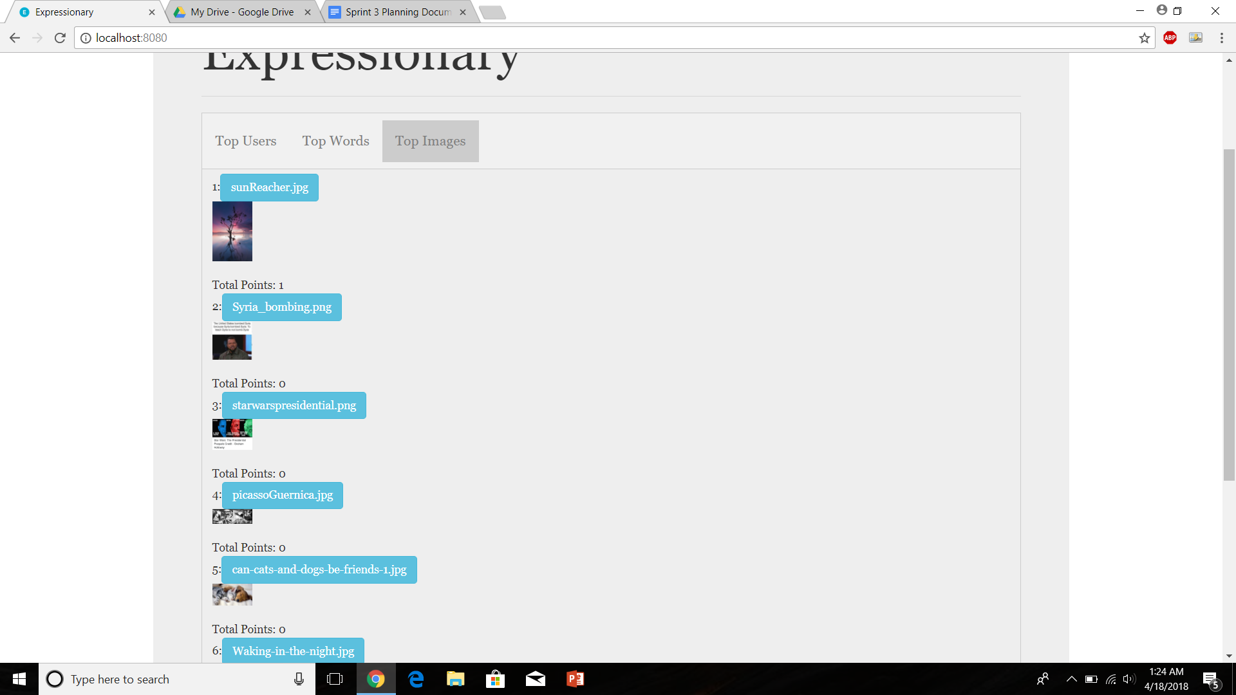

Report the response

**Results:**

The leaderboard updates properly after points are increment for the new content

**USER STORY # 5**

**Test No.1**

Verify that the header contains a field called appendix

**Procedure:**

* Navigate to the home page
* Check the header
* Report the response

**Test**

Navigate to the home page and check the header





Report the response

**Results:**

There contains a tab called appendix

**Test No.2**

Check if the appendix contains a list of all the users

**Procedure:**

* Navigate to the appendix
* Check if user tab exists
* Check if the appendix shows all the users
* Report the response

**Test**

Navigate to appendix



Click on user and report the response

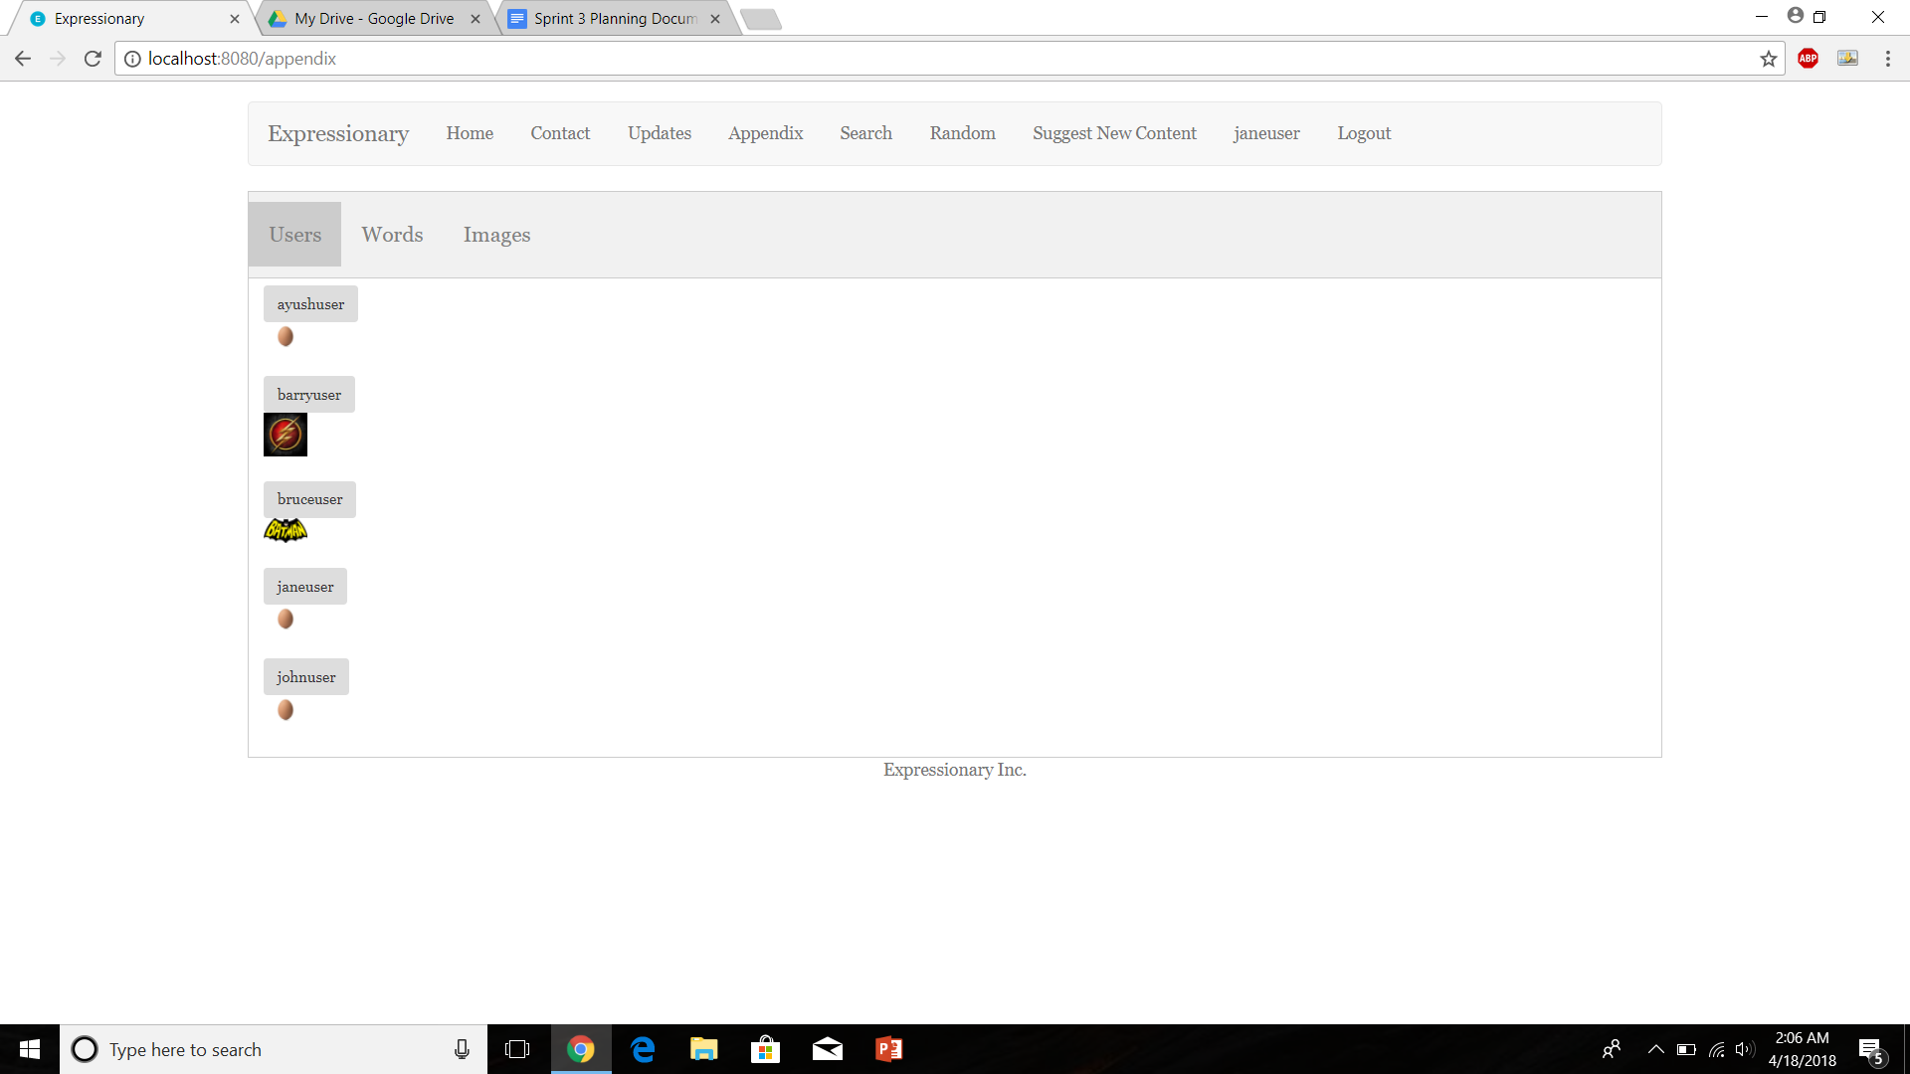

Report the response

**Results:**

The users tab contains a list of all the users currently held by the database

**Test No.3**

Check if the appendix contains a list of all the words

**Procedure:**

* Navigate to the appendix
* Check if word tab exists
* Check if the appendix shows all the words
* Report the response

**Test**

Navigate to appendix



Click on word and report the response

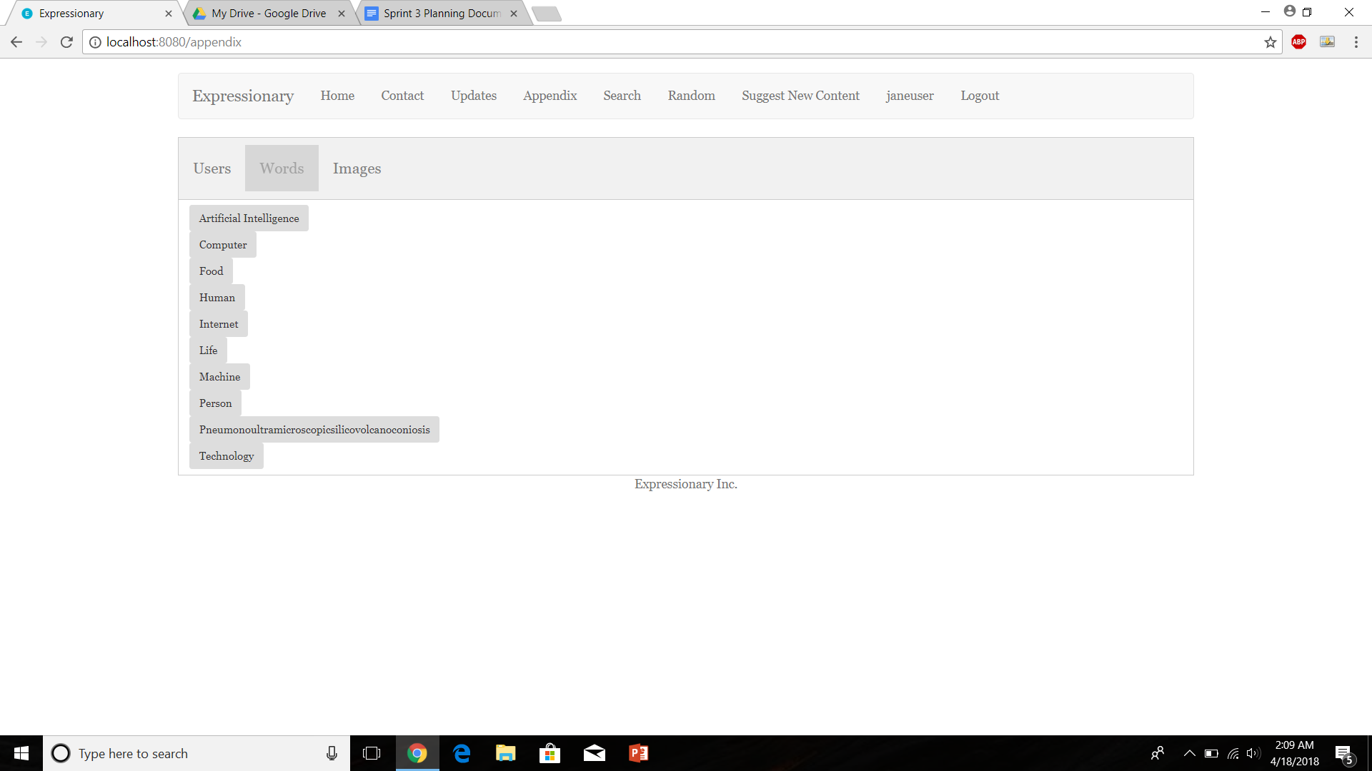

Report the response

**Results:**

The words tab contains a list of all the words currently held by the database

**Test No.4**

Check if the appendix contains a list of all the images

**Procedure:**

* Navigate to the appendix
* Check if image tab exists
* Check if the appendix shows all the images
* Report the response

**Test**

Navigate to appendix



Click on user and report the response

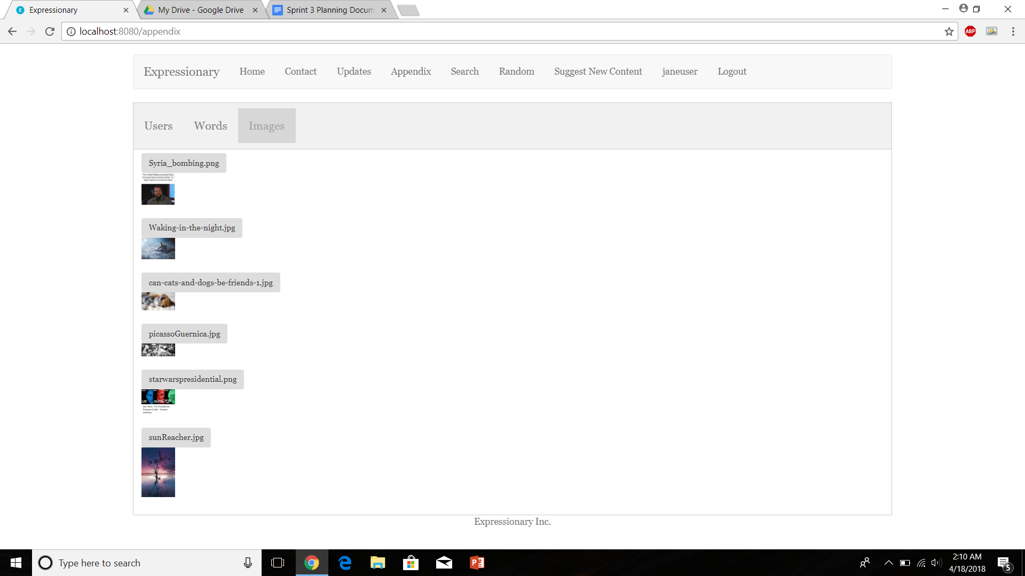

Report the response

**Results:**

The images tab contains a list of all the images currently held by the database

**Test No.5**

Verify that all the users in the appendix are listed in alphabetical order.

**Procedure:**

* Navigate to the appendix
* Click on the user’s tab
* Check the ordering
* Report the response

**Test**

Navigate to appendix



Click on the users tab, inspect the order and report the response

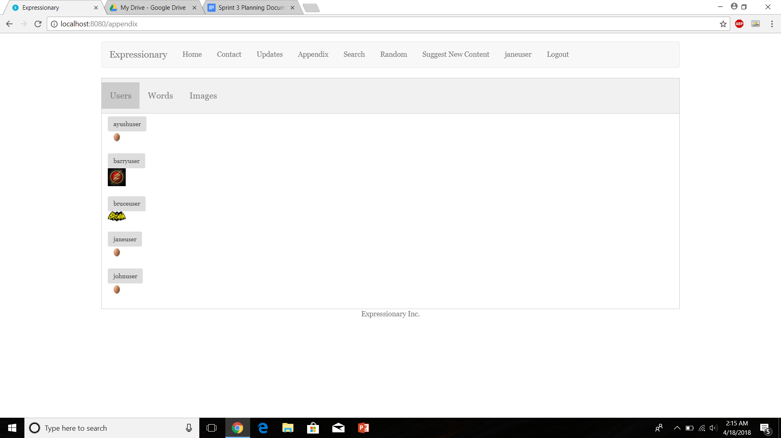

Report the response

**Results:**

The users appear to be in the correct order

**Test No.6**

Verify that all the words in the appendix are listed in alphabetical order.

**Procedure:**

* Navigate to the appendix
* Click on the words tab
* Check the ordering
* Report the response

**Test**

Navigate to appendix



Click on the words tab, inspect the order and report the response

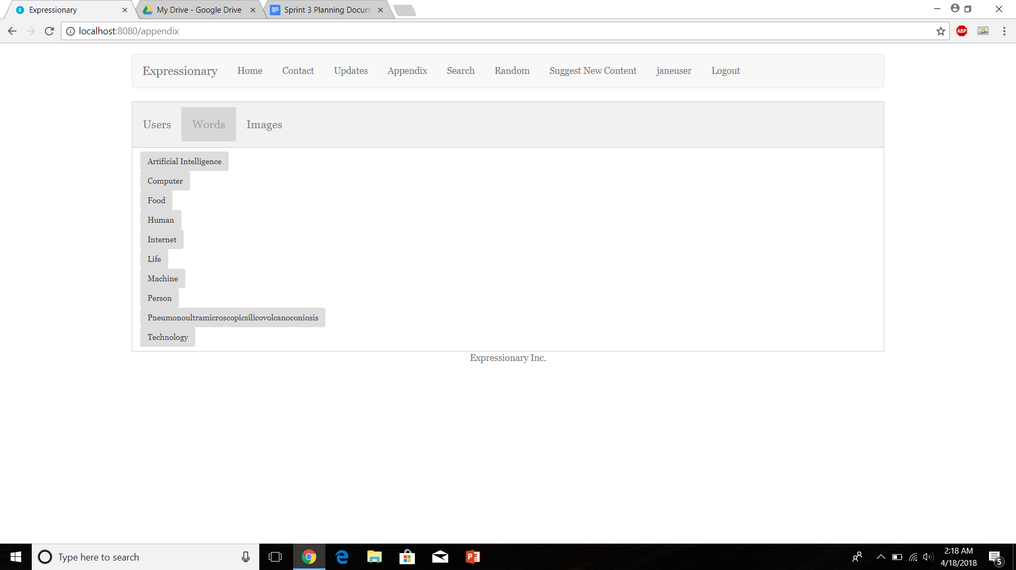

Report the response

**Results:**

The words appear to be in the correct order

**Test No.7**

Check to see if a logged in user can view the appendix the same way a non-logged in user can.

**Procedure:**

* Navigate to the appendix
* Log in and access users tab
* Log out and access users tab
* Report the response

**Test**

Navigate to appendix



Log in and check users tab in appendix



Log out and check the users tab in appendix

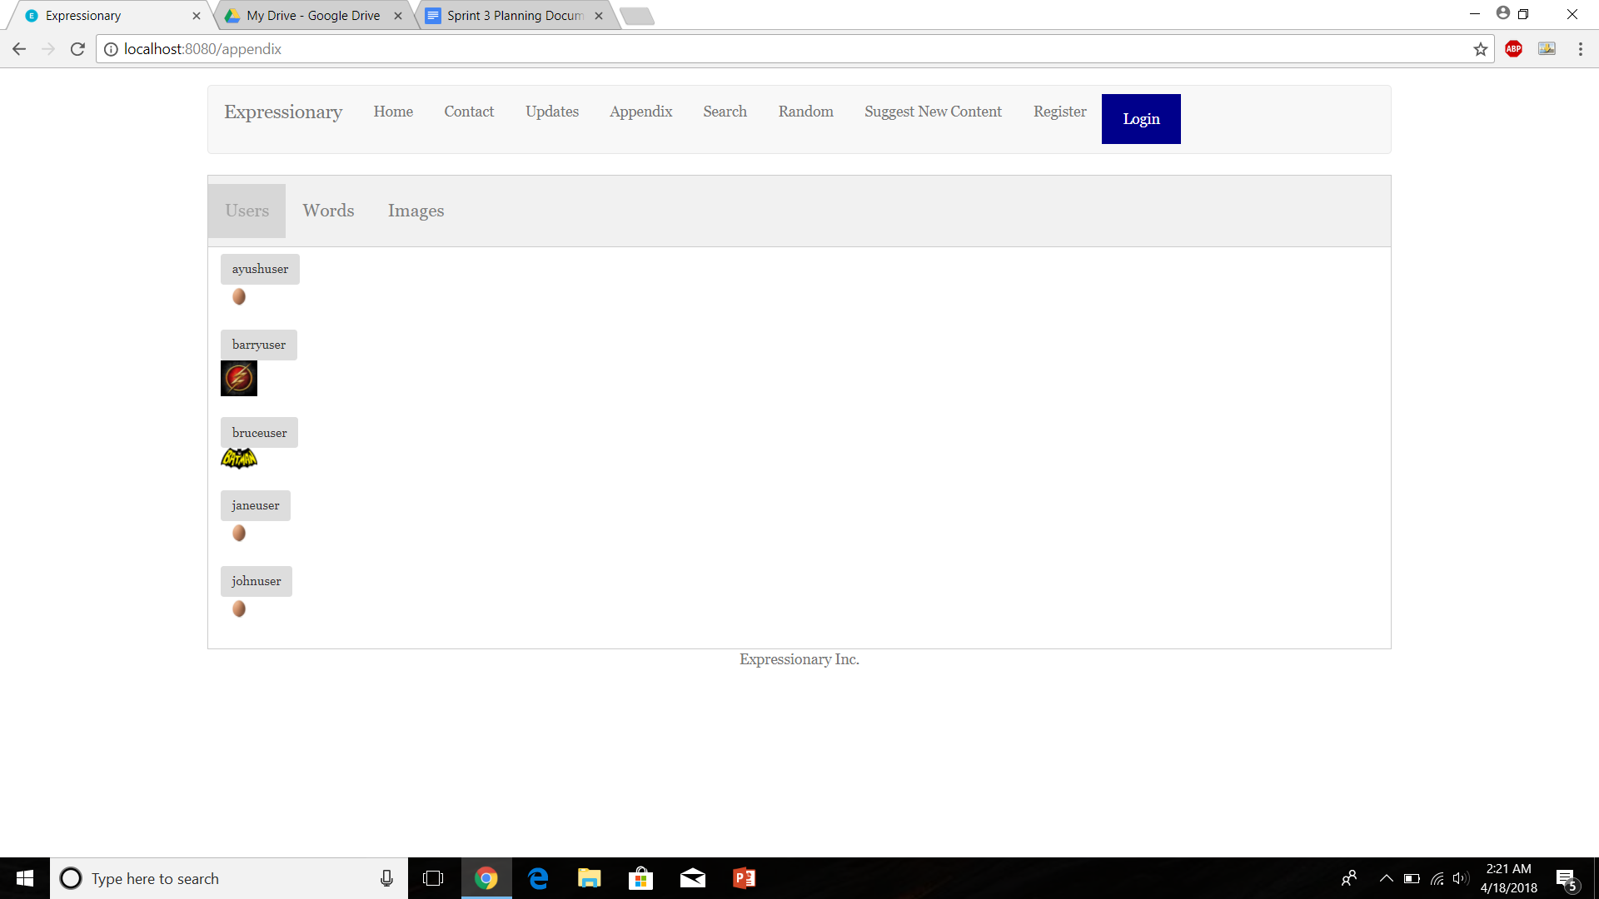

Report the response

**Results:**

The users tab appears to be the same whether a user is logged in or not. This is the expected result

**Test No.8**

Register a new user and check if the new user appears in the appendix

**Procedure:**

* Check the appendix
* Register a new user (Intermediate steps will not be shown)
* Check the appendix
* Report the response

**Test**

Check the users tab in appendix



Register a new user

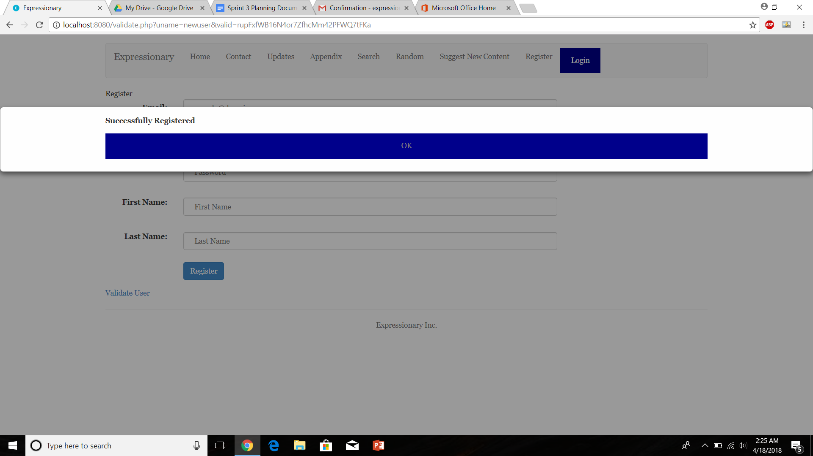

Check the appendix again

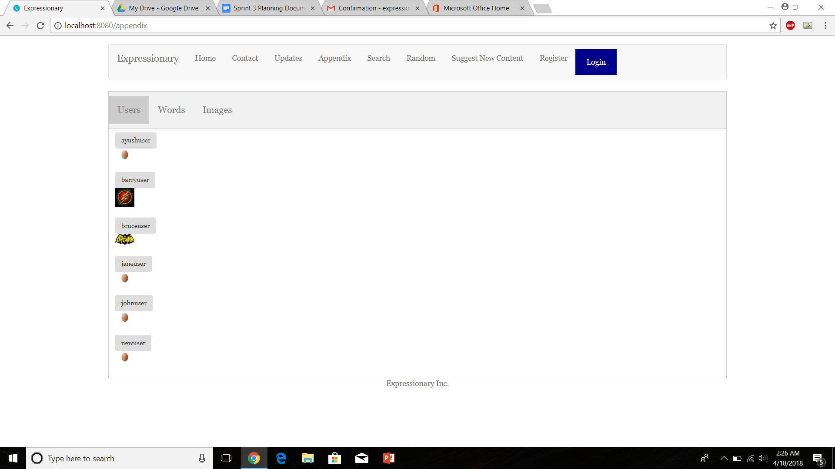

Report the response

**Results:**

The new user shows up in the appendix

**USER STORY # 6**

**Test No.1**

Verify to check if a tab exists in the header to suggest new content

**Procedure:**

* Navigate to the home page
* Check the header
* Report the response

**Test**

Navigate to the home page and check the header





Report the response

**Results:**

There contains a tab called suggest new content

**Test No.2**

Test to check if suggest new content tab has options to let you suggest all the content types supported by the webpage

**Procedure:**

* Navigate to suggest new content page
* Check the page
* Report the response

**Test**

Navigate to the suggest new content page

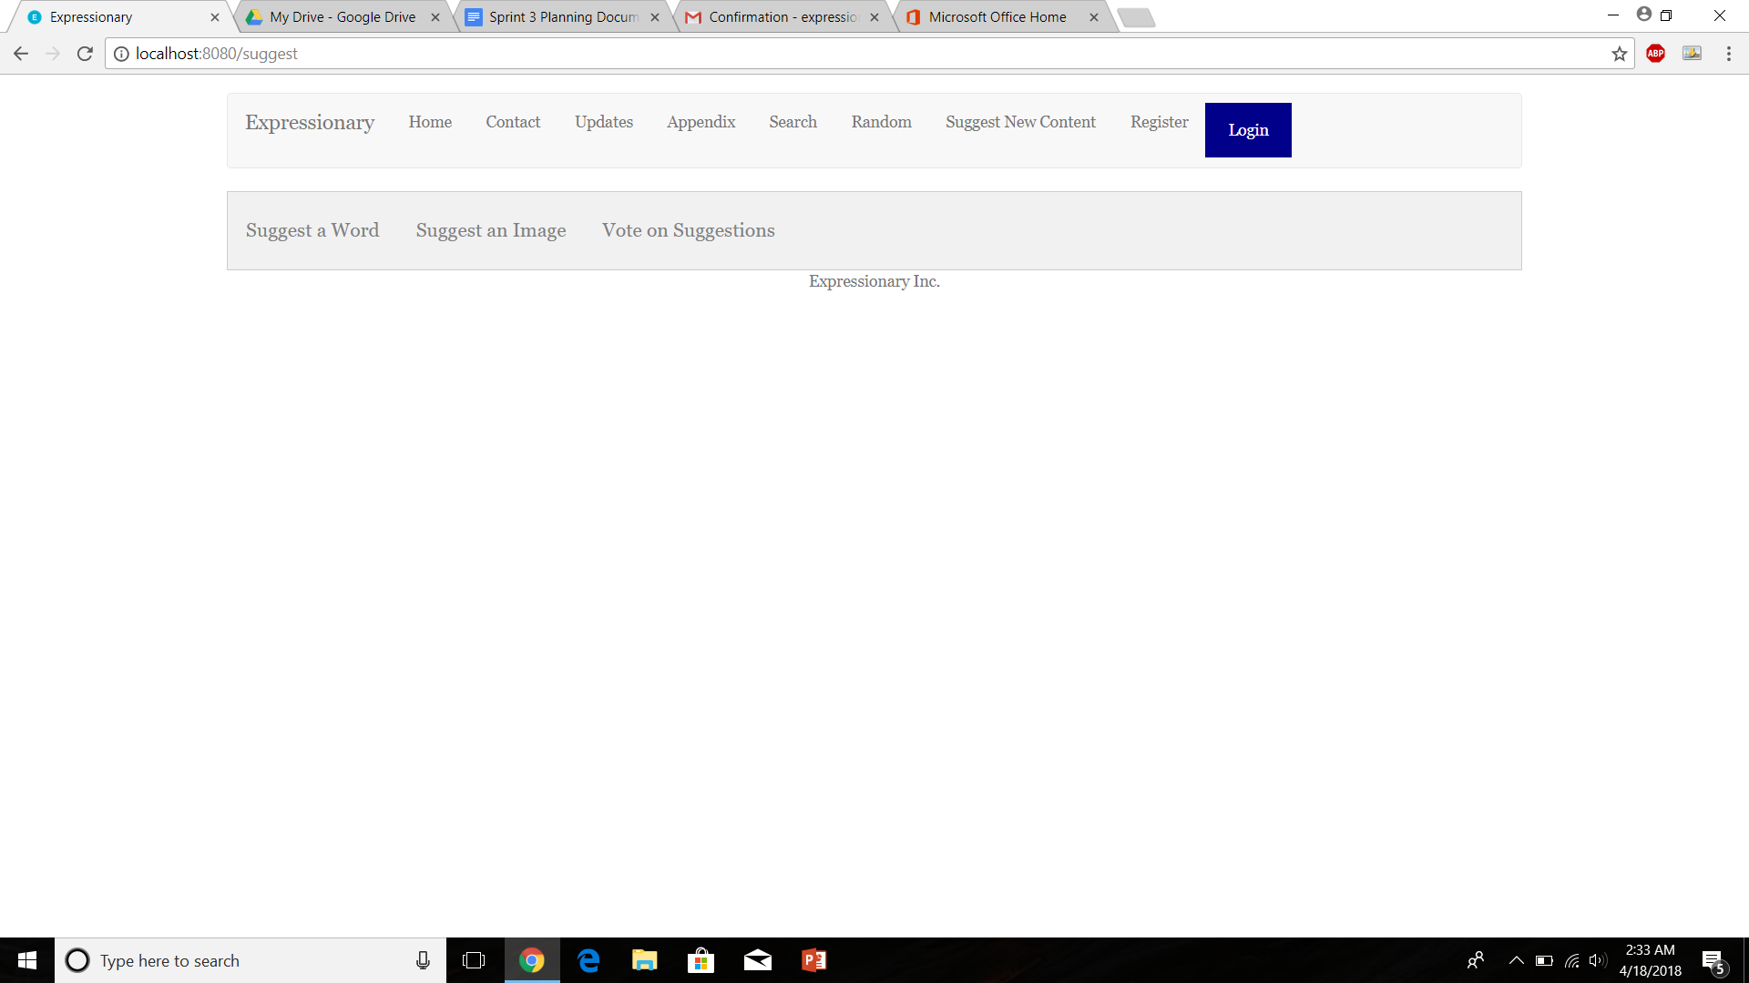

Report the response

**Results:**

There are 2 options for suggesting a word and image (the 2 content types supported by the server)

**Test No.3**

Test to check if a non- logged in user can suggest new word

**Procedure:**

* Navigate to suggest new content page
* Log out if currently logged in
* Try suggesting a word
* Report the response

**Test**

Navigate to the suggest new content page and ensure the user is logged out



Go to the suggest word tab and enter a new word, press send afterwards

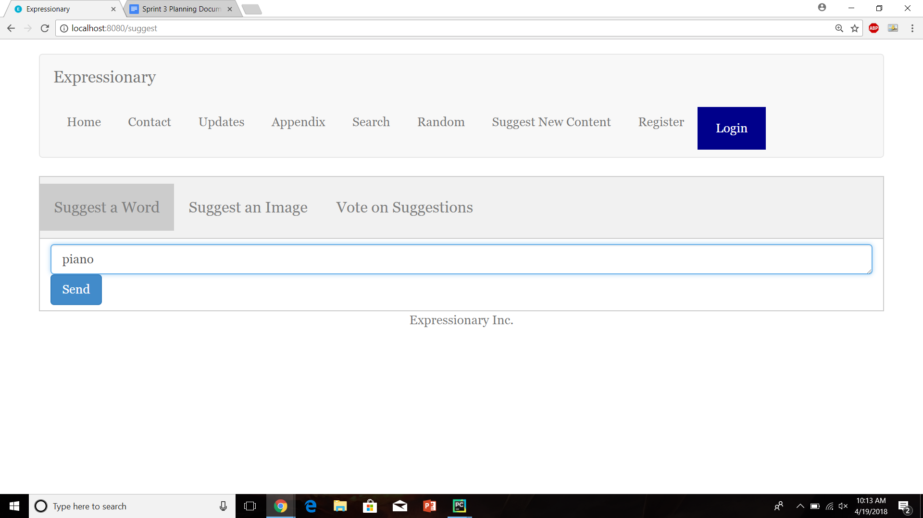

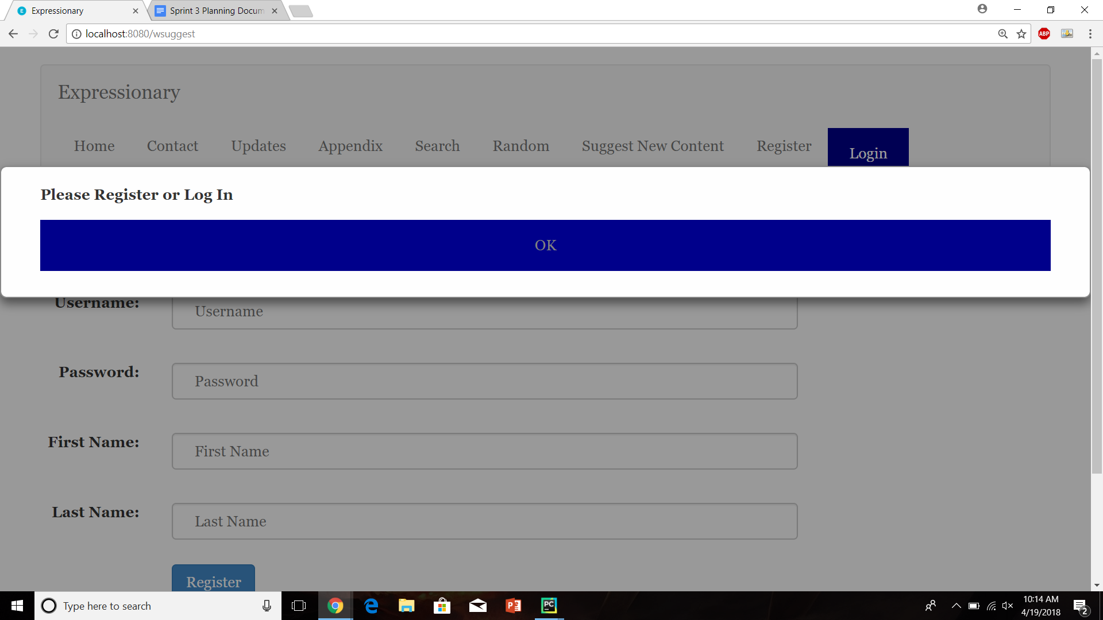

Report the response

**Results:**

New word cannot be suggested by non-logged in users

**Test No.4**

Test to check if a non- logged in user can suggest new image

**Procedure:**

* Navigate to suggest new content page
* Log out if currently logged in
* Try suggesting a image
* Report the response

**Test**

Navigate to the suggest new content page and ensure the user is logged out



Go to the suggest image tab and choose a file, press upload afterwards

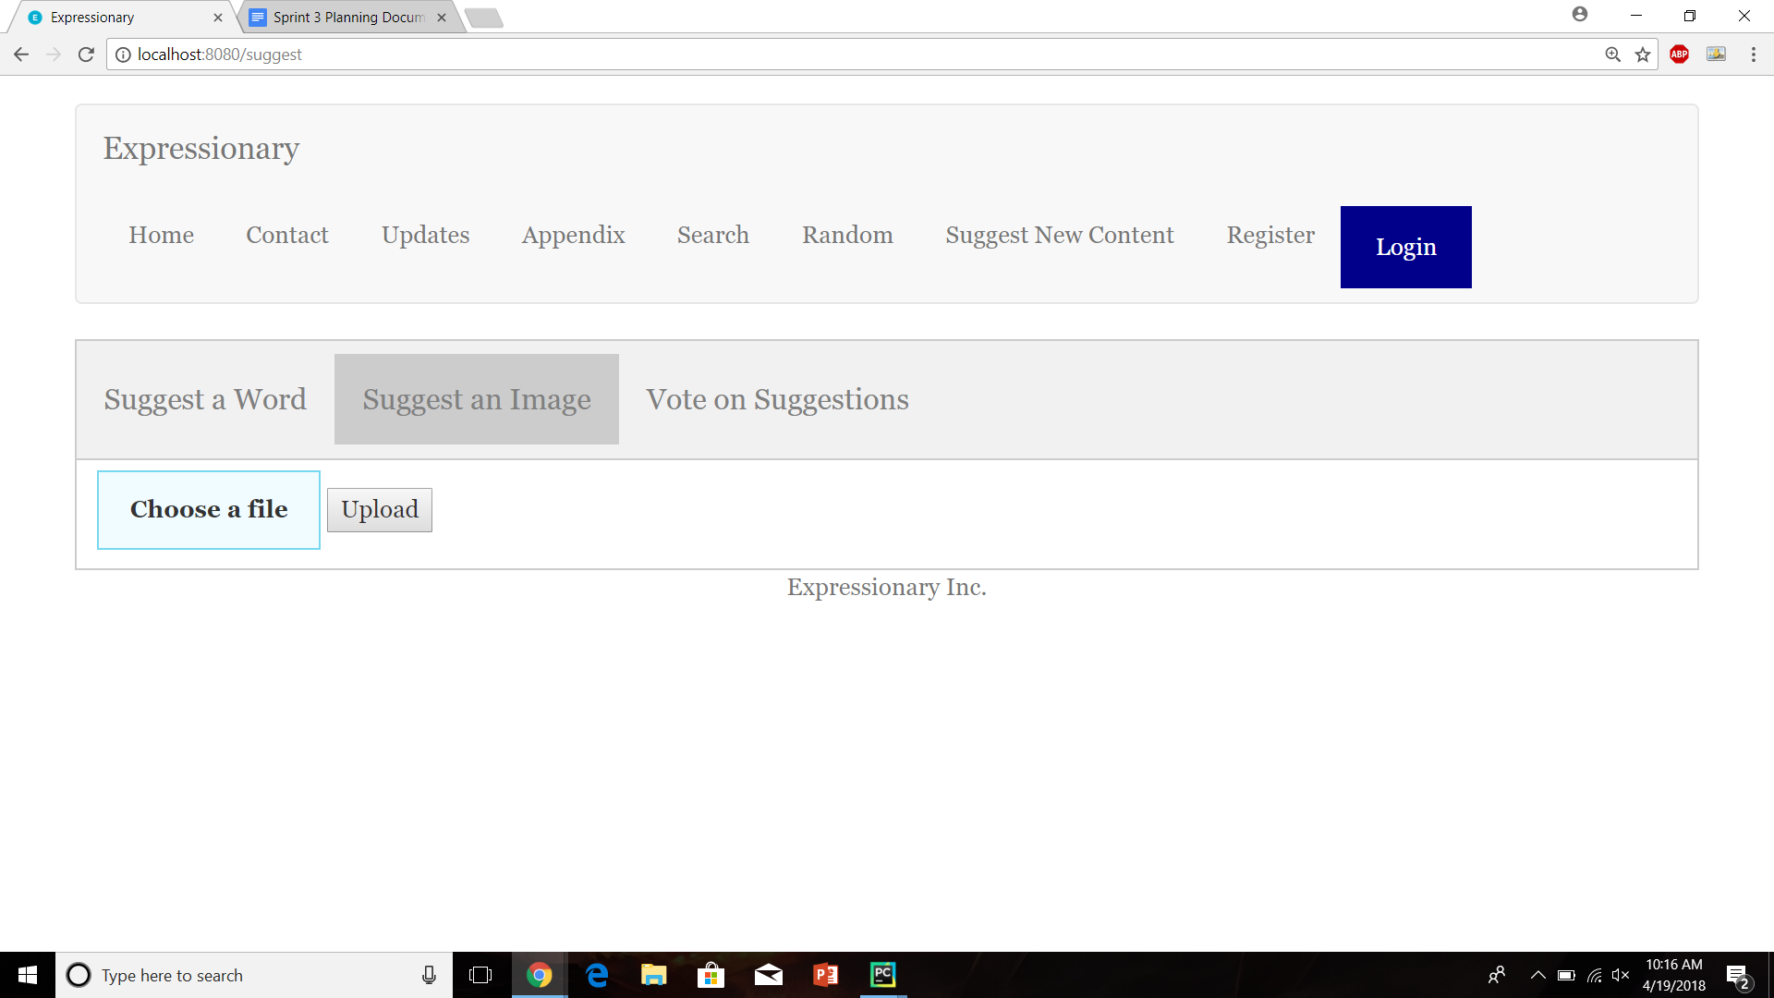



Report the response

**Results:**

New image cannot be suggested by non-logged in users

**Test No.5**

Test to check if suggested word shows up for voting after it has been suggested

**Procedure:**

* Navigate to suggest new content page
* Log in and suggest a new word
* Check the suggested words tab.
* Report the response

**Test**

Navigate to the suggest new content page



Log in and suggest a new word

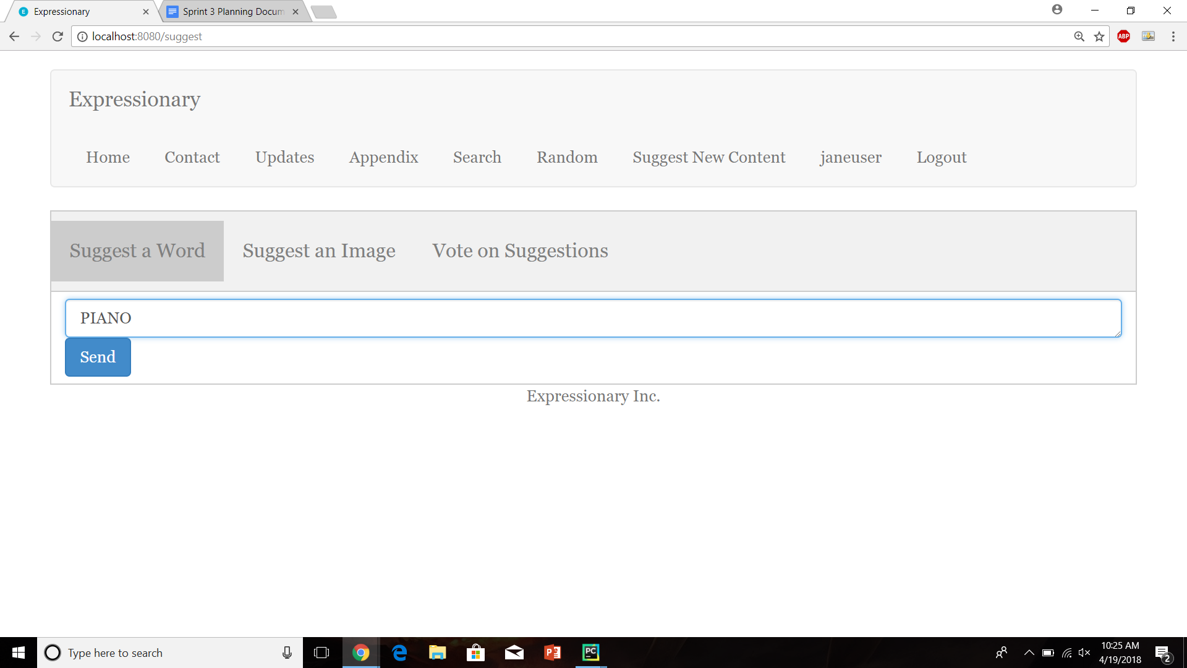

Check the Vote on Suggestions/Suggested Word tab

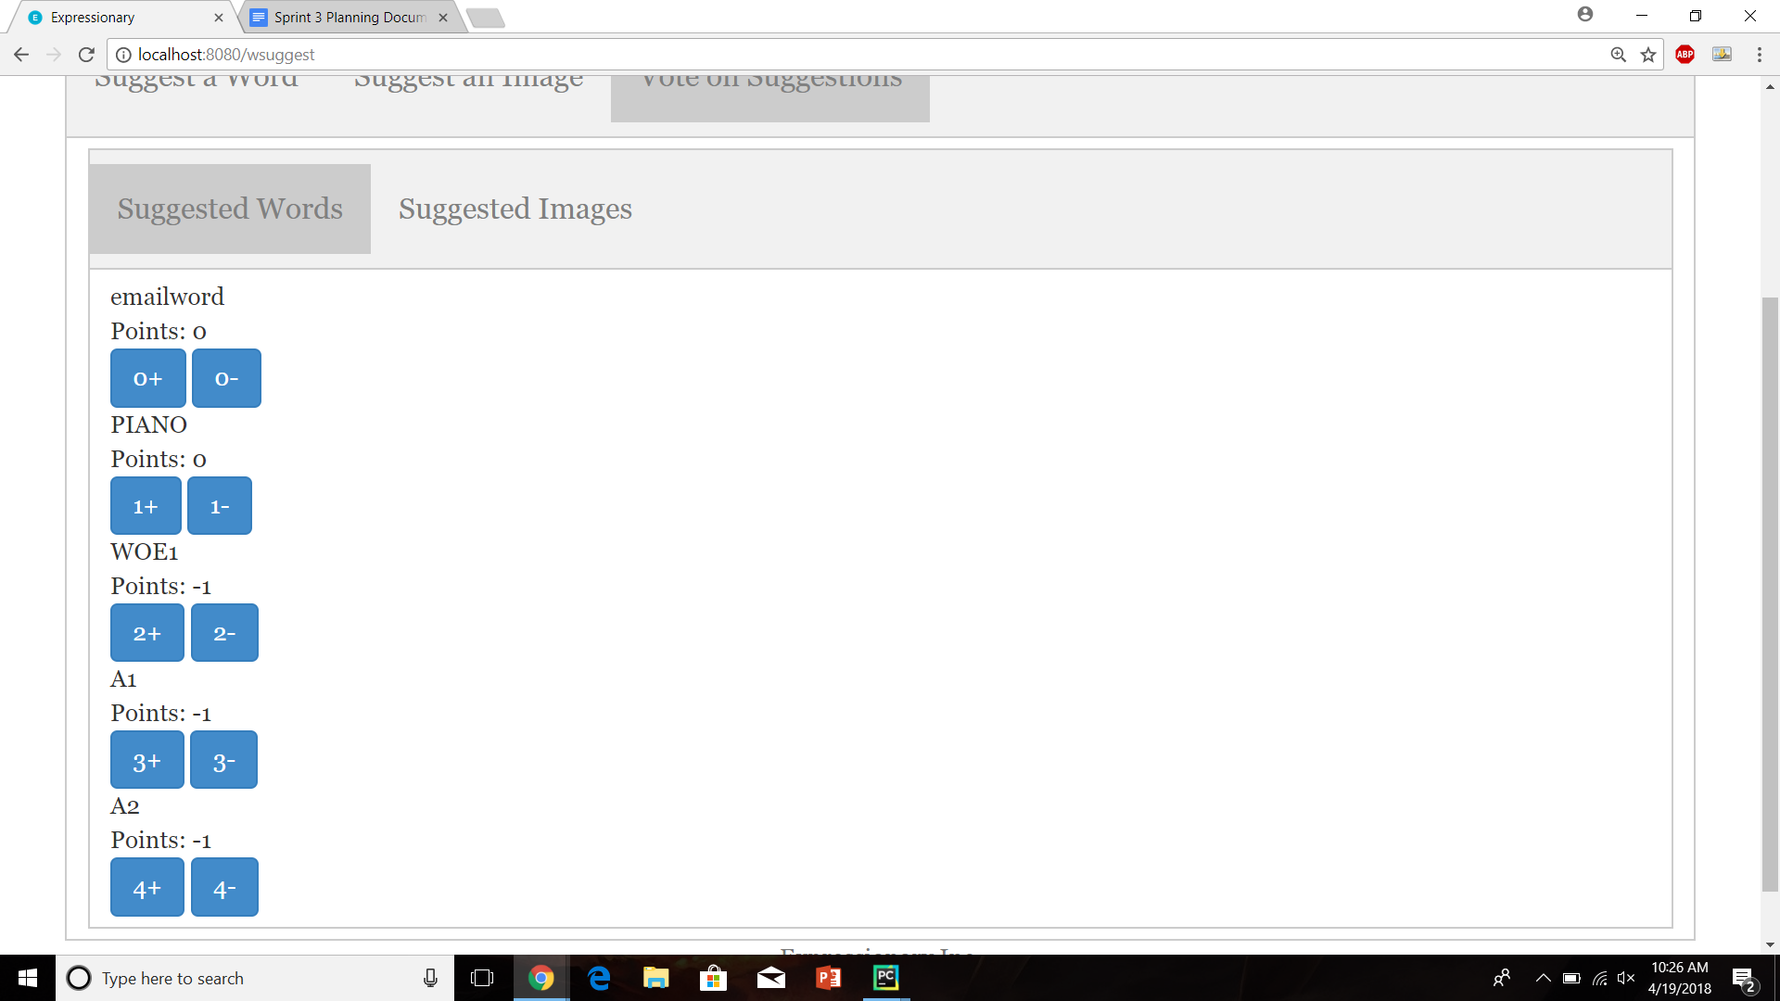

Report the response

**Results:**

The newly suggested word shows up in suggested words for voting after it has been suggested

**Test No.6**

Test to check if suggested image shows up for voting after it has been suggested

**Procedure:**

* Navigate to suggest new content page
* Log in and suggest a new image
* Check the suggested words tab.
* Report the response

**Test**

Navigate to the suggest new content page



Log in and suggest a new image

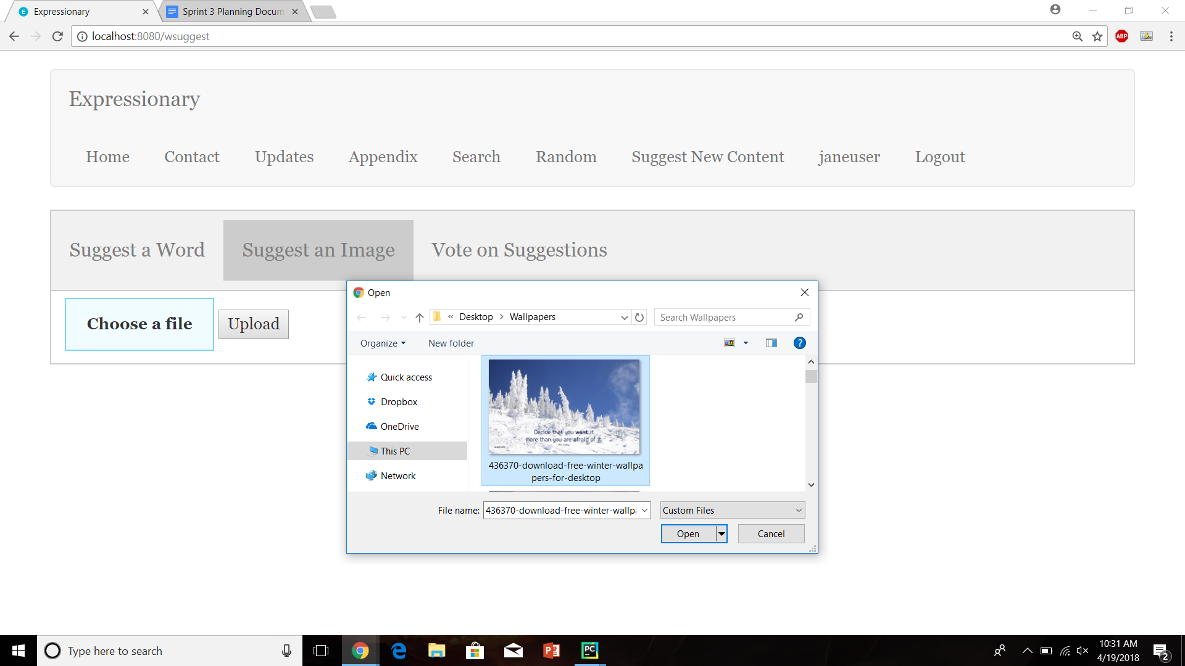

Check the Vote on Suggestions ->Suggested Images tab

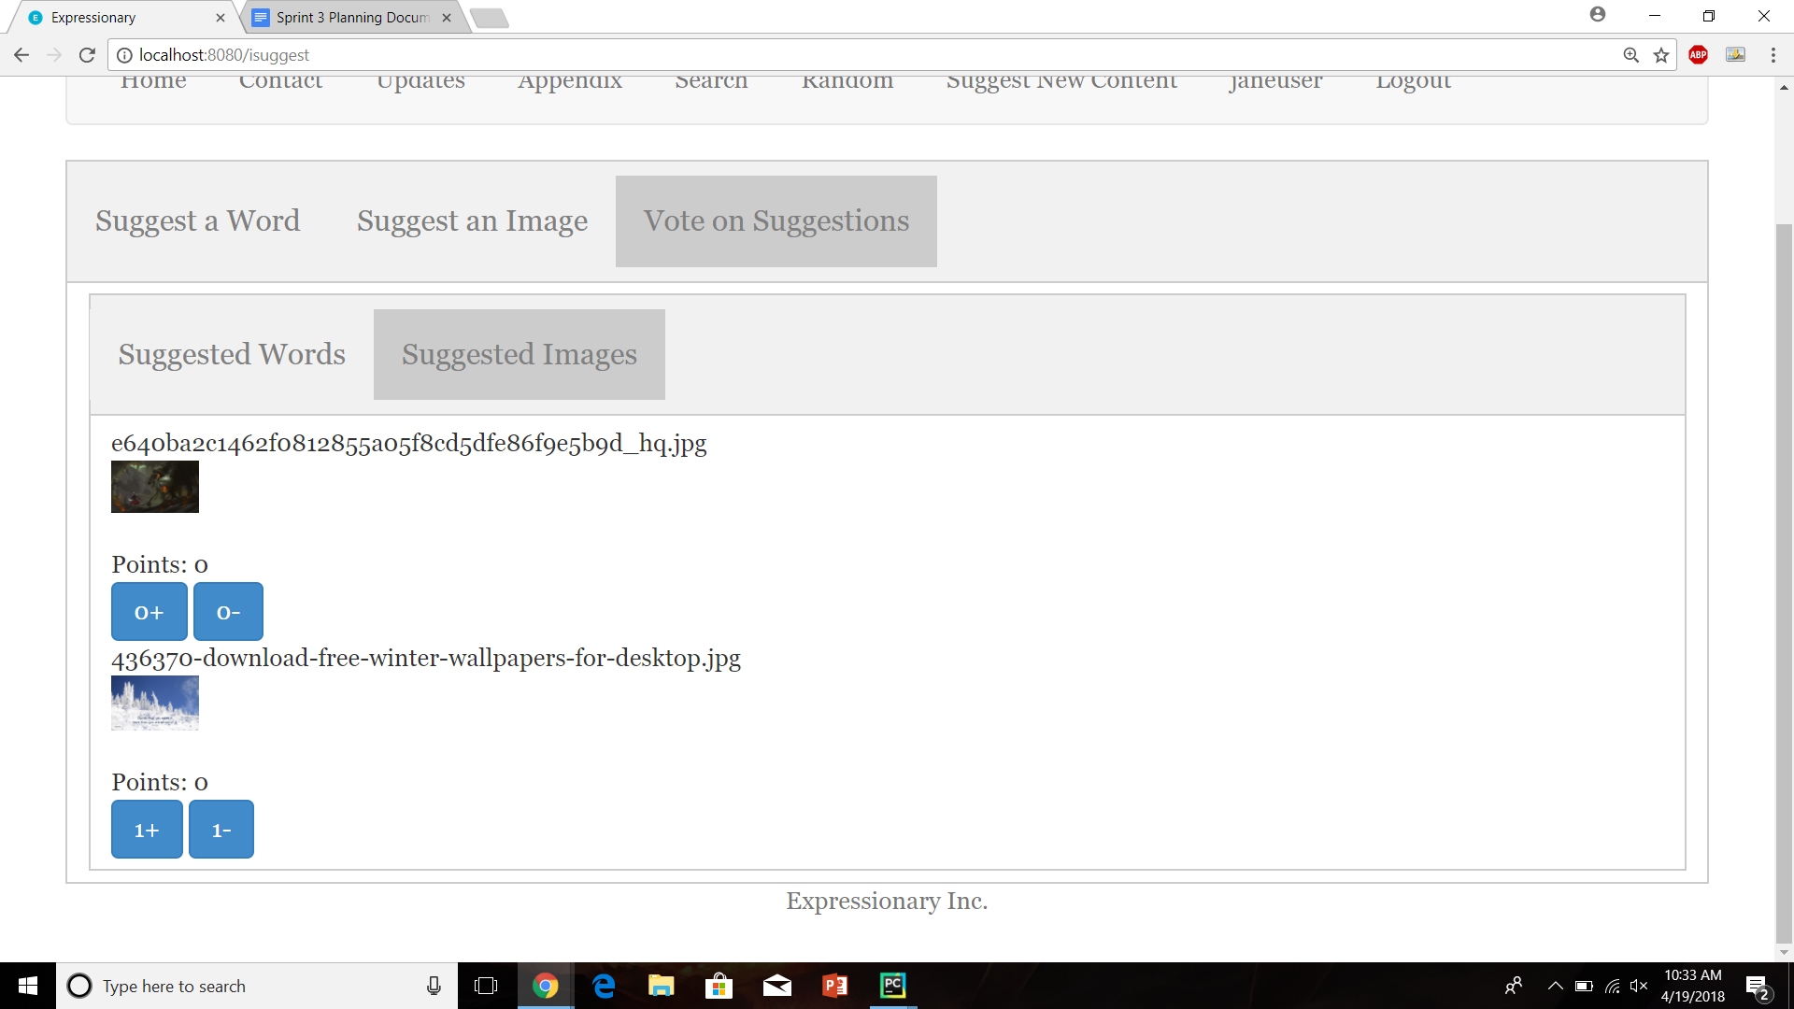

Report the response

**Results:**

The newly suggested image shows up in suggested images for voting after it has been suggested

**Test No.7**

Test to check if suggested word is dropped after receiving down votes by more then 20% of the Expressionary users. (In our case we have 7 total users which means each post requires 2 votes to be rejected)

**Procedure:**

* Navigate to suggest new content page
* Log in and downvote on a word
* Have another user log in and downvote on the same word again
* Check the suggested words tab
* Report the response

**Test**

Navigate to the suggest new content page



Log in and downvote on a word

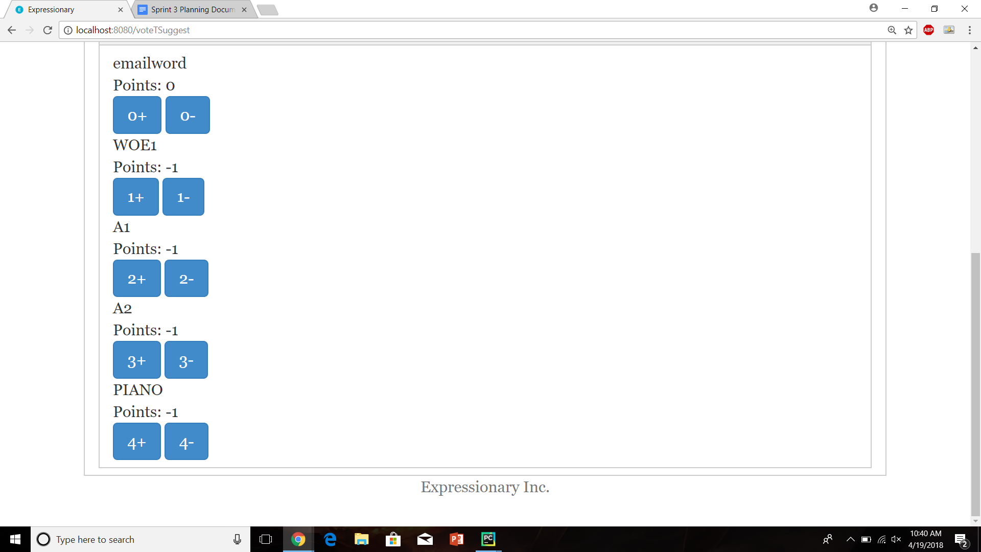

Have another user log in and downvote on the same word again

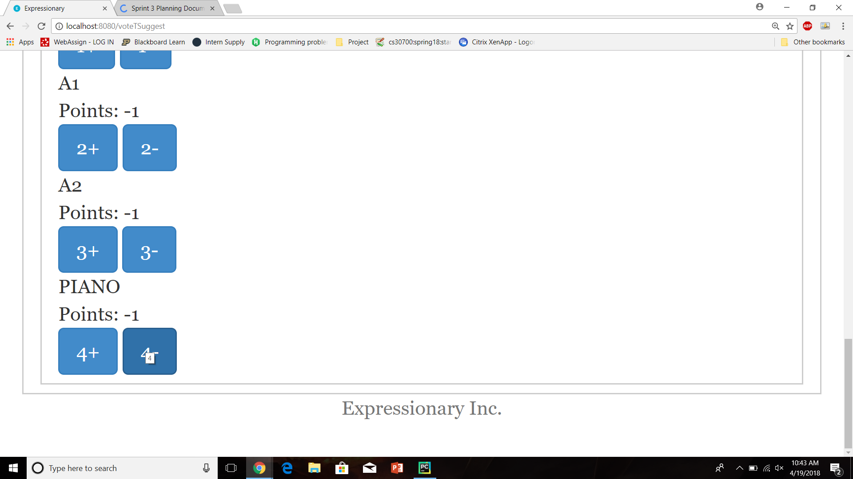

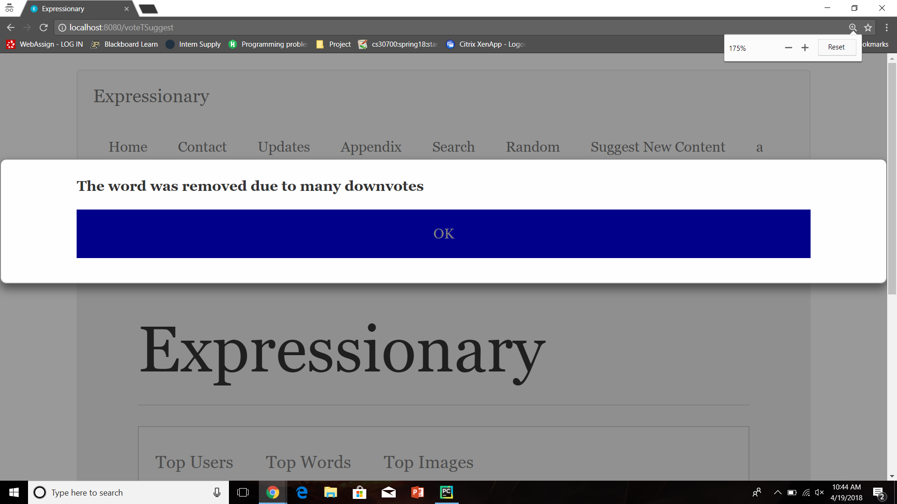

Check the suggested words tab

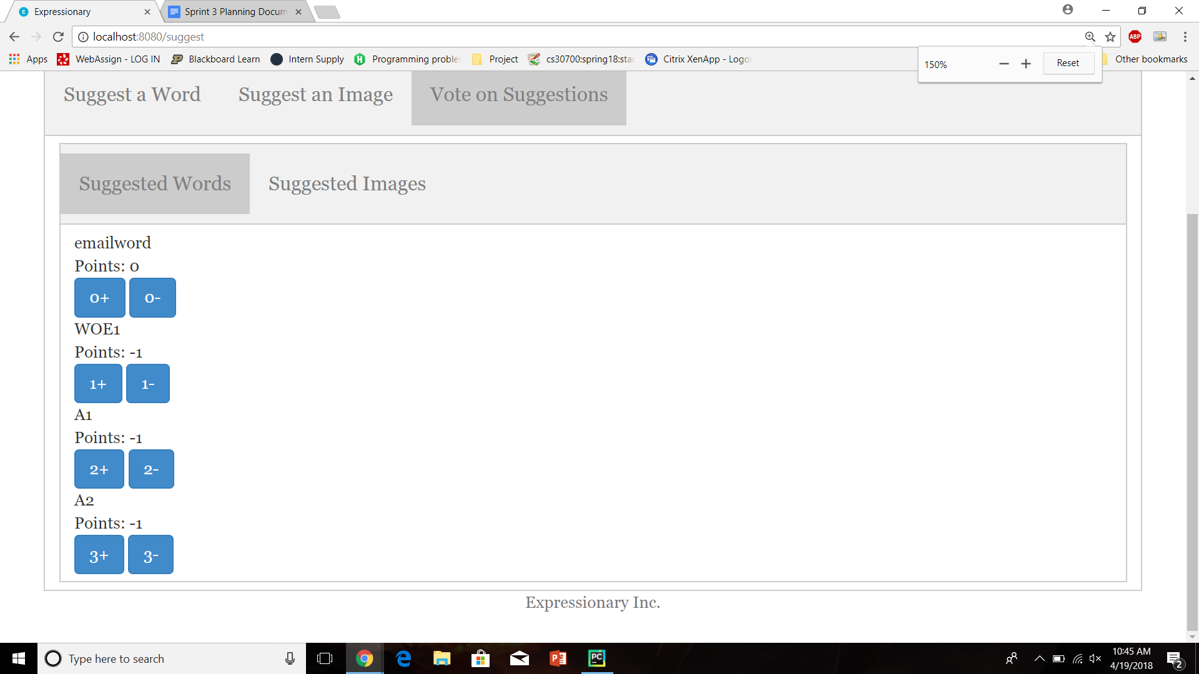

Report the response

**Results:**

The new post was removed after enough (2 in our case) downvotes.

**Test No.8**

Test to check if suggested image is dropped after receiving down votes by more than 20% of the Expressionary users. (In our case we have 7 total users which means each post requires 2 votes to be rejected)

**Procedure:**

* Navigate to suggest new content page
* Log in and downvote on an image
* Have another user log in and downvote on the same image again
* Check the suggested images tab
* Report the response

**Test**

Navigate to the suggest new content page



Log in and downvote on an image

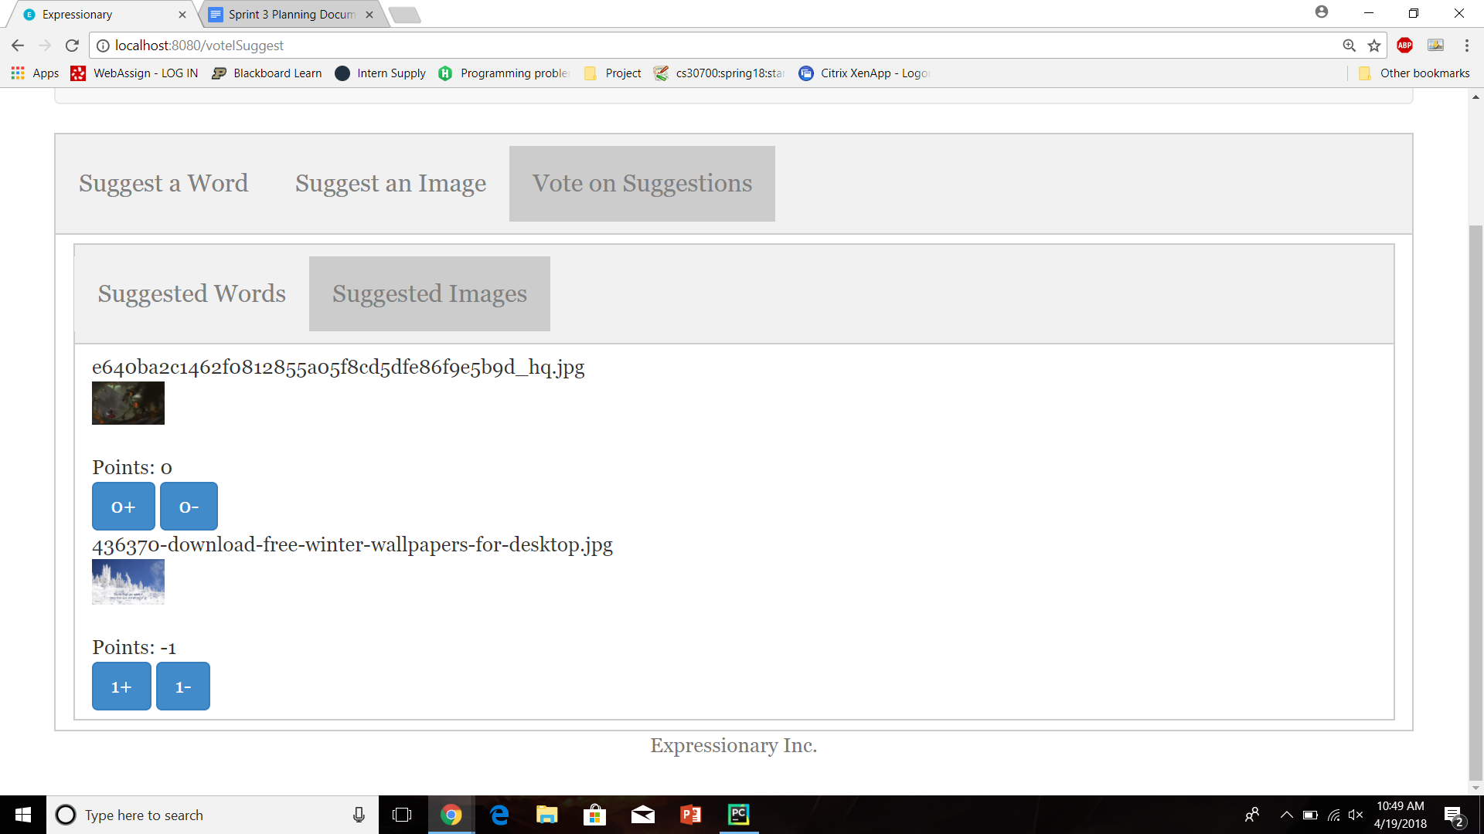

Have another user log in and downvote on the same image again

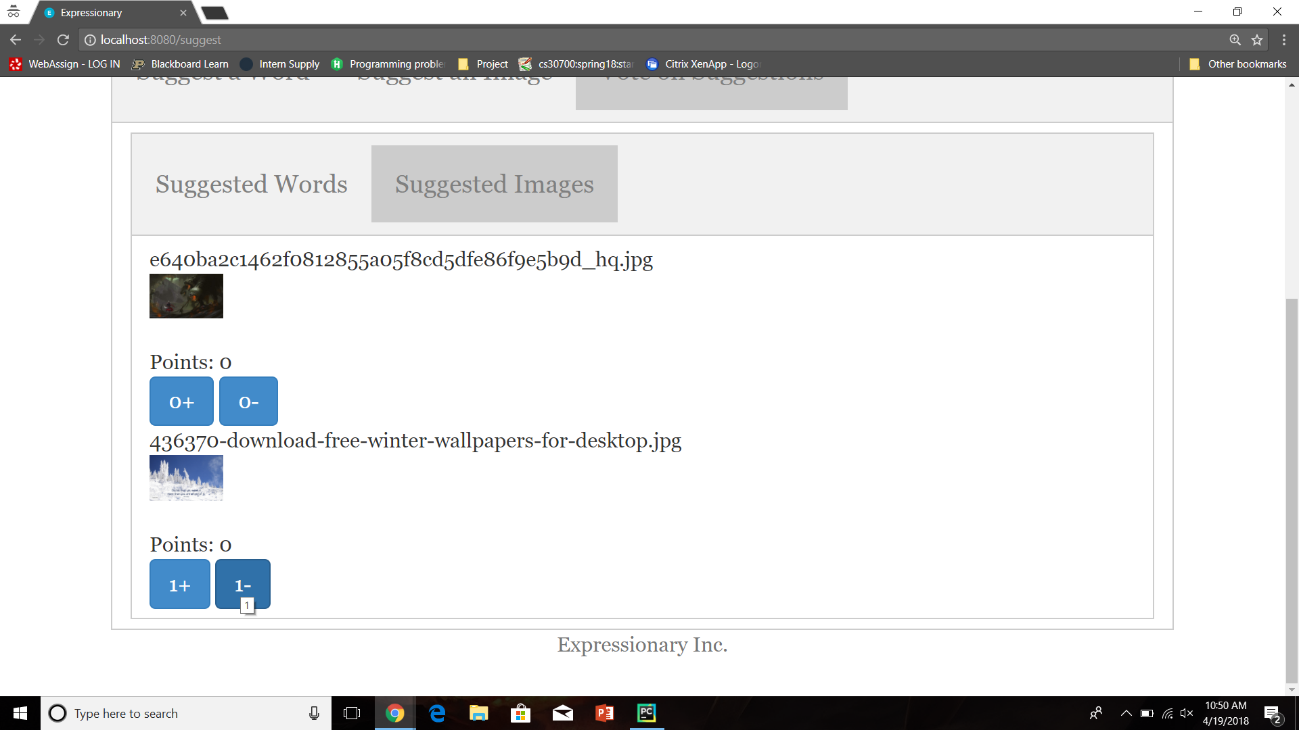

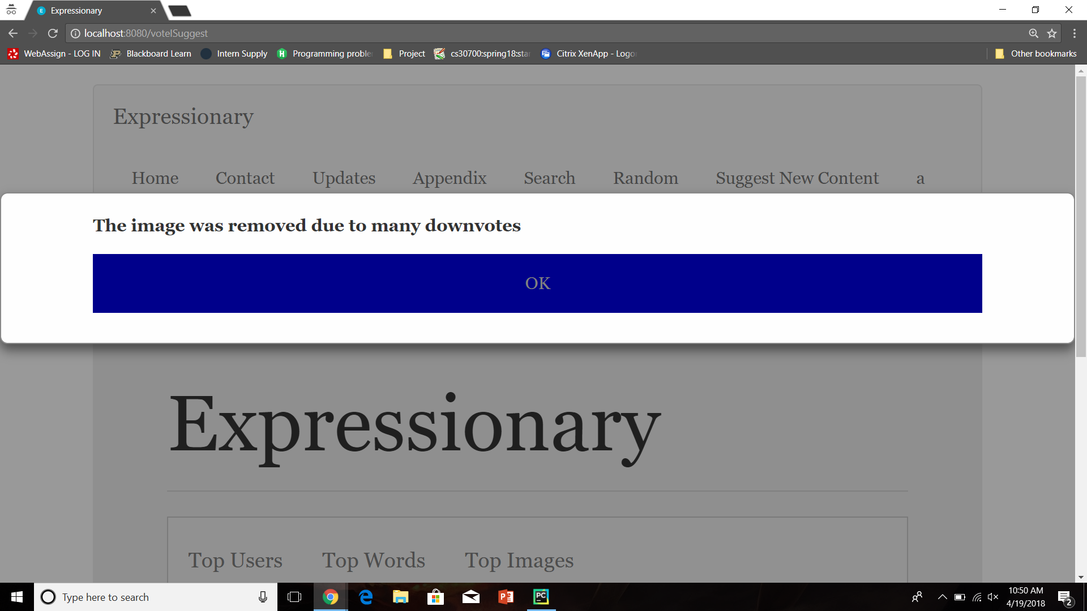

Check the suggested images tab

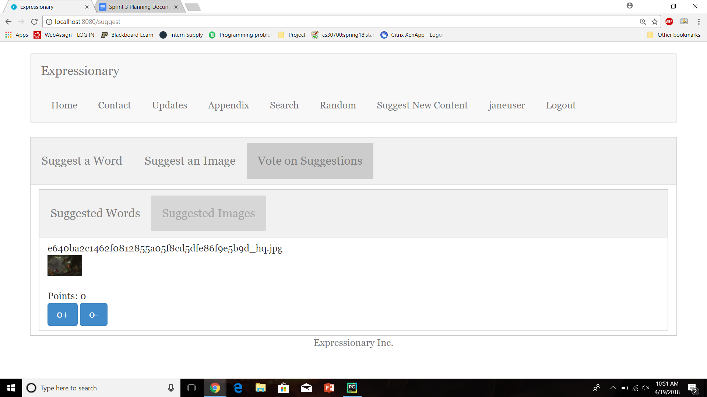

Report the response

**Results:**

The new post was removed after enough (2 in our case) downvotes.

**NOTE: I WILL BE ADDING THE POSTS THAT WERE JUST REMOVED FOR FURTHER TESTING, THIS IS NOT SHOWN IN THE TESTS.**

**Test No.9**

Test to check if suggested word is added to the appendix after receiving up votes by more than 20% of the Expressionary users. (In our case we have 7 total users which means each post requires 2 votes to be accepted)

**Procedure:**

* Navigate to suggest new content page
* Log in and upvote on a word
* Have another user log in and upvote on the same word again
* Check the suggested words tab
* Report the response

**Test**

Navigate to the suggest new content page



Log in and upvote on a word

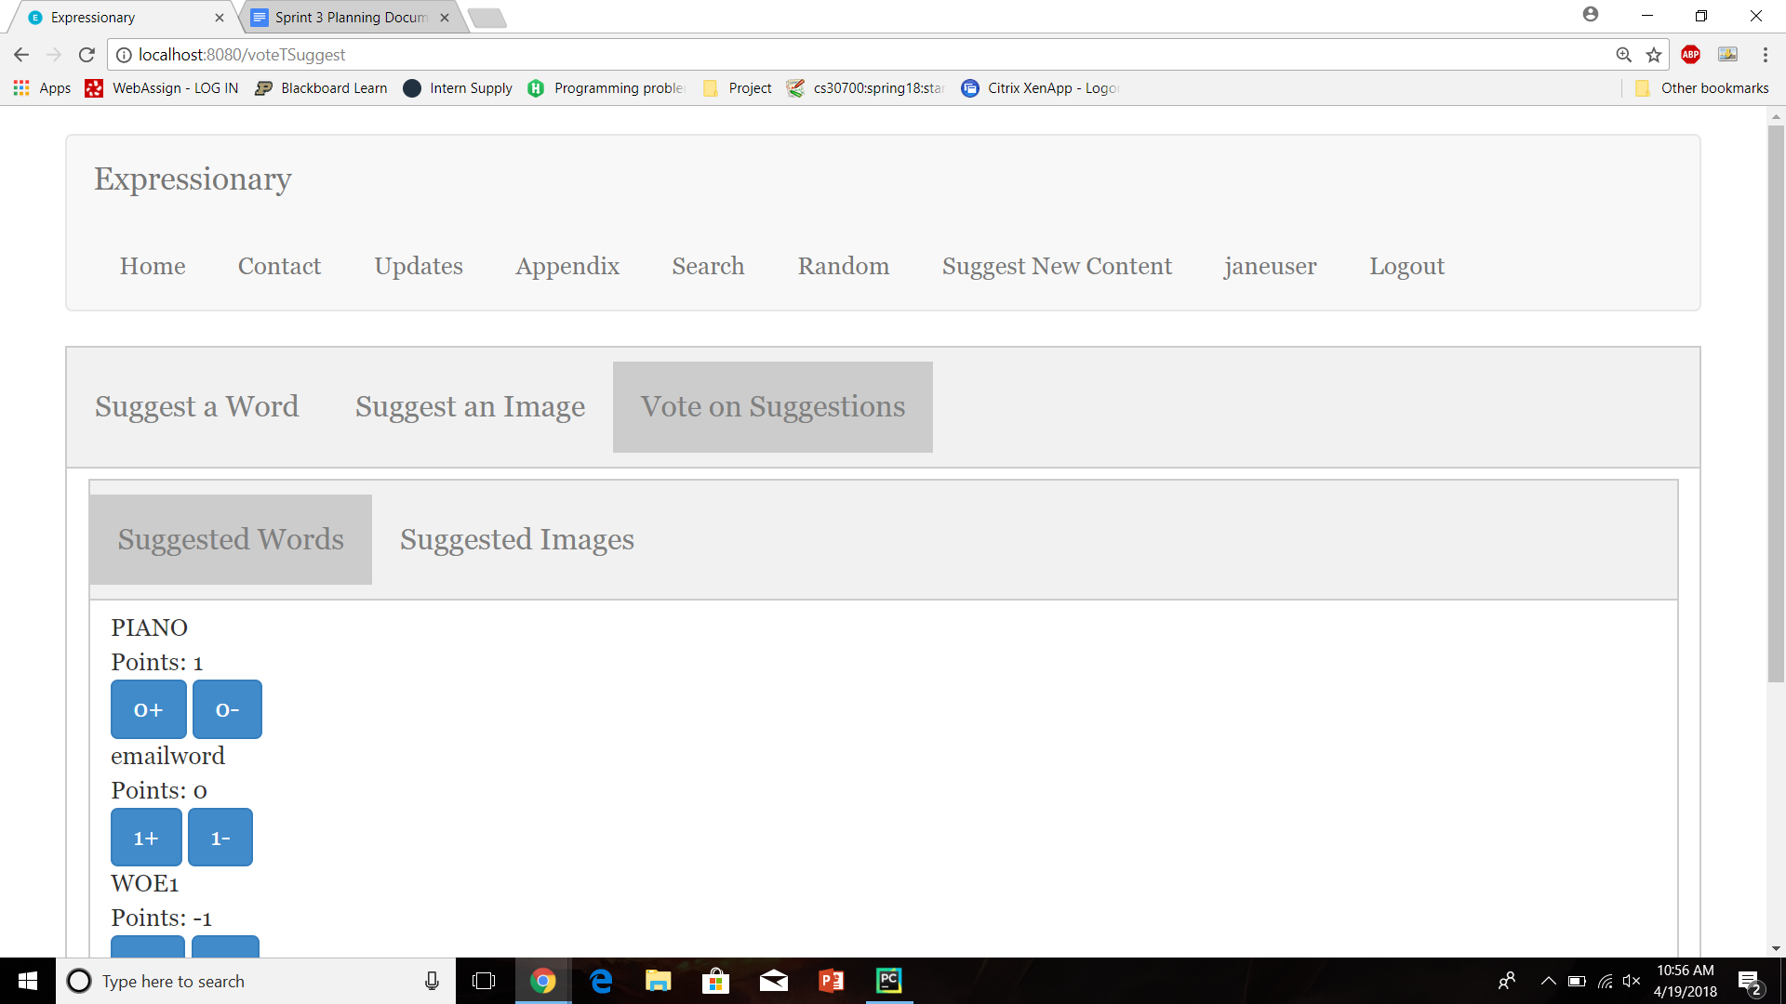

Have another user log in and upvote on the same word again

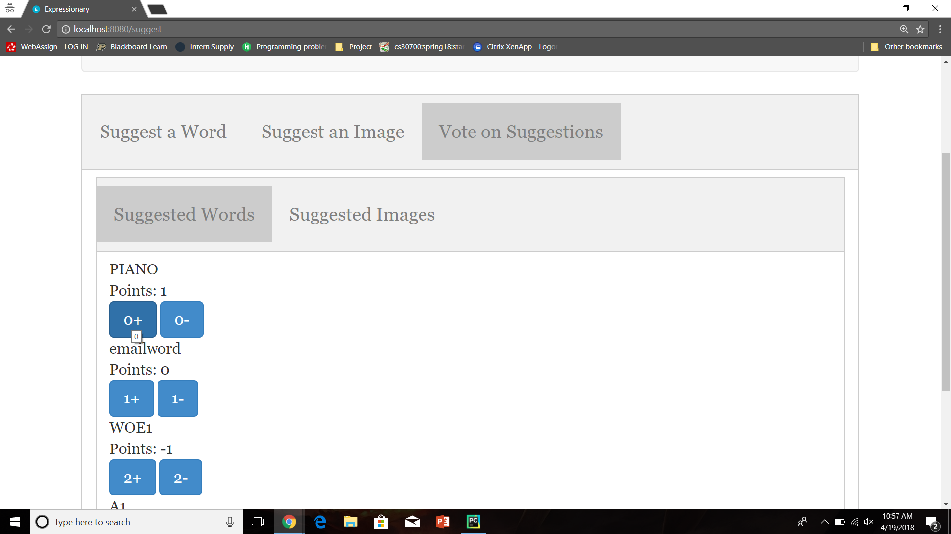

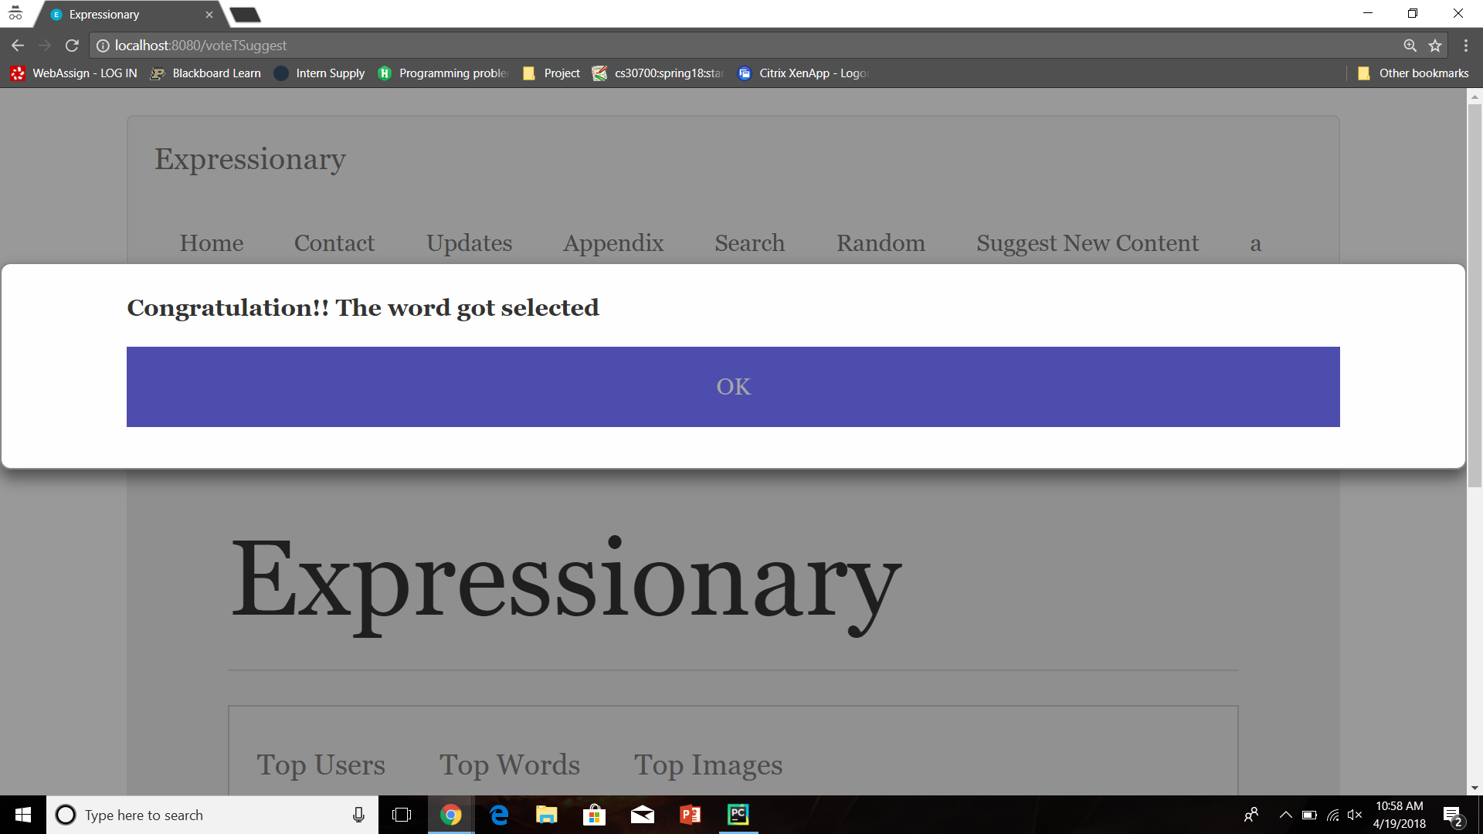

Check the suggested words tab

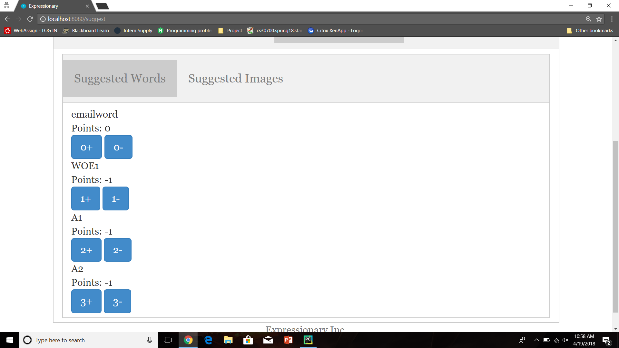

**Results:**

The new post was removed from suggestions after enough (2 in our case) upvotes.

**Test No.10**

Test to check if suggested image is added to the appendix after receiving up votes by more than 20% of the Expressionary users. (In our case we have 7 total users which means each post requires 2 votes to be accepted)

**Procedure:**

* Navigate to suggest new content page
* Log in and upvote on an image
* Have another user log in and upvote on the same image again
* Check the suggested images tab
* Report the response

**Test**

Navigate to the suggest new content page



Log in and upvote on an image

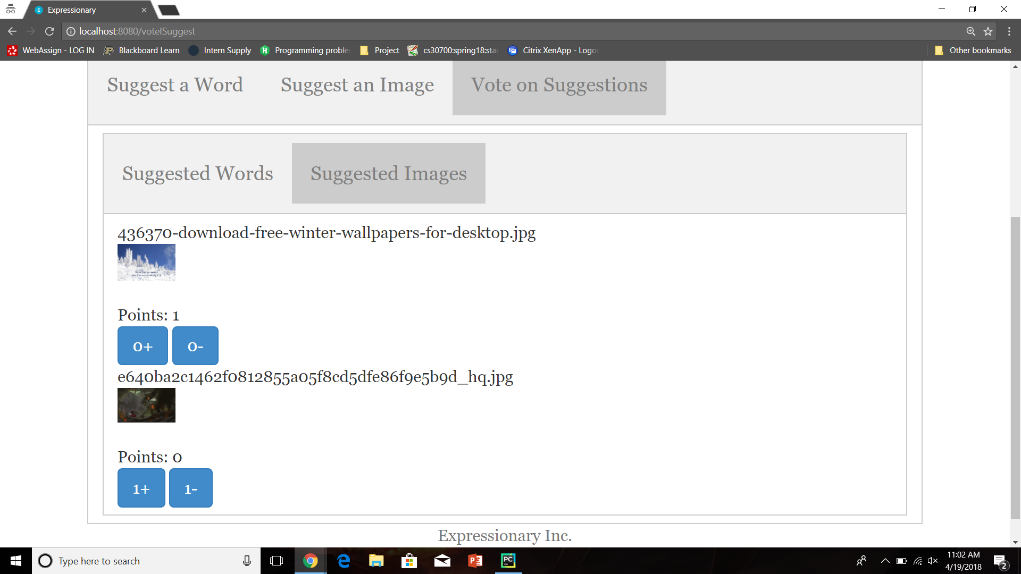

Have another user log in and upvote on the same image again

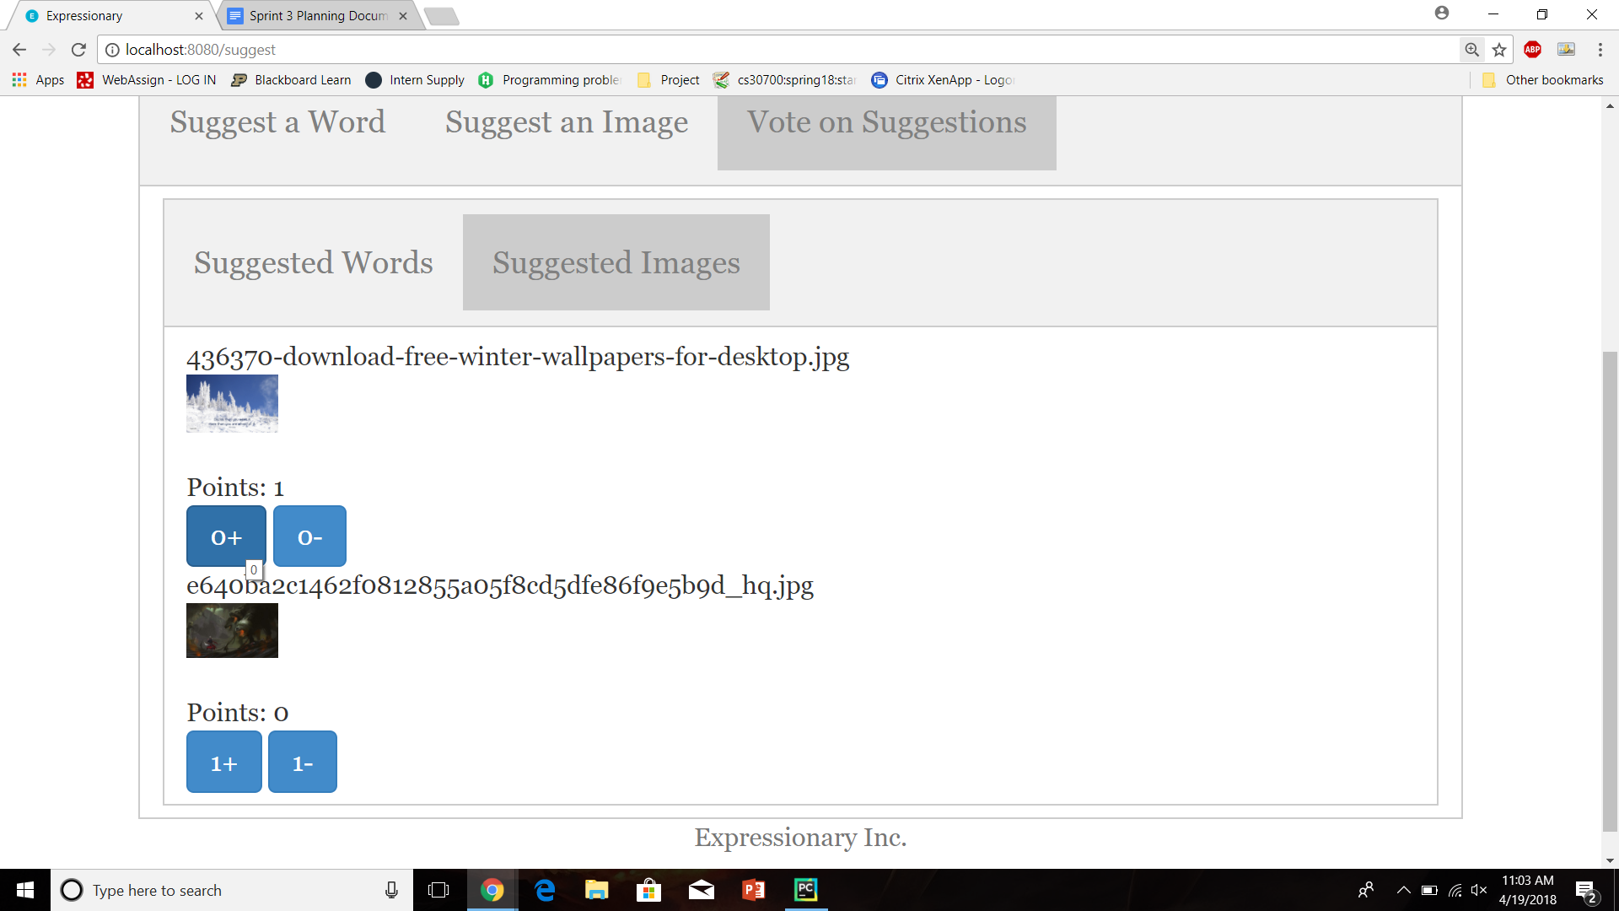

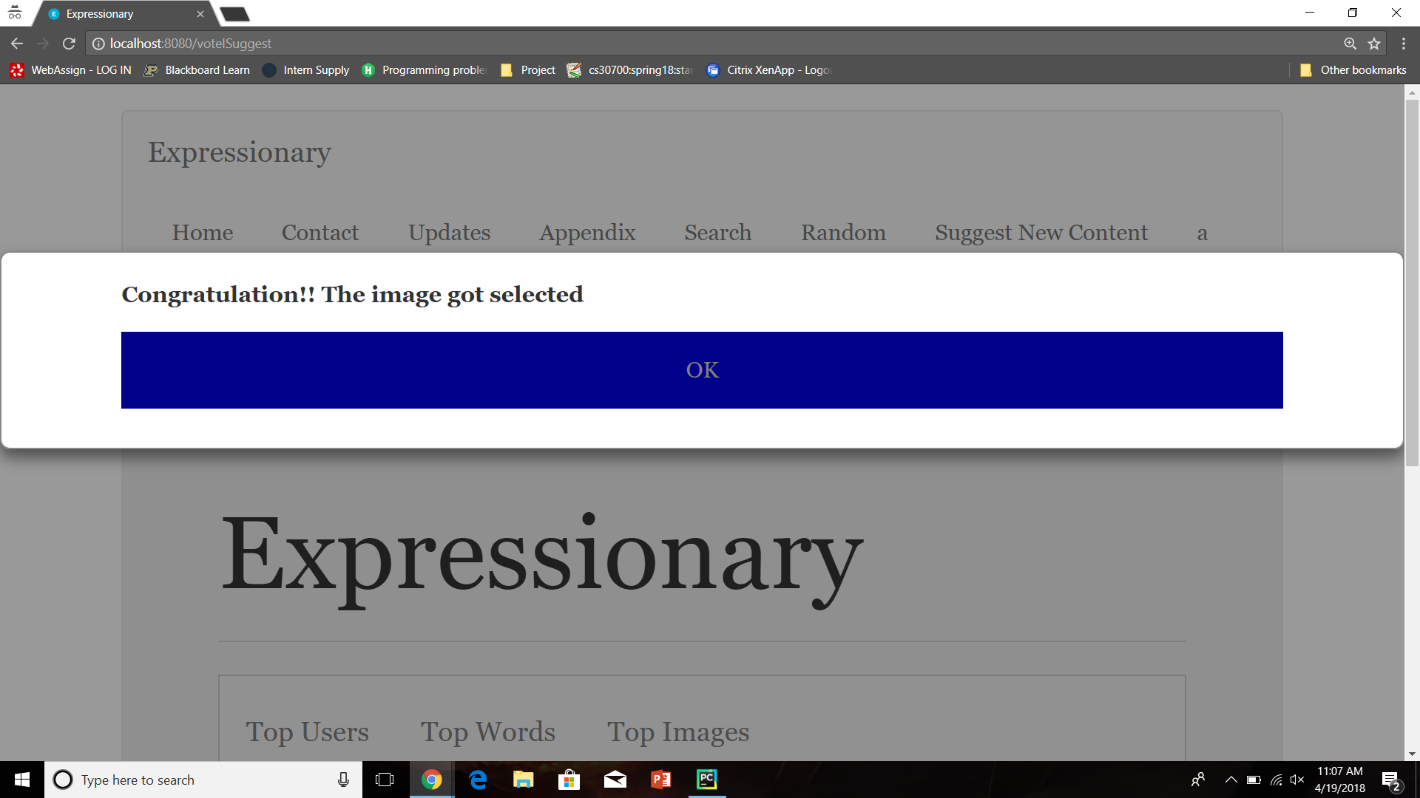

Check the suggested images tab

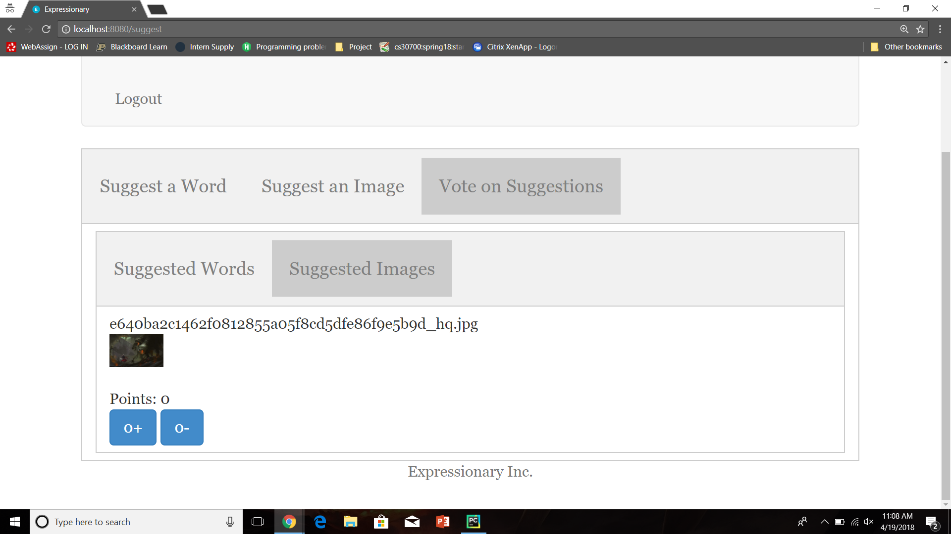

**Results:**

The new post was removed from suggestions after enough (2 in our case) upvotes.

**Test No. 11**

Test to check if the new word that received enough upvotes was added to the word list for the webpage (Check the appendix).

**Procedure:**

* Navigate to the appendix
* Click on the words tab, look for the newly upvoted word(Piano)
* Report the response

**Test**

Navigate to the suggest new content page

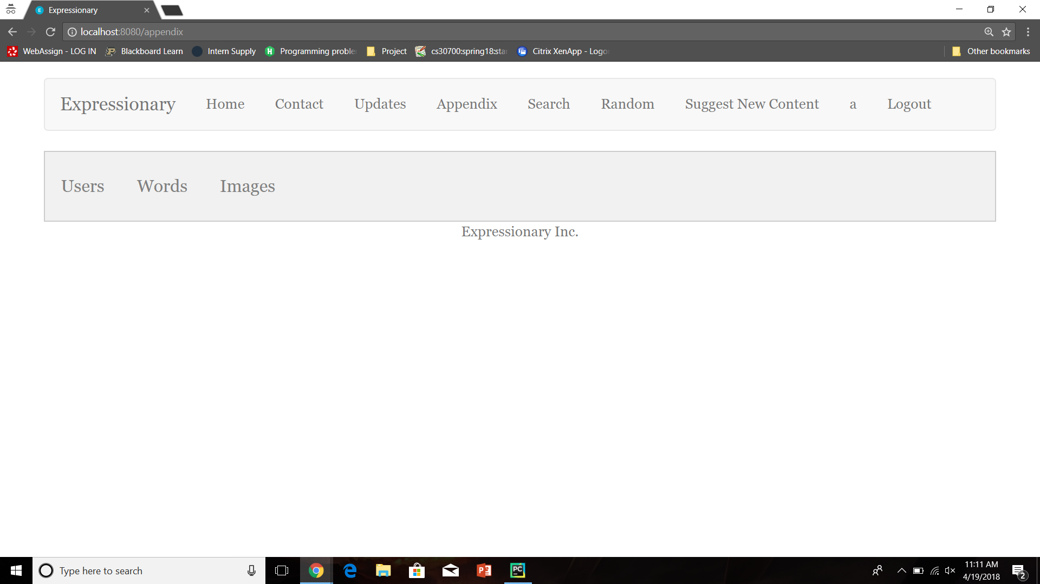

Check the words tab

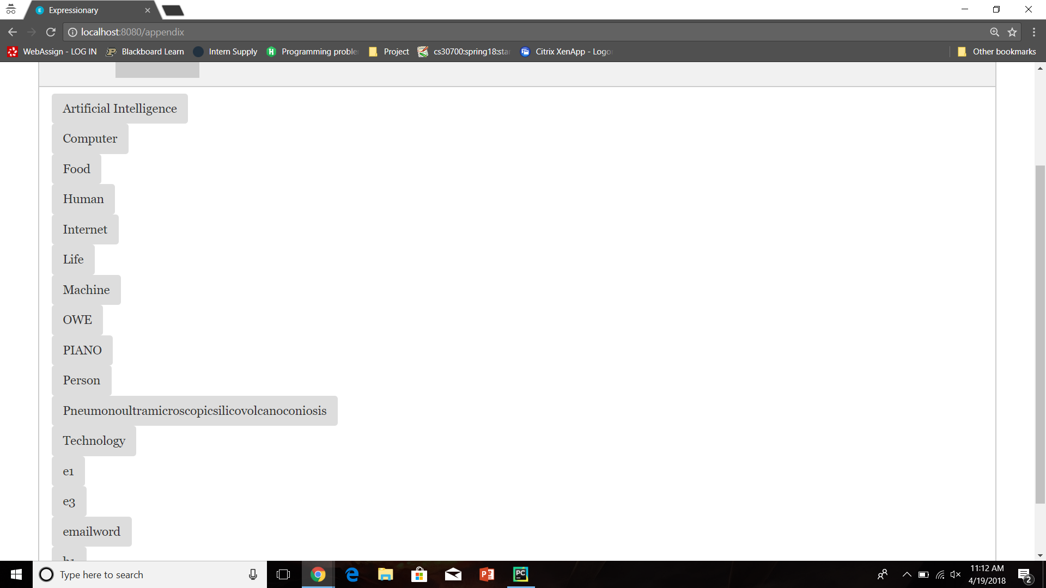

Report the response

**Results:**

The newly added word exists in the appendix, it was successfully added to the website

**Test No. 11**

Test to check if the new image that received enough upvotes was added to the image list for the webpage (Check the appendix).

**Procedure:**

* Navigate to the appendix
* Click on the image tab, look for the newly upvoted image(Wallpaper)
* Report the response

**Test**

Navigate to the suggest new content page



Check the images tab

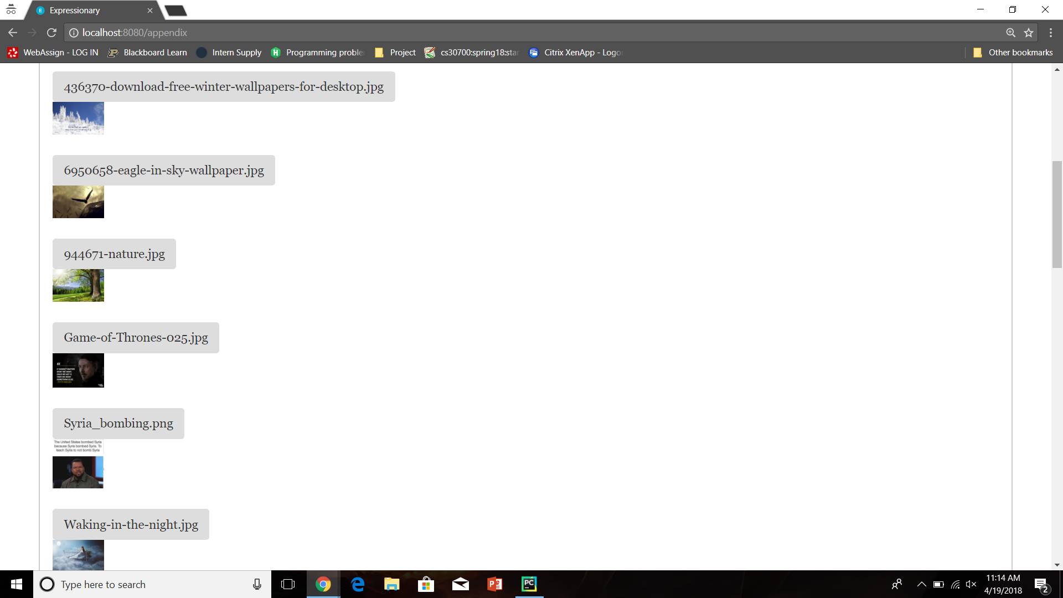

Report the response

**Results:**

The newly added image exists in the appendix, it was successfully added to the website

**USER STORY # 7**

**Test No.1**

There are clickable buttons on the leaderboard instead of just plain text

**Procedure:**

* Navigate to the home page
* Check the leaderboard
* Report the response

**Test**

Navigate to the home page and check the leaderboard

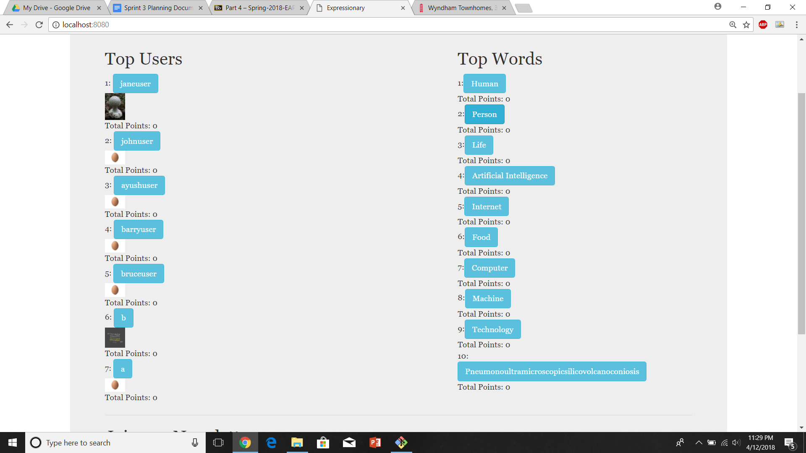

Report the response

**Results:**

All the words and users on the leaderboard appear to be clickable

**Test No.2**

Clicking on a word takes you to the appropriate word page

**Procedure:**

* Navigate to the home page
* Click on a word in the leaderboard
* Report the response

**Test**

Navigate to the home page and check for logout button



Click on a word (in our case “Human”)

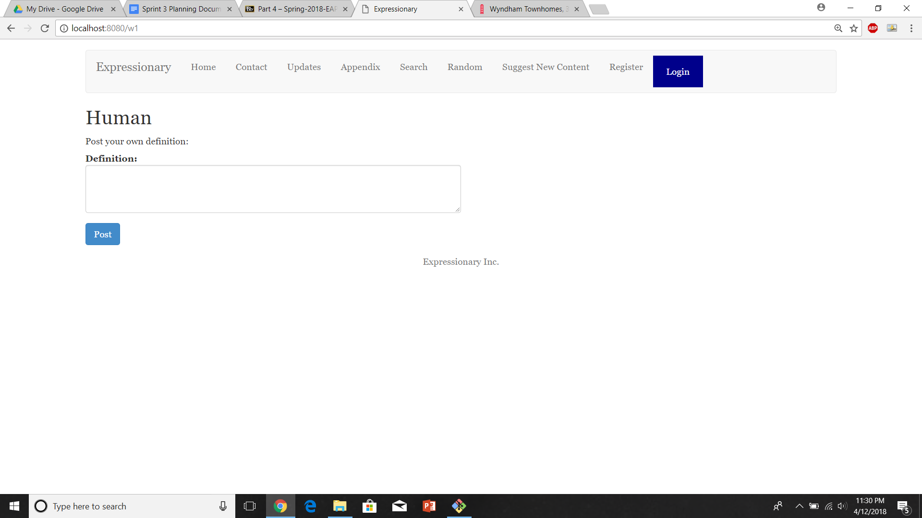

Report the response

**Results:**

Clicking on the word takes you to the correct word page

**Test No.3**

Clicking on multiple words back and worth should still work the same

**Procedure:**

* Navigate to the home page
* Click on a word from the leaderboard
* Repeat a few times
* Report the response

**Test**

Navigate to the home page



Select a word and repeat

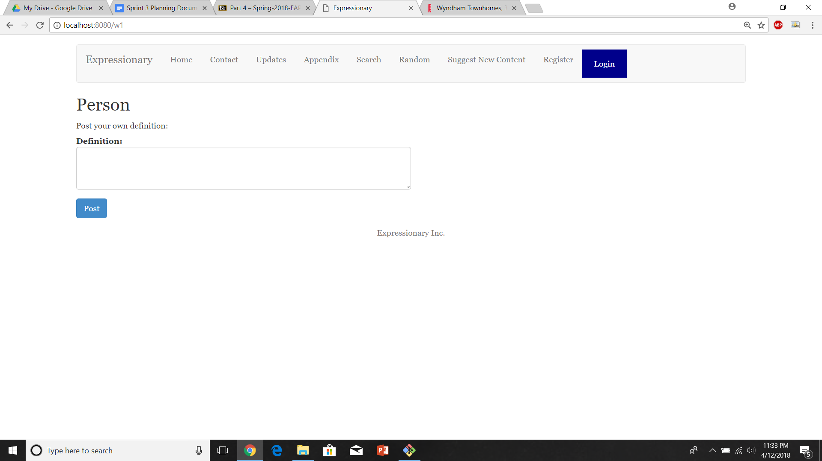

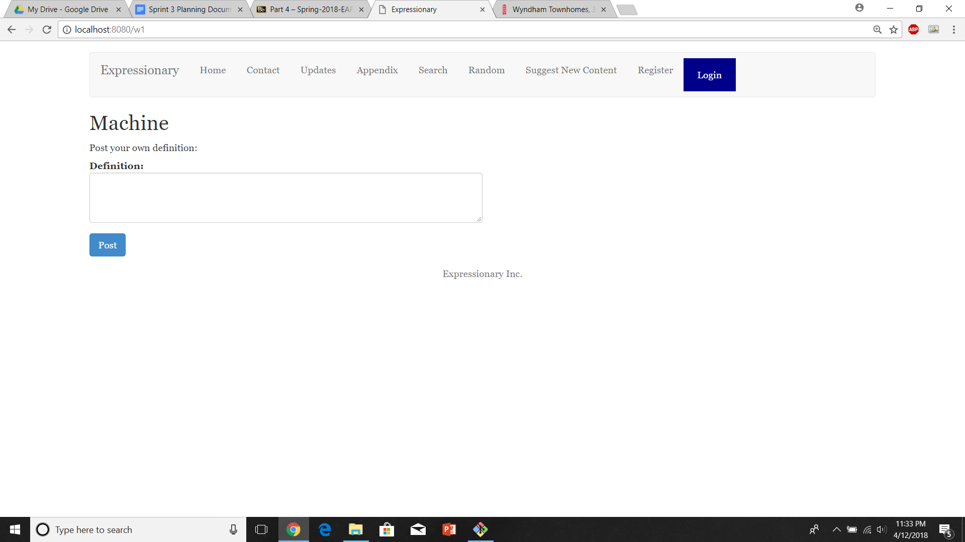

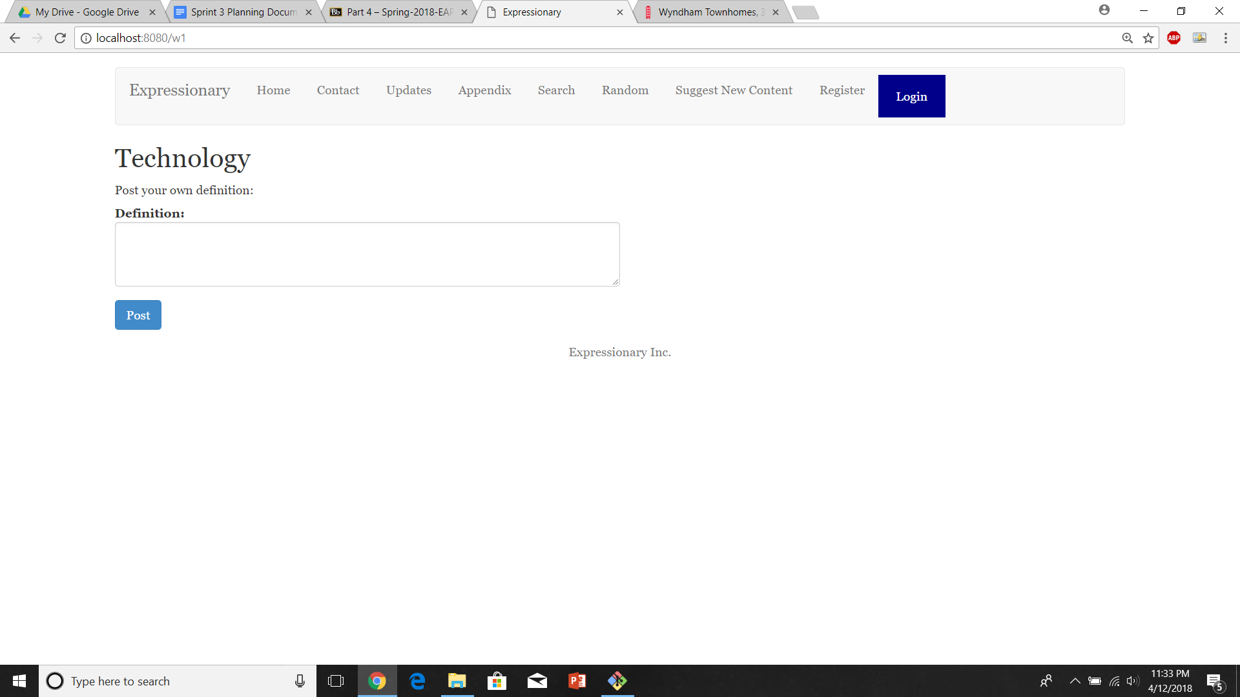

Report the response

**Results:**

Clicking on multiple words back and forth still works the same way and we can easily navigate to any webpage

**Test No.4**

Clicking on a user takes you to the appropriate user page

**Procedure:**

* Navigate to the home page
* Click on a user in the leaderboard
* Report the response

**Test**

Navigate to the home page and check for logout button



Click on a user (in our case “johnuser”)

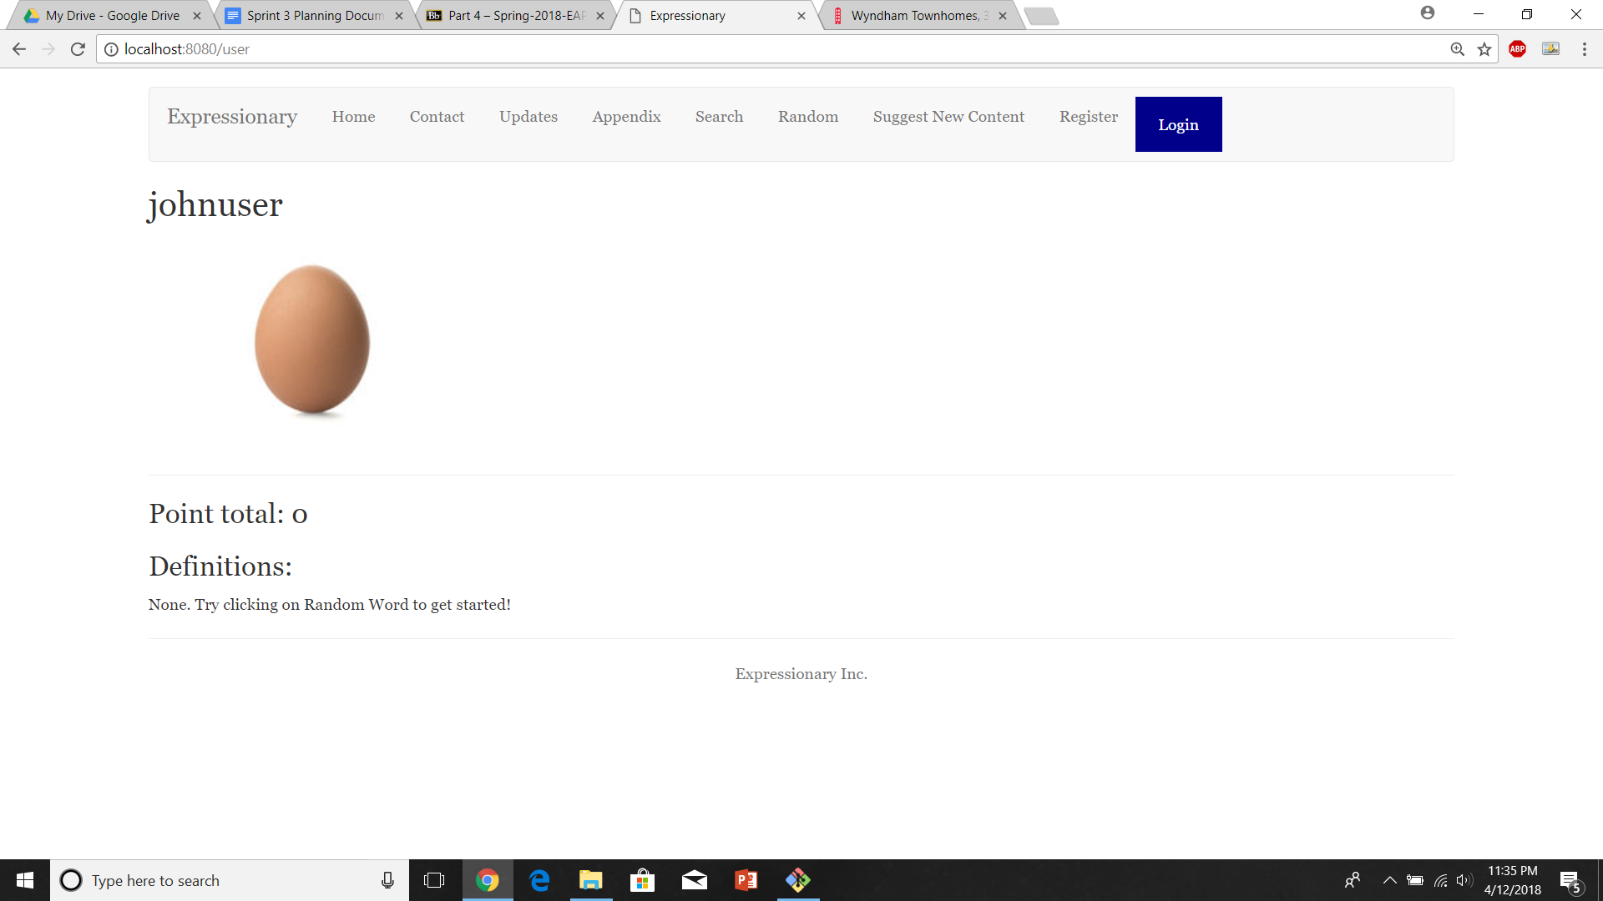

Report the response

**Results:**

Clicking on the user takes you to the correct user page

**Test No.5**

Clicking on multiple users back and worth should still work the same

**Procedure:**

* Navigate to the home page
* Click on a user from the leaderboard
* Repeat a few times
* Report the response

**Test**

Navigate to the home page



Select a user and repeat

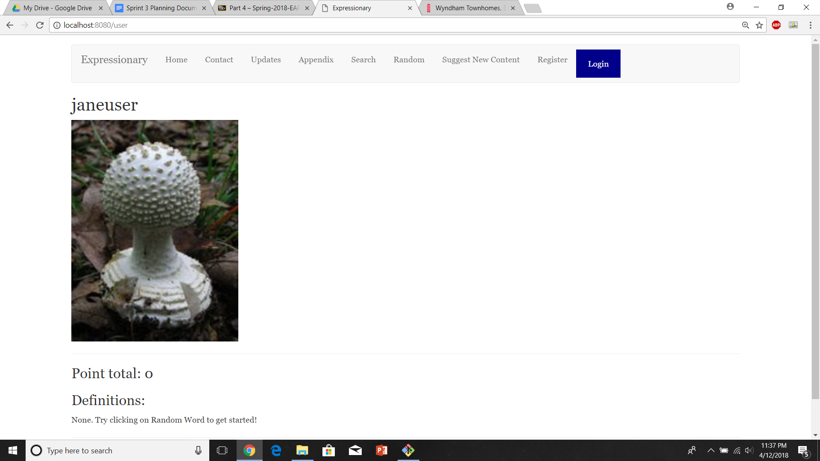

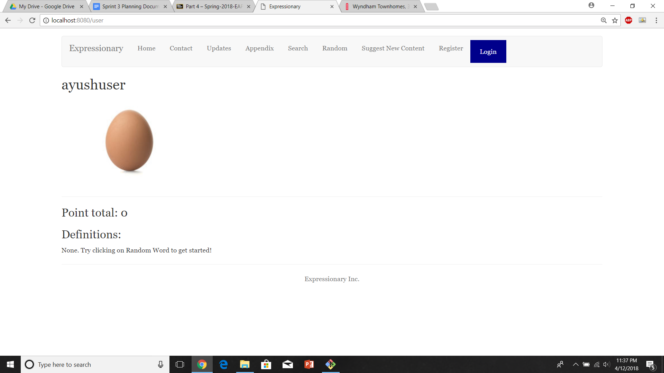

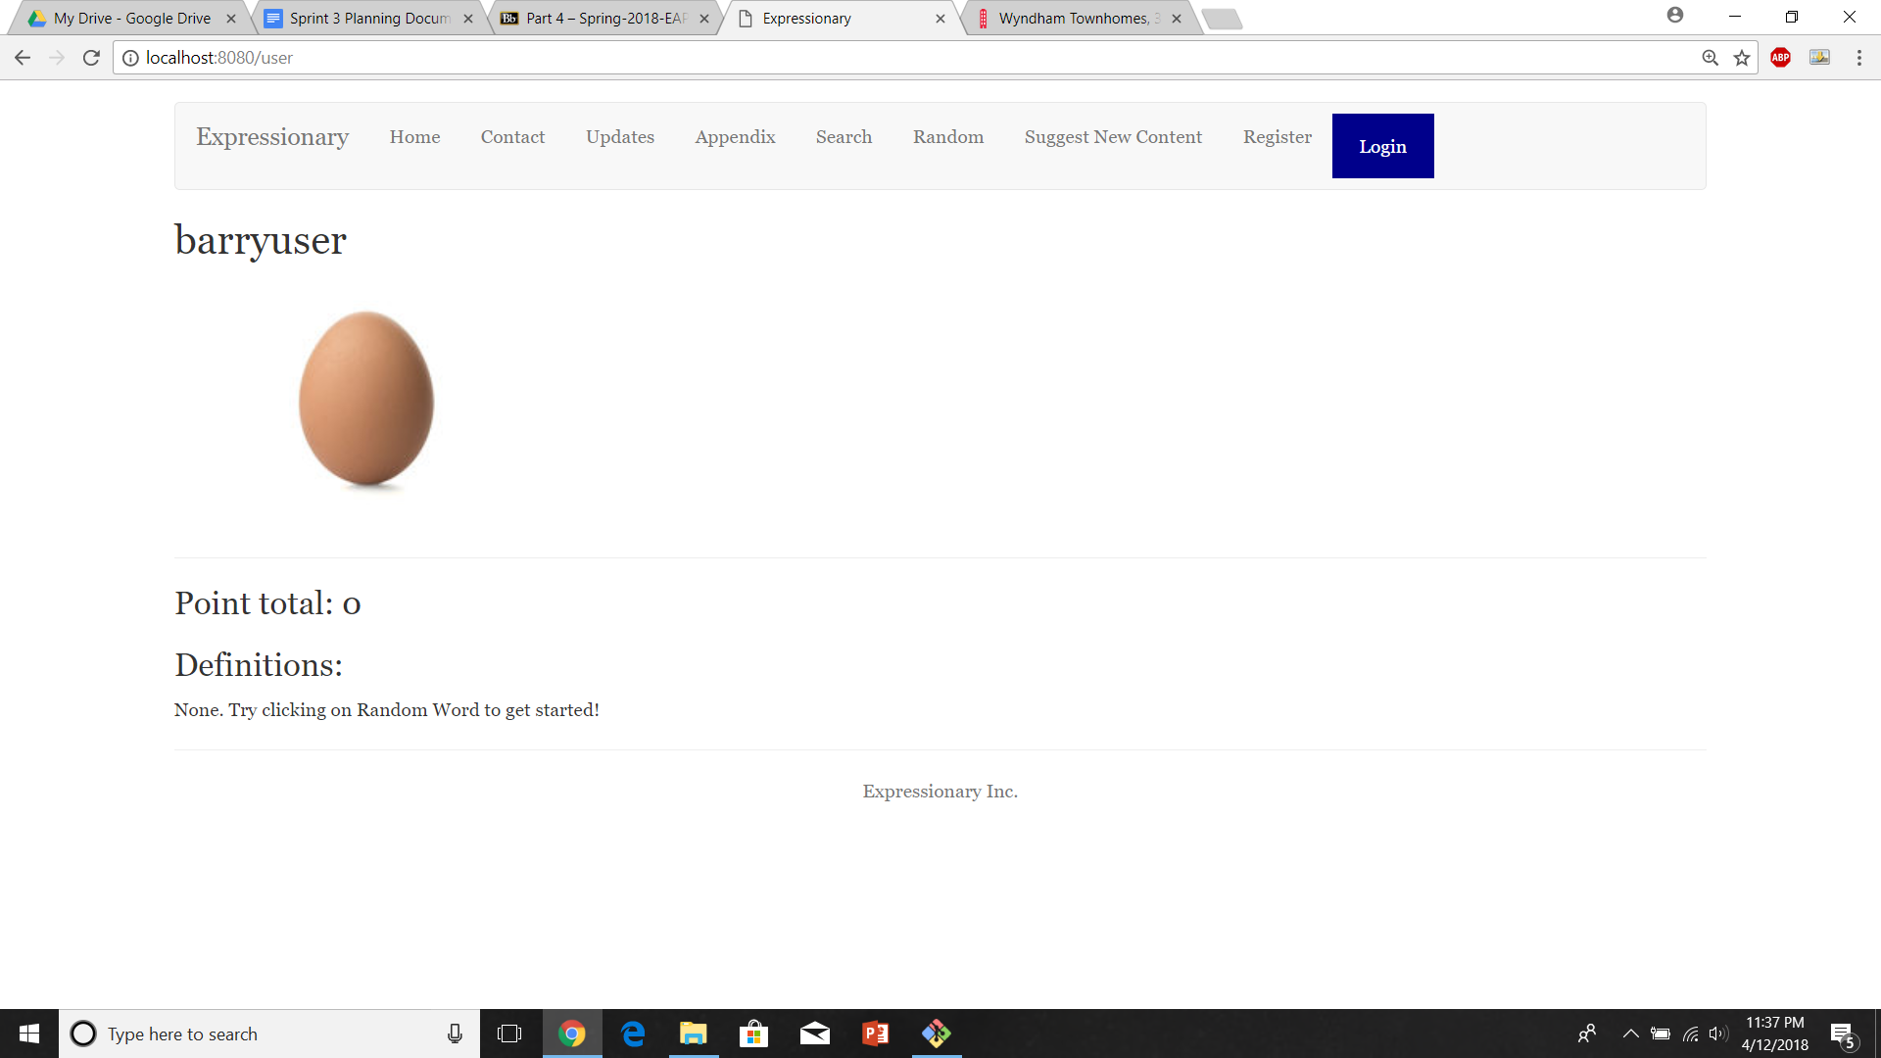

Report the response

**Results:**

Clicking on multiple users back and forth still works the same way and we can easily navigate to any user page.

**Test No.6**

Verify that A leaderboard for content other than word (images) exists.

**Procedure:**

* Navigate to the home page
* Check for an image leaderboard
* Report the response

**Test**

Navigate to the home page and check for image leaderboard

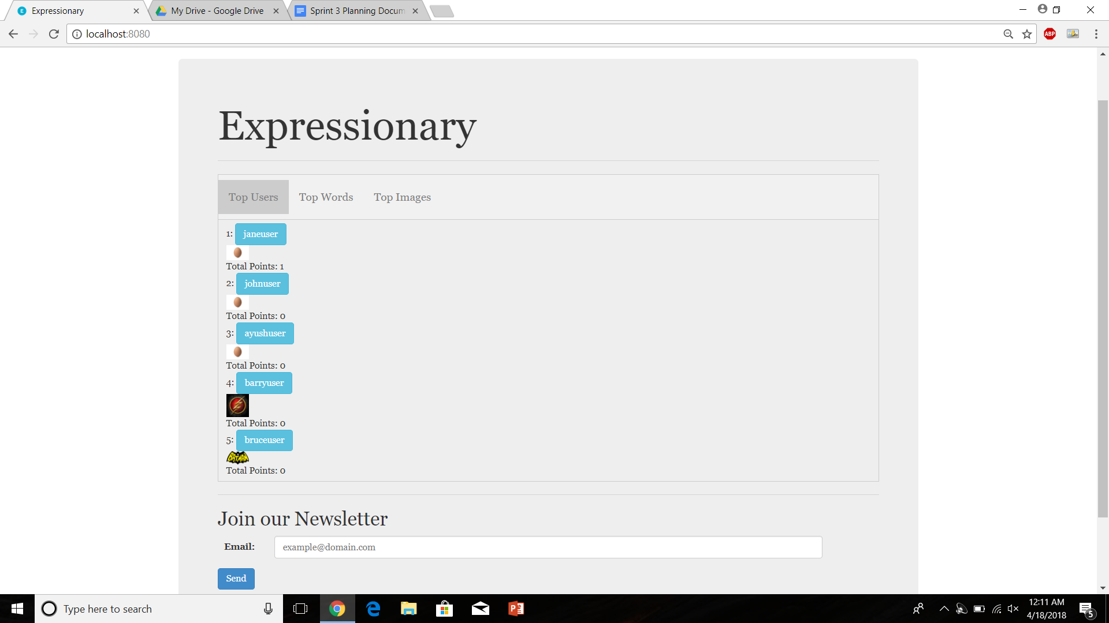

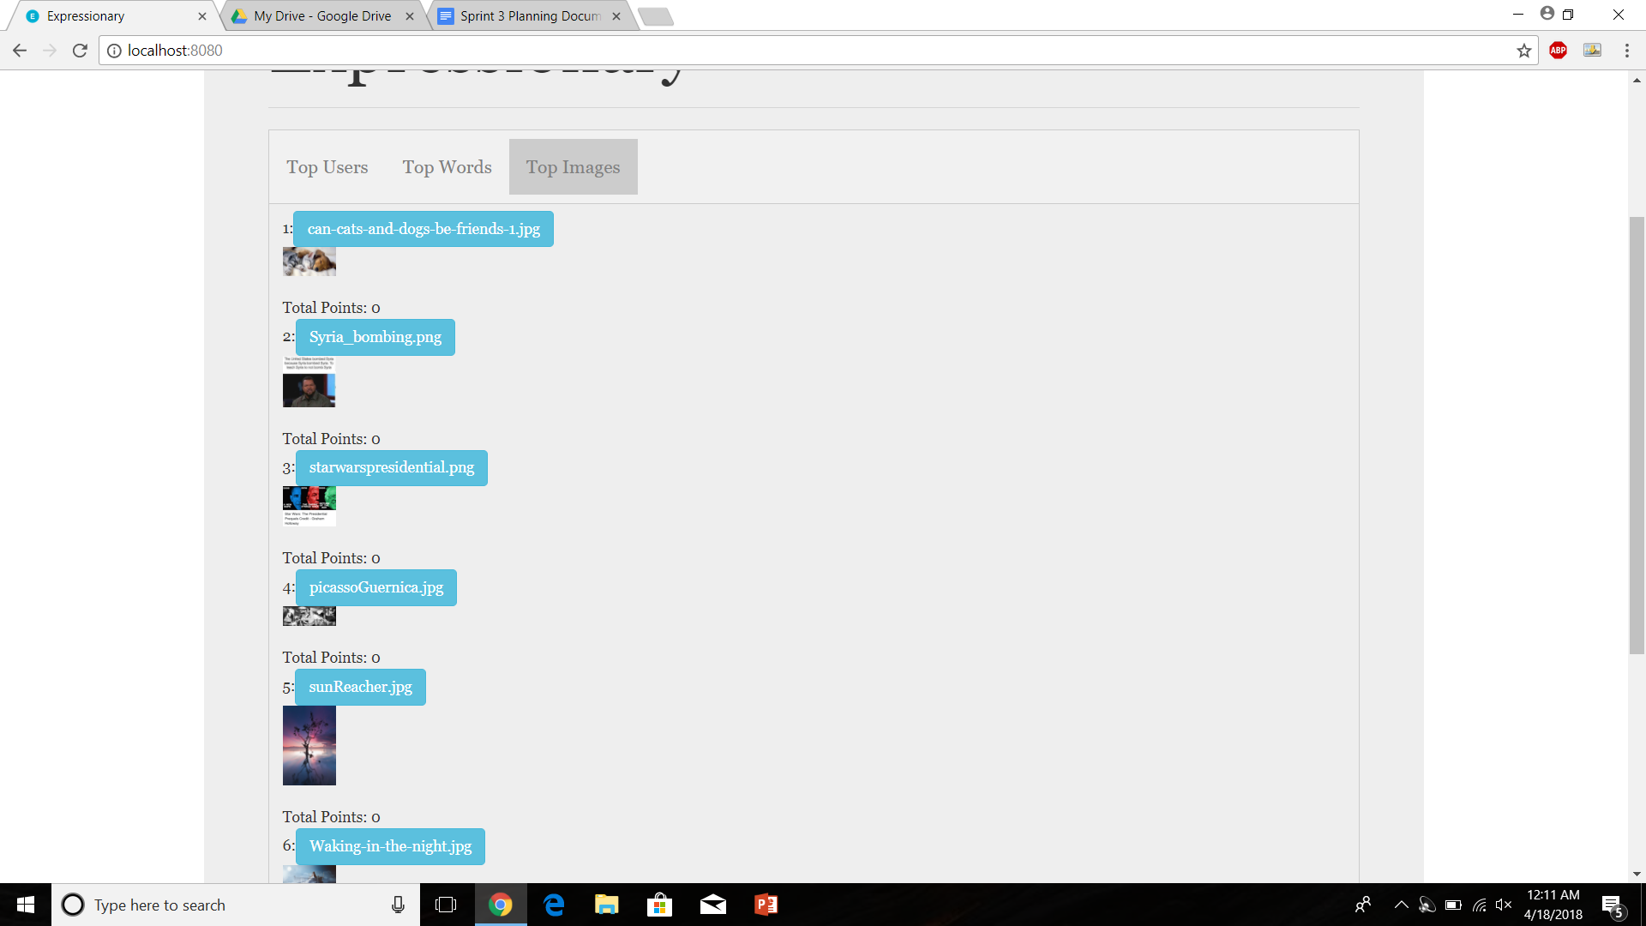

Report the response

**Results:**

Image leaderboard exists, shows all the images with their point total.

**Test No.7**

Clicking on an image takes you to the appropriate image page

**Procedure:**

* Navigate to the home page
* Click on an image in the leaderboard
* Report the response

**Test**

Navigate to the home page and check for logout button

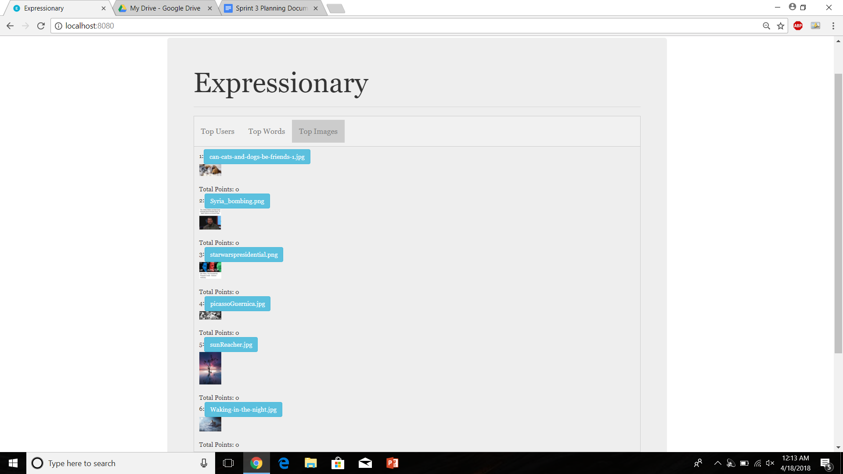

Click on an image (in our case “starwarspresidential.png”)

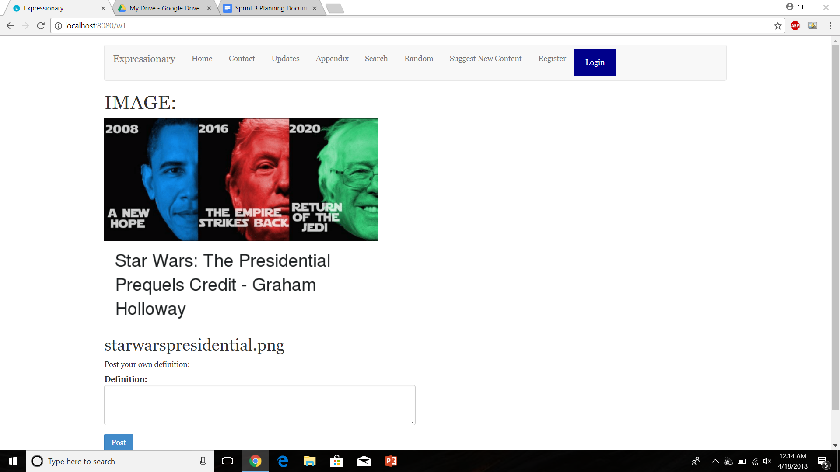

Report the response

**Results:**

Clicking on the image takes you to the correct image page

**Test No.8**

Clicking on multiple images takes you to their appropriate pages without breaking

**Procedure:**

* Navigate to the home page
* Click on an image in image leaderboard
* Navigate back to home
* Repeat a few times
* Report the response

**Test**

Navigate to the home page and check for logout button



Click on an image

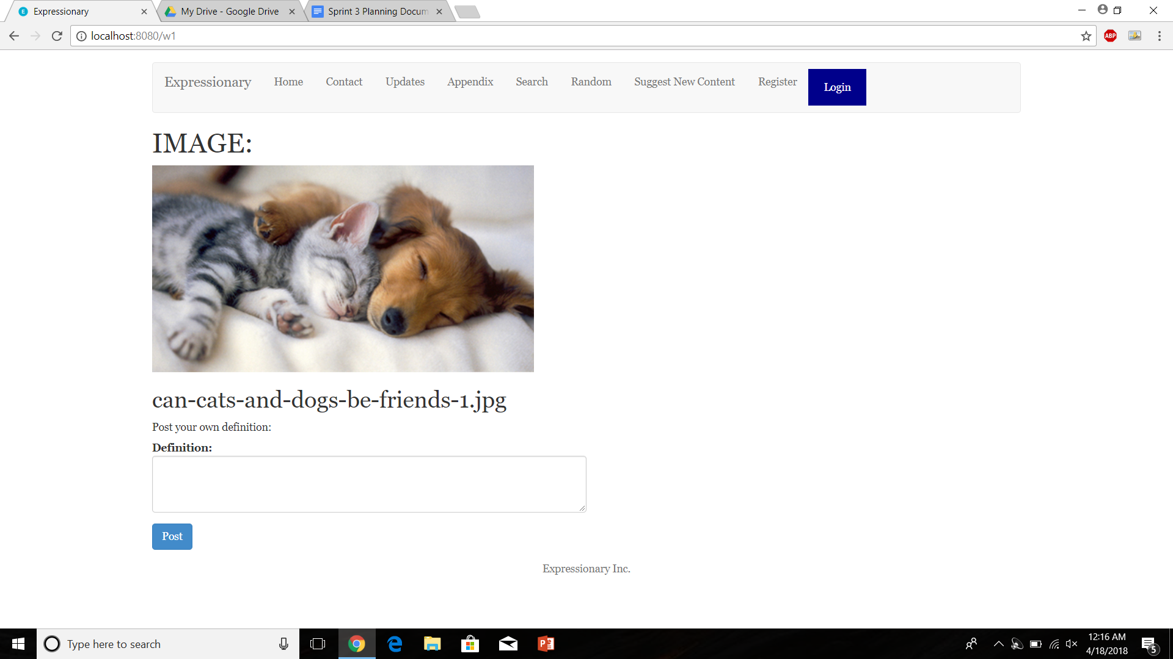

Repeat a few times



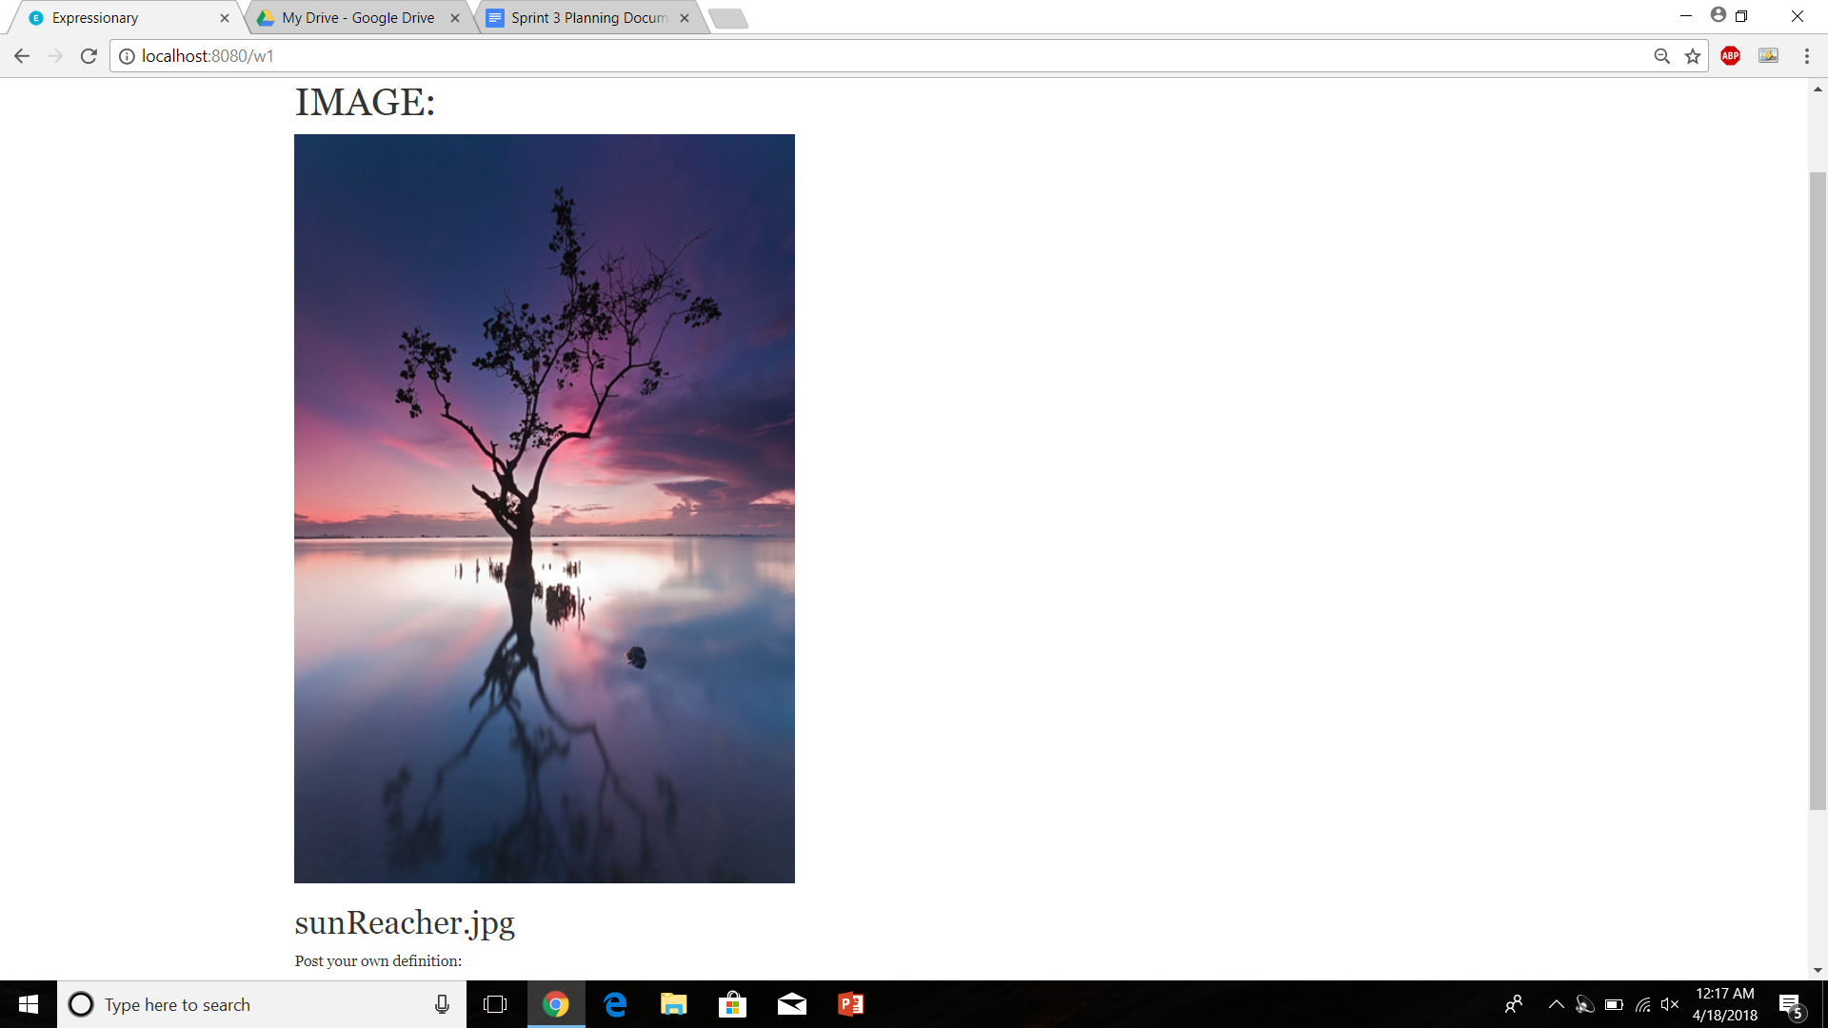

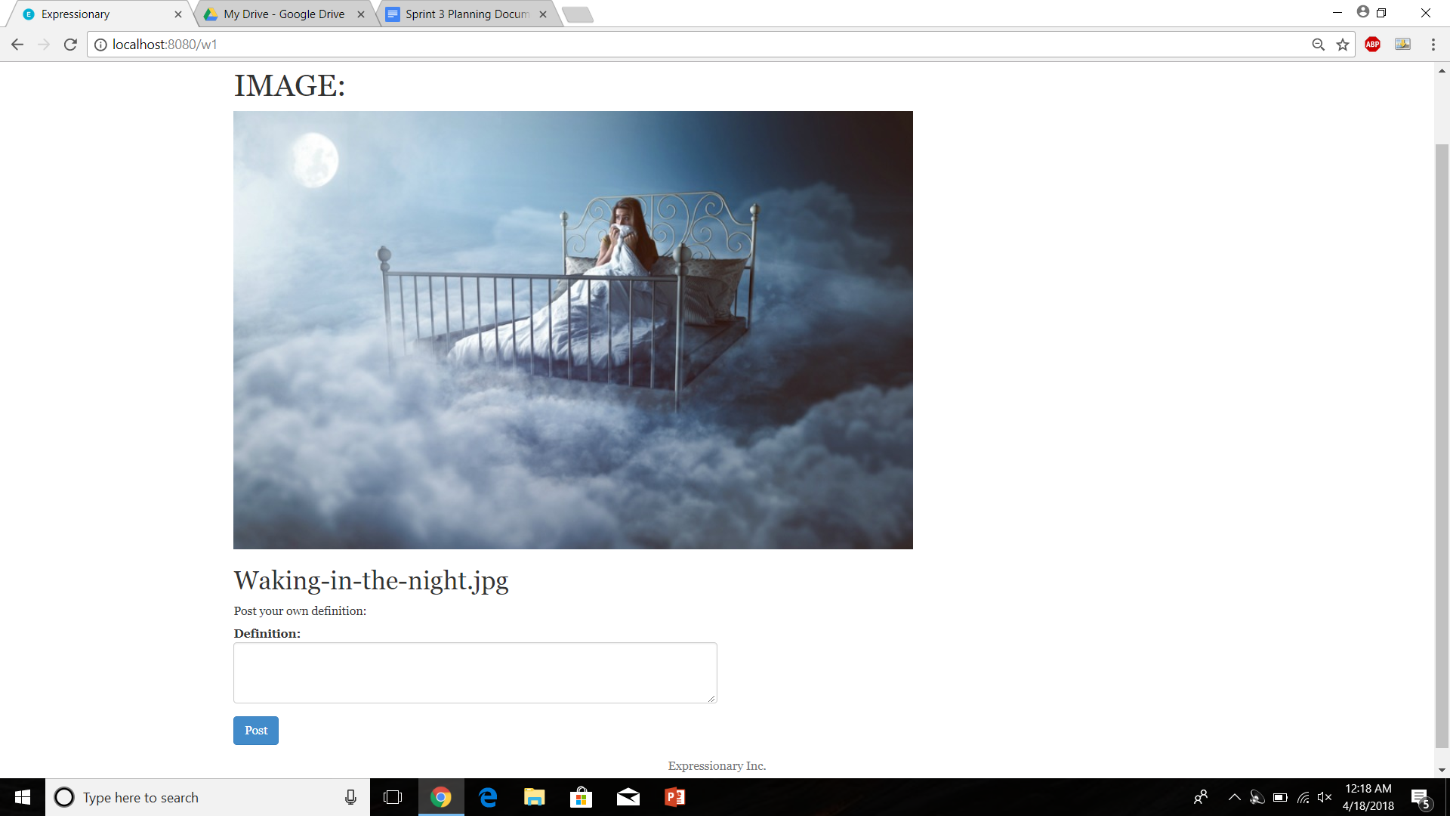

Report the response

**Results:**

Clicking on the image multiple times takes you to their respective pages without breaking.

**USER STORY # 8**

**Test No.1**

Check if unsubscribe and subscribe buttons exist on the user page

**Procedure:**

* Navigate to the home page
* Check the leaderboard
* Report the response

**Test**

Navigate to the home page and check the leaderboard



Report the response

**Results:**

All the words and users on the leaderboard appear to be clickable

**NOTE: INTERMEDIATE STEPS FOR THE NEXT FEW TESTS WILL BE SKIPPED TO AVOID REPETITIONS AS THEY HAVE BEEN DISCUSSED IN PREVIOUS TESTS**

**Test No.2**

Test to check if user receives email if his/her word gets selected

**Procedure:**

* Navigate to home page
* Login and Subscribe to the mailing list if not already subscribed
* Post a word, get enough upvotes to get the word selected.
* Check your email
* Report the response

**Test**

Navigate to the home page and login

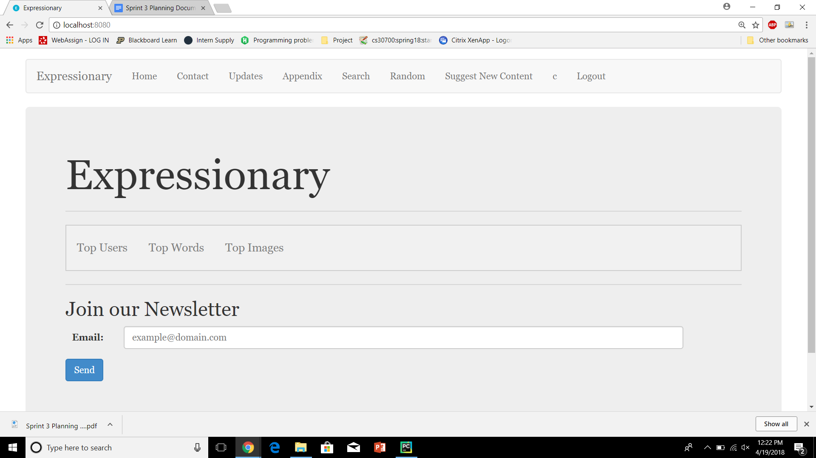

Post a word, get enough upvotes to get the word selected.



Check your email

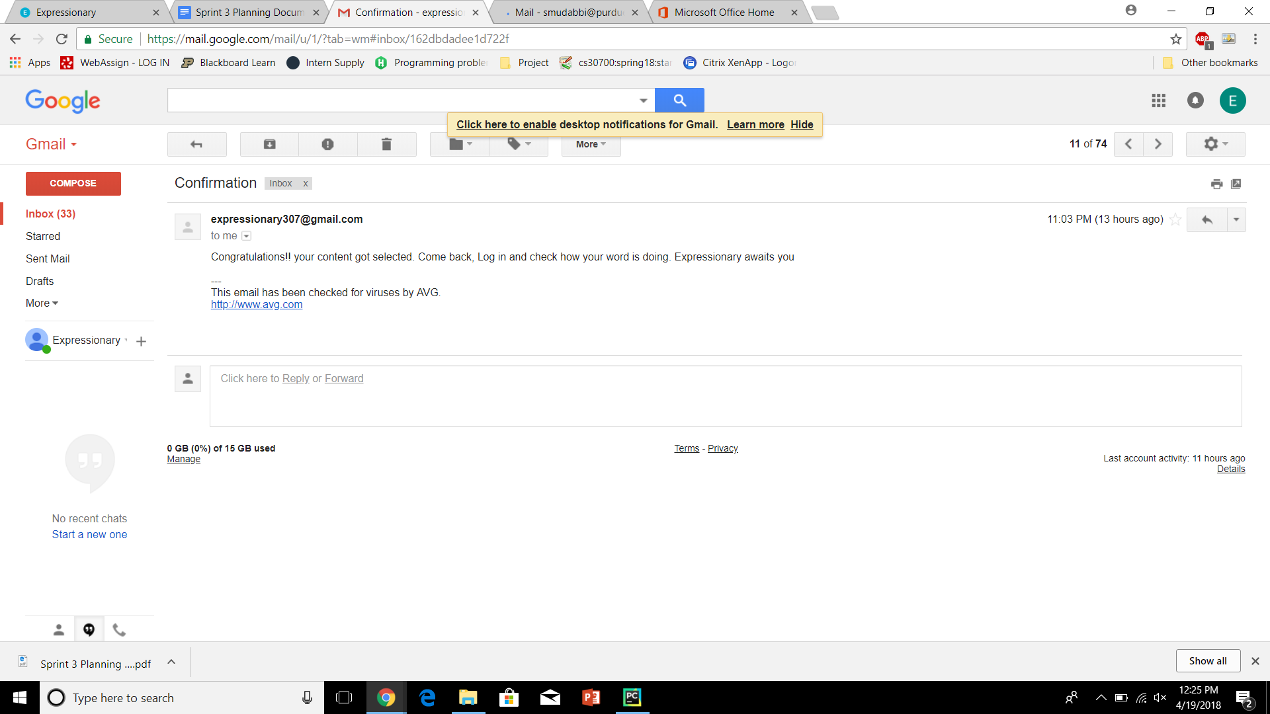

Report the response

**Results:**

The user that suggested the word received an email when his/her word received enough upvotes.

**Test No.3**

Test to check if user receives email if his/her word gets selected

**Procedure:**

* Navigate to home page
* Login and Subscribe to the mailing list if not already subscribed
* Post a word, get enough upvotes to get the word selected.
* Check your email
* Report the response

**Test**

Navigate to the home page and login



Post a word, get enough upvotes to get the word selected.



Check your email

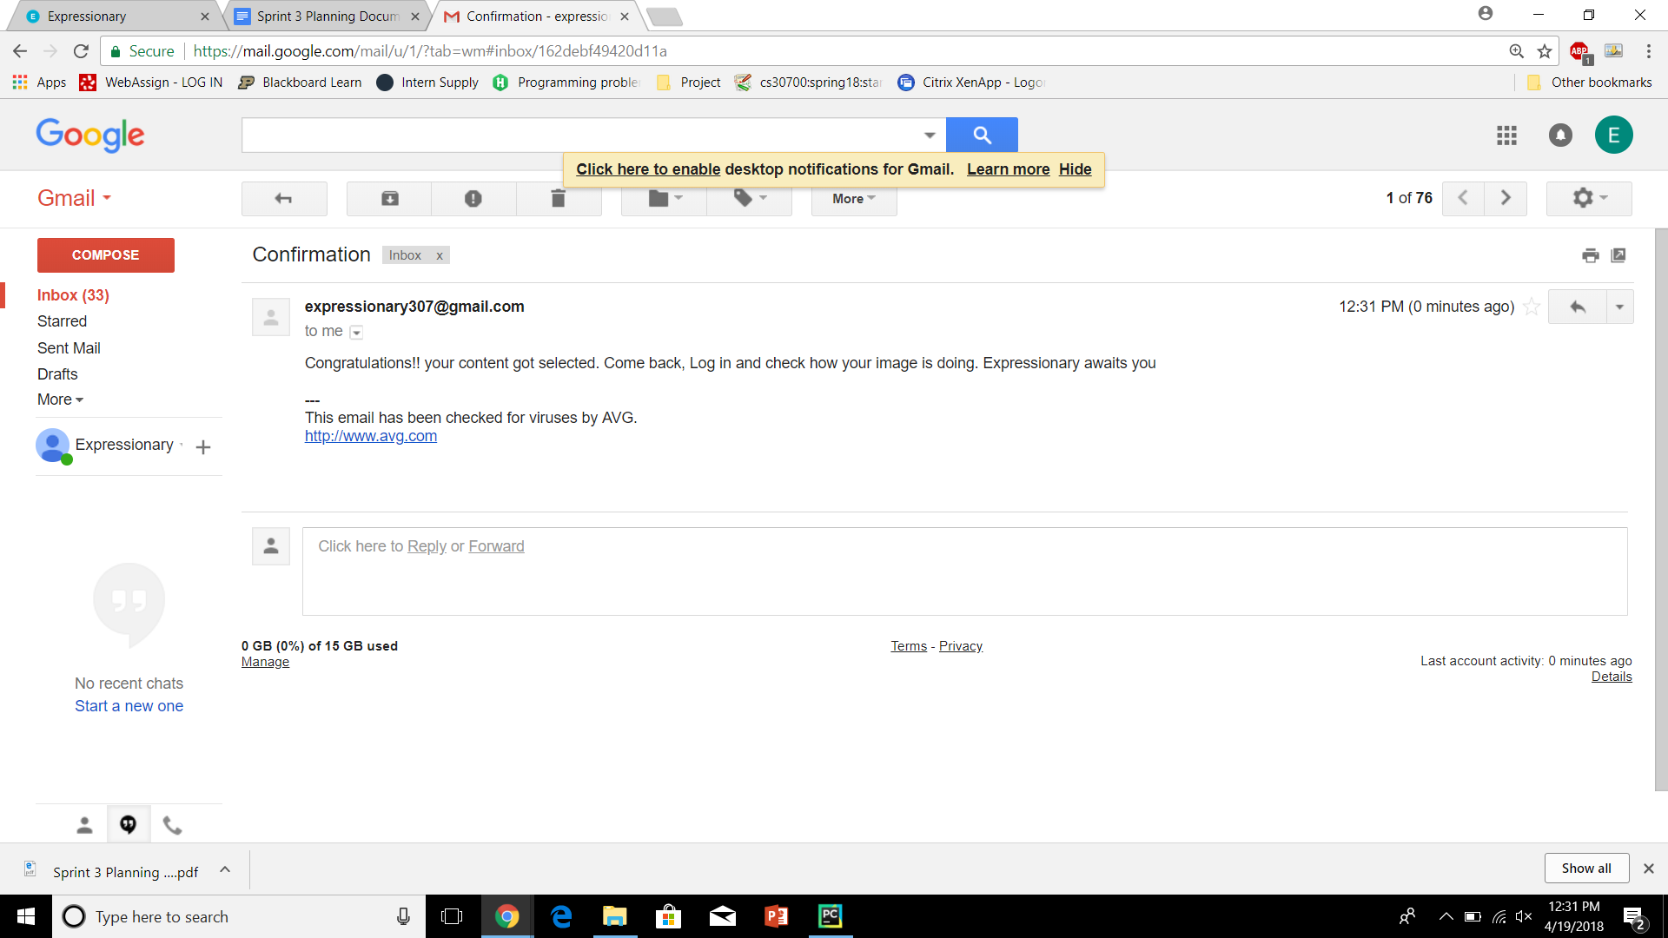

Report the response

**Results:**

The user that suggested the word received an email when his/her image received enough upvotes.

**Test No.4**

Test to check if a user reaches a new milestone (enough points) he receives an email.

**Procedure:**

* Navigate to home page
* Login and Subscribe to the mailing list if not already subscribed
* Get enough points on a word to get a milestone
* Check your email
* Report the response

**Test**

Navigate to the home page and login



Get enough points on a word to get a milestone

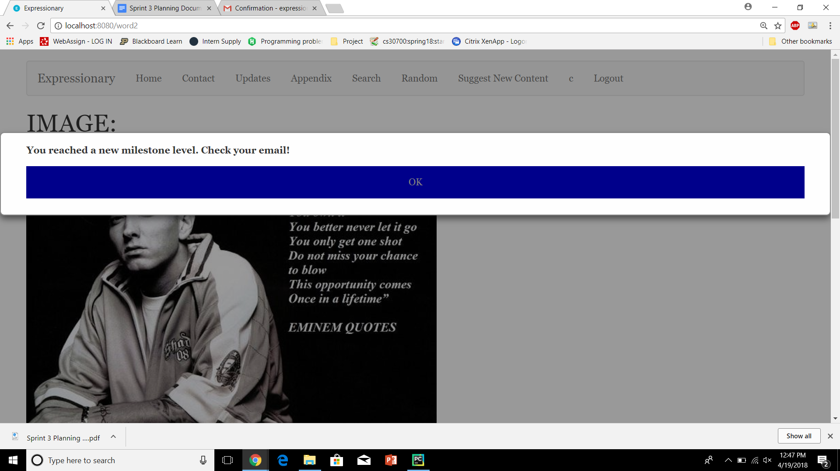

Check your email

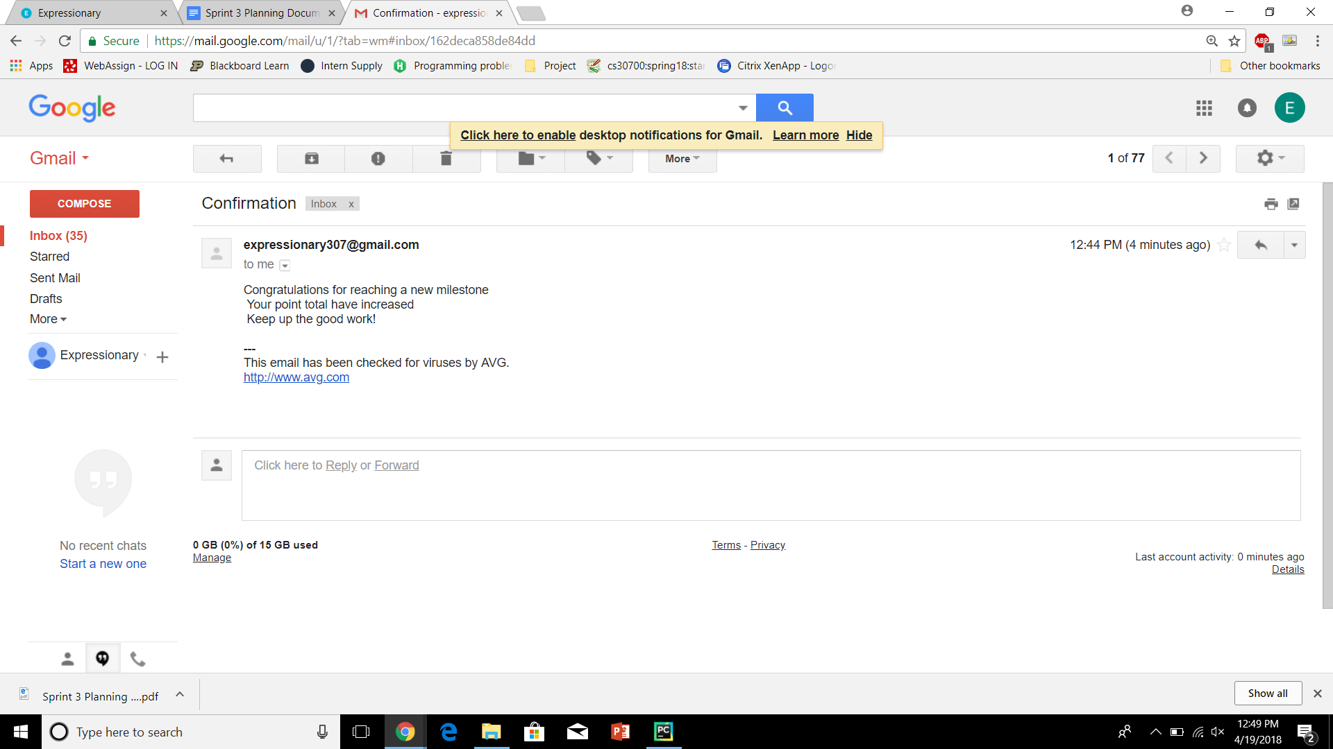

Report the response

**Results:**

The user received an email on reaching a new milestone